COMP1682 – Undergraduate Final Year Project

An Investigation into how technology is changing the Fitness Industry in order to produce a Social

Network Web Application for fitness enthusiasts.

Supervisor: Keeran Jamil & Aditi Rawal

*A dissertation submitted in partial fulfilment of the University of Greenwich’s*

BSc (Hons) Business Information Systems

Faculty of Architecture, Computing & Humanities

Word Count: 17154

Excluding Table of Contents, References & Appendix

Product and Development Files: Uploaded as ZIP File

# ABSTRACT

This report focuses on a project that would aim to empower fitness instructors by building a social network web application, which will elevate their professional expertise. The study will explore the current techniques and tools within social media and explain how they can be used to increase customer retention and client engagement. In addition, the report will evaluate the research undertaken and discuss how the findings of the research will benefit the business and contribute to developing a quality product with basic functionality.

# ACKNOWLEDGMENTS

The completion of this project would not have been possible without the support and guidance from many important people. Special acknowledgements for these following people who helped to make this project a success.

Special thanks and gratitude to Mrs Keeran Jamil who has been my personal tutor and supervisor for this project. Keeran has guided me through my entire project, always offering invaluable advice.

Thank you for all the motivational talks and continuous support during every stage of the project.

Mrs Aditi Rawal, my second supervisor who has been supportive of me during the course of my project. Thank you for providing honest feedback and comments which helped to shape the unique factor of the system.

My mother and sisters who have supported me during my four years in University. Thank you for your endless motivation and guidance, without you this would not have been possible.

My circle of friends who have supported me throughout my final year. Thank you for the constant motivation. Thank you for putting up with my mad ramblings.

Finally, my mentor who helped me to choose a project topic in the early stages. Thank you for all your guidance and for being quick to give me confirmation and clarity on the work I produced.

# CONTENTS

1. Glossary & Keywords ..................................................................................................................... 6
2. Introduction ................................................................................................................................... 7
   1. Project Background .................................................................................................................... 7
   2. Project Aim ................................................................................................................................. 7
   3. Project Objectives ...................................................................................................................... 8
   4. Legal, Social, Ethical and Professional Issues ............................................................................ 9
      1. Legal .................................................................................................................................... 9
      2. Social ................................................................................................................................. 10
      3. Ethical & Professional ....................................................................................................... 10
3. Chosen Methodology ................................................................................................................... 11
   1. DSDM Atern & Project ............................................................................................................. 11
   2. Feasibility Study ........................................................................................................................ 12
4. Literature Review ......................................................................................................................... 13
   1. Introduction .............................................................................................................................. 13
   2. Social Media (SM)..................................................................................................................... 13
   3. Social Media Marketing (SMM) & Tools .................................................................................. 15
   4. Social Customer Relationship Marketing (CRM) ..................................................................... 16
   5. Data Visualisation ..................................................................................................................... 17
   6. Social Personalisation (SP) & Tools .......................................................................................... 19
   7. Conclusion ................................................................................................................................ 20
      1. Report Findings ................................................................................................................. 20
      2. Product Idea ...................................................................................................................... 20
5. Research Report .......................................................................................................................... 21
   1. Design & Usability Principles for Social Networks .................................................................. 21
   2. Heuristics applied to Existing Social Networks ....................................................................... 24
   3. Conclusion ................................................................................................................................ 24
   4. Research for Development Software & Tools ......................................................................... 25
      1. The Pros & Cons of SQLiteStudio ..................................................................................... 25
      2. The Pros & Cons of Ruby on Rails .................................................................................... 26
      3. The Pros & Cons of Sublime Text 2 .................................................................................. 27
   5. Conclusion ................................................................................................................................ 28
   6. Research for Existing Fitness Technology ................................................................................ 28
      1. Virtuagym - https://virtuagym.com ................................................................................. 29
      2. ATX Nutrition - https://about.activtrax.com .................................................................... 30
   7. Conclusion ................................................................................................................................ 31
6. Requirements Analysis ................................................................................................................. 32
   1. Gathering Requirements .......................................................................................................... 32
   2. High level Requirements .......................................................................................................... 33
   3. Prioritised High level Requirements ........................................................................................ 34
   4. Timeboxing ............................................................................................................................... 35
      1. Calculations ....................................................................................................................... 35
      2. Timebox Table ................................................................................................................... 36
   5. Functional requirements.......................................................................................................... 37
   6. Non-functional requirements .................................................................................................. 38

Organisational/Product Constraints ............................................................................................... 38

Technical Constraints ...................................................................................................................... 38

Security Constraints ........................................................................................................................ 38

Legal & Regularity Constraints ........................................................................................................ 39

* 1. Use Case Diagrams ................................................................................................................... 40
     1. Use Case Diagram - Visitor Perspective ........................................................................... 40
     2. Use Case Diagram – Registered User Perspective .......................................................... 41
     3. Use Case Diagram - Administrator Perspective ............................................................... 42
  2. Rich Picture ............................................................................................................................... 43

1. Design .......................................................................................................................................... 45
   1. Entity Relationship Diagram..................................................................................................... 45
   2. Conceptual ERD ........................................................................................................................ 46
   3. Logical ERD ............................................................................................................................... 47
   4. Data Dictionary ......................................................................................................................... 48
   5. User Design Considerations ..................................................................................................... 49
   6. Prototyping ............................................................................................................................... 50
      1. Low Fidelity Paper-Based Designs ................................................................................... 50
      2. Low Fidelity Wireframe Design ........................................................................................ 50
2. Implementation ........................................................................................................................... 54
   1. Chosen Software for Development ......................................................................................... 54 8.2 Social Network Website - Functionality .................................................................................. 55

8.3 Social Network Website – Legal & Social Issues ..................................................................... 74

1. Testing ......................................................................................................................................... 77
   1. White Box Testing ..................................................................................................................... 77
   2. Usability Testing ........................................................................................................................ 77
2. Critical Evaluation ........................................................................................................................ 78
   1. Product Evaluation ................................................................................................................... 78
      1. Future Developments ....................................................................................................... 79
   2. Personal Evaluation .................................................................................................................. 80
   3. Conclusion ................................................................................................................................ 81
3. References ................................................................................................................................... 82
   1. References of Code .................................................................................................................. 86
4. Appendix...................................................................................................................................... 88
   1. Appendix A – Project Proposal ................................................................................................ 88
      1. Project Background .......................................................................................................... 88
      2. Aims ................................................................................................................................... 88
      3. Objectives.......................................................................................................................... 89
      4. Legal, Social, Ethical and Professional Issues .................................................................. 92
      5. LSEPI Conclusion ............................................................................................................... 93
   2. Appendix B - Heuristics Evaluation for Facebook & Instagram (see page 120) ................... 94
   3. Appendix C - Initial Meeting with Business Analyst & Client ................................................. 94
   4. Appendix D – Data Dictionary .................................................................................................. 96
   5. Appendix E – Low Fidelity Designs of Social Network Website ............................................. 99
      1. Low fidelity Design Admin Dashboard & User Home Page ............................................ 99
      2. Low Fidelity Design of User Registration Form ............................................................. 100
      3. Low Fidelity Design of Food Diary & User Diary Log ..................................................... 100
      4. Low Fidelity Design of the User Profile Page & Edit Profile Page ................................. 101
      5. Low Fidelity Design of User ‘Find Friends’ Page ............................................................ 101
      6. Low Fidelity Design of User Login & Administrator Login Forms ................................. 102
      7. Low Fidelity Design of About Us & Contact Us Page .................................................... 102
      8. Low Fidelity Design of Message & Post Forms .............................................................. 103
   6. Appendix F - Meeting with Designer, Developer & Client (User Feedback 1) ..................... 104
   7. Appendix G - Meeting with Designer, Developer & Client (User Feedback 2) .................... 104
   8. Appendix H – Coding Screenshots & Brief Annotations ....................................................... 105
      1. Database connection ...................................................................................................... 105
      2. Registration Form ........................................................................................................... 107
      3. Signing In ......................................................................................................................... 108
      4. Personal Greetings .......................................................................................................... 109
      5. Editing Profile Page ......................................................................................................... 110
      6. Using the Food Diary – Visitor........................................................................................ 111
      7. Using the Food Diary – Registered User ........................................................................ 111
      8. Using the Food Diary – Admin ....................................................................................... 112
      9. Searching For a ‘Fit-Time Pal’ ......................................................................................... 112
      10. Creating a Post ............................................................................................................ 113
      11. Creating a Tag .............................................................................................................. 114
      12. All Validations .............................................................................................................. 115
   9. Appendix I – White Box Testing ............................................................................................. 117
   10. Appendix J – Usability Testing ................................................................................................ 119
   11. Appendix K Development Plan – Gantt Chart ....................................................................... 121
       1. Facebook ..................................................................................................................... 122
       2. Instagram..................................................................................................................... 129

## 1 Glossary & Keywords

Data Visualisation

Enterprise Social Networking

Fitness Technology

Fitness Instructors

DBMS - Database Management System

Social CRM - Social Customer Relationship Management

SSM - Social Media Marketing

SM - Social Media

SP - Social Personalisation

## 2 Introduction

### 2.1 Project Background

The fitness industry has evolved dramatically over the past few years due to the rapid change in technology. According to Vulliamy (2013), in this day and age there are clever workout apps that can provide users with a digital personal trainer, helping them to stay fit and healthy. This is not an issue for the user as they are able to manage their own fitness training however, Hague (2014) claims that fitness instructors are at risk of being marginalised, “the fitness industry, (and in particular, personal trainers), have not yet grasped how they're currently being replaced by (arguably!), a better and more convenient solution.”

Furthermore, Hills (2014) states that fitness instructors are great at interacting with clients’ onsite but, they are currently failing to encourage clients to stay active in their free time and fear that they are at risk of losing business. Following this, Hills (2014) argues that “personal trainers are good at their jobs. But being the best in the world for an hour a week still leaves 167 hours that their clients can choose whether they will take their advice or not. So the question arises, what about the other

167 hours; the time when the client gets closer to their goals, or further from them.”

In conclusion, the notion that fitness instructors fear that they are at risk of losing business, and in the long term their jobs, is supported by McGunagle (2013) who argues that, “fitness professionals have spent years studying their craft, but still struggle to find clientele who are willing to pay for their services.”

### 2.2 Project Aim

The aim of the project is to empower fitness instructors by building a social network web application which will elevate their professional expertise. The web application must allow fitness instructors to engage with clients, motivating them to keep a healthy lifestyle whilst away from the gym. In addition, the web application must allow fitness instructors to promote their business, attracting fitness fanatics as well as prospective clients.

### 2.3 Project Objectives

* The project will research current technologies, techniques and tools that could support fitness instructors in establishing their business; motivating & interacting with clients whilst marketing the business.

* The project will analyse existing social networks and fitness systems. Comparing and contrasting the key features, functionalities and interface designs that are used.

* The project will research development tools, looking at the benefits and drawbacks of development software to find the most suitable tools to build the proposed system.

* The project will produce a series of diagrams and experiment designs, which will be based on the requirements gathered.

* The project will develop a user-friendly, social network web application that will allow users to view information about the business, register, edit their profile, find other users who have the same interests, share posts ,be inspired , and finally create a log in their food diary which will be reviewed by the administrator (fitness instructor).

* The project will develop a social network web application that will allow the administrator to monitor the growth of the business, share posts to inspire users, view diary logs that have been created by users; monitoring their ‘food habits’ and most importantly setting short term goals.

### 2.4 Legal, Social, Ethical and Professional Issues

This section highlights all the Legal, Social, Ethical and Professional issues that a system developer would need to be aware of during this project. By following the Acts and solutions discussed, the project will not only be able to keep the customers data well-secured but it will ensure that both Systems Developer & Web Designer of the project, will fulfil their trust and aim to deliver something that is whole-hearted.

#### 2.4.1 Legal

For this project the user will not be asked to share confidential information such as their payment details, however the development of a social network web application will allow users to register, log in and re-set passwords. This shows that users will be prompted to input sensitive information and for this reason, it can be deemed that the security of the customers’ data is a major legal issue that the developer should be aware of. By following the Data Protection Act (DPA) 1988, the developer would be able to encrypt the database management system to ensure sensitive information is secure from unauthorised access. Also, adhering to the DPA would protect the users’ information further by making sure that their data is not shared to third parties, without the consent of the individual.

The data collection process is another major legal issue that the developer should be aware of. As the system will be collecting the users’ data, it is important that customers are clear about what their data is being used for, therefore the developer would have to include an ‘Opt-out & Opt-in’ clause within the system. This feature would be used an agreement; telling the user how their information is intended to be used, then prompting the user to either confirm or decline the collection of data.

Following the idea of being transparent about data collection, the Data Protection Act would also enable the developer to make it clear how a customer’s information will be discarded. For example, the developer would state in the terms and conditions, the length of time the users’ data will be kept for in the case that they choose to withdraw from the system.

Data accessibility is another major legal issue that a developer should be aware of. For example, the developer should be aware of who is authorised to access which information (under which conditions) in order to prevent sensitive data being stolen. The Computer Misuse Act 1990 deals with unauthorised access or modification of any computer material, and this Act would allow the developer to issue policy guidelines on the website to make sure potential offenders are aware of the criminal offence.

Moreover, as users will be sharing content and images over the social network, the system will fall under the Harassment Act 1997. The developer will therefore include policy rules that will inform the user that cyber bullying is not accepted, and suspects will be removed from the system.

#### 2.4.2 Social

When changing a password it will be the user who will be responsible for setting a strong password therefore, it is important that the system prompts the user to choose something that cannot be easily guessed, and advises them to refrain from telling anyone. Moreover, access to the system will be for anyone who wishes to sign up, therefore users will need to refrain from sharing personal information with users they do not know, to avoid malicious cyber-attacks.

#### 2.4.3 Ethical & Professional

One of the greatest ethical issues in the role of Systems Developer is the trust factor. The client is putting trust into the developers’ skills & abilities to produce a quality system; therefore it is important that all expectations set are viable and not misleading.

From a professional stand point, it is the developers’ responsibility to follow the clients’ needs and build what they say they will do. For example, if the developer knows that they will not be able to implement a function, they would need to be honest about what they can offer to avoid misleading the client. Following professional competence and integrity it outlined in the BCS Code of conduct that members should not claim any level of skills that they do not possess. Furthermore, the BCS guidelines will ensure the developer possess the correct skills to produce a system that not only meets the clients’ expectation but it is delivered on time.

## 3 Chosen Methodology

The Dynamic Systems Development Method (DSDM) Atern approach is popular in the business industry, particularly in small-medium scale projects because the process uses an iterative and incremental approach, ensuring the system is developed quickly and on time. In addition, the Atern approach uses a range of RAD techniques that can provide a business with partial solutions, therefore the DSDM Atern approach will be used as the methodology for the project.

### 3.1 DSDM Atern & Project

The DSDM Atern approach follows the principal that the quality of a project is consistent. This is an ideal method as it will allow the Business Analyst to set targets of a high quality standard at the start of the project, assuring the system is exactly what the proposed client wants and meets the business case. Furthermore, RAD techniques such as Facilitated Workshops will help the analyst to define the scope of the project and identify the high level requirements before the development process begins; ensuring the system is fit for purpose.

The vision for the first release is to build a system with basic functionality and the use of MoSCoW Rules, a RAD technique, will prioritise the high level requirements before the development process begins, ensuring the fundamental requirements for the first release of the system are clearly specified. Without prioritising the requirements first, a fairly accurate estimate of resources and time is virtually impossible.

Another benefit of the DSDM Atern method is that it follows the principle of extreme time management where the deadline is immovable once it is set. Timeboxing, a RAD technique which manages incremental development, will ensure the requirements always fit within the time scope guaranteeing the developer implements the end product on time. Although the time scale is fixed for the life of the project, another benefit of this approach is that the requirements can be changed through prioritisation in contrast to the Waterfall method, where users are forced to fix their requirements in concrete at the start of the cycle.

Furthermore, the DSDM Atern approach uses Prototyping, an iterative process that will allow the designer to elaborate on the high level requirements captured during the process. In addition, prototyping will allow the developer to refine the requirements if necessary in contrast to the waterfall method that does not allow rapid iterative delivery.

In summary the DSDM Atern approach is an ideal method for the project because it enables an incremental approach to development & an iterative approach to delivery, and this would perfectly assist the development of a social network web application within a strict deadline of 6 months.

### 3.2 Feasibility Study

According to Hofstrand (2009) , a feasibility study is an analysis of the practicality of an idea and this can be used in many ways, “individuals with a business idea should conduct a feasibility study to determine the viability of their idea before proceeding with the development of a business.” Therefore, the feasibility study will be used to conclude whether the DSDM Atern approach is a suitable methodology for the project.

|  |  |  |
| --- | --- | --- |
| DSDM Atern Principles | Suitability | Comments |
| 1. Focus on the business need |  | The business case has been identified and the project stands as the business goal. |
| 2. Deliver on time |  | The project has a fixed deadline of 6 months. |
| 3. Collaborate |  | The client will be involved in all stages of the project i.e. interviews, meetings workshops, prototyping etc. |
| 4. Never compromise quality |  | Targets of a high quality standard will be set at the start of the project, assuring the system is exactly what the user wants and meets the business case. |
| 5. Build incrementally from firm foundations |  | The developer will ensure the requirements always fit within the time scope guaranteeing the end product is delivered on time. |
| 6. Develop iteratively |  | The developer will create prototypes and receive plenty of feedback from the client. |
| 7. Communicate continuously and clearly |  | The developer will actively involve the client, receiving many ideas and suggestions for change. The client will be able to elaborate on the high level requirements captured during the process in meetings. |
| 8. Demonstrate control |  | Ensuring both the developer and client can agree on the levels of functionality and usability for the system. |

## 4 Literature Review

This chapter aims to build a clear argument that will support the purpose of the project, therefore a wide range of existing literature will be examined. Reviewing the existing literature will provide the analyst with a greater knowledge of current techniques and tools used within social media, as well as popular concepts that can be used to support the development of the system.

### 4.1 Introduction

In this technology driven world, users now have the option of using free workout applications, helping them to keep fit from the comfort of their house. While this is convenient for the user, fitness instructors fear they are being replaced by these new developments. In addition, whilst fitness instructors are great at interacting with their client’s onsite, they are currently failing to maintain client engagement; motivating their clients to stay active in their free time, and fear that they are at risk of losing business in the long term.

Despite this, it is now argued by many people in the business & fitness industries that fitness instructors can elevate their professional expertise; motivate and engage with clients, if they adapt to the latest technologies and trends. In addition, these technologies can provide them with a platform to attract potential customers and avoid loss of business.

### 4.2 Social Media (SM)

Social media enables users to interact, create or share content to participate in social networking and as technology evolves dramatically each year, social networking has become an important part of life online. This is supported by Fita (2012) who reported that social media is popular because it is cost-effective and provides the user with many benefits such as, “staying in touch with friends and colleagues - It gives the user the opportunity to meet new people around the world.”

In addition, Fita (2012) argues that a major advantage of social media is that, “social networks allow users to create groups” , and this idea is agreed by Rouse & Wigmore (2015) who claims that one of the key components of social media is Enterprise Social Networking (ESN) as it, “allows a business to connect individuals who share similar hobbies or interests.”

Similar to chat rooms, group chats allow individuals who have the same hobbies to come together and share tips, pictures and videos. This concept is supported by Fita (2012) who states that, “group chats act just like a club whose membership is open to anybody who shares similar interests”. Overall this confirms that social media can be used to unite people of all backgrounds, giving them an online forum to share common views and knowledge in creative ways.

On the other hand, although social networks allow users to interact efficiently, there are a few drawbacks. According to Hamel (2010), chat rooms can be one of the most dangerous places on the internet because, “it allows visitors to choose a user name that is not associated with any real information about the person using it”. Hamel (2010) also reports that the anonymity of a user can make it difficult to identify whether a user is being honest.

However Fita (2012) made a convincing case and argued that, “the introduction of profiles on social networking sites allowed people to know more information about a person before they interact with them.” In addition, Mitchell (2015) discusses the development of security within social networking sites and states that, “the user can now keep their profile closed and be aware of who they let join their network”. Mitchell (2015) also states that a benefit of social networks is that, “the privacy features allows a user to restrict strangers”. Overall, it can be argued that social networks are becoming safer to use as it provides the user with an element of privacy & security.

Furthermore, due to the proliferation of social websites, see Figure 1, social media is used for more than just a form of online communication. Ruiter (2014) discusses the use of social media and found in her research, “Based on the challenges of 2013, almost 19% of SMEs within the Health & Fitness sector aim to spend the year improving their knowledge of customer service - One way to improve customer service is better communication on social media”. This concept of using social media in a business to improve customer serviceis supported by Tuli, (2014) who argues that, “organisations need to approach social networking as a huge opportunity - a new way to communicate with and learn from clients in a mode that clients have embraced.” He then goes on to state that, “by interacting with clients in their familiar mode (SM) businesses will see significant improvements in customer service.”

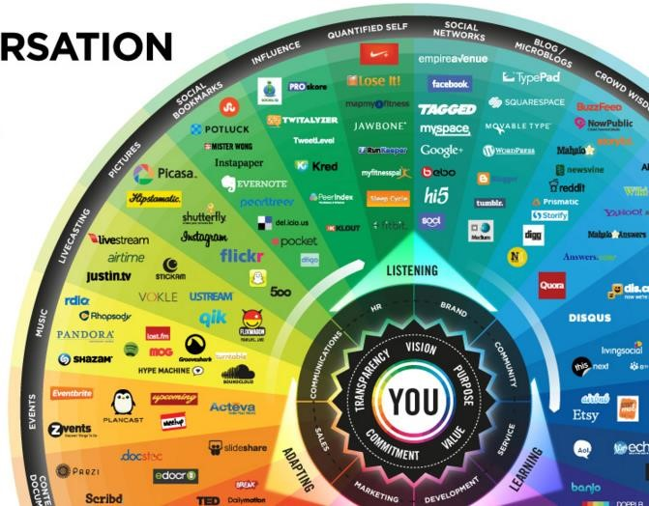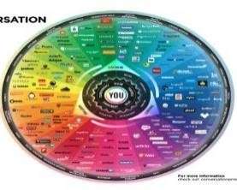

However, Tuli (2014)continues to discuss the use of social media in a business and reports that, “It can be seen as a threat because of the seemingly endless data streams social networks generate.” This means that all the data on the website would have to be examined to identify whether the information is useful to the business, and this could be time consuming.

Despite this, Tuli (2014) argues that, “by taking a strategic, knowledge-based approach, businesses can most fully leverage the potential of social networks to truly enhance the customer experience and improve business performance.” In addition, Tripathi (2015) agrees with the notion of social media advancing a company and states that, “social media is an incredible tool that assists in gaining a better understanding of the customers needs.” This confirms that social media has gained more importance in businesses over the last year, as it can be used to gain a greater knowledge of the clients ‘needs/wants’, overall ensuring a quality service can be provided.

*Figure 1 - Social Media Chart*  *Social sites & services categorised* *into various types of social media.*

*Fita (2012)*

### 4.3 Social Media Marketing (SMM) & Tools

SMM is an effective marketing tool that enables companies to expand their online presence to a wider audience. This is supported by Fita (2013) who reported that, “Businesses around the globe are starting to use them (SMM) as a way to increase their marketing efforts and help to get their brand noticed online.” In addition Rouse & Wigmore (2015) recently stated that, “In business, social media is used to market products and promote brands, connect to current customers and foster new customers.” Although this confirms that the use of SMM has become a popular marketing tool in the last 2 years, it is also clear the SMM assists in establishing a business.

Whilst displaying their professional content online, the use of SMM can help a business to promote their professional expertise and attract customers. This is supported by Fita (2012) who argues that, “(SM) helps organisations to reach their potential customers easily - unlike search engines like Google- social networks have developed and targeted a solution to which businesses can use to reach their potential customers.”

In today’s technology-driven world, the concept of ‘Hash-tagging’ is a great example of a marketing tool to use within a business as it helps to create awareness. This idea is agreed by Fita (2013) who argues that, “One of the best ways to get noticed is to create an online trend - users need to make use of Hashtags to get their business known.”

In addition, Fita (2013) discusses the use of Hashtags in a business and states that, “the most important benefit of using Hashtags is that it creates awareness for your brand.” He then goes on to report that, “By introducing your business to an online trend, it will allow people to associate your business with it and create awareness.” Another benefit of using Hashtags is the fact that it enables a business to track their reputation and this is supported by Fita (2013) who states that “Hashtags make it easy for you to monitor what people are saying when they talk about your business.” In the case that a client is not happy with the service delivered by a business, Hashtags are an effective marketing tool that can notify the business of this. Overall, SMM can give businesses the opportunity to rectify issues as well as to rebuild the clients confidence if they are in doubt.

On the other hand, the integration of SSM in a business can pose a few challenges. In a well-argued study Hamel (2010) identifies the disadvantages of SMM and believes that, “Malicious users can expose others to bad language and adult images or references. “ He then goes on to report that,

“Some Internet users may make comments that invoke anger or create arguments”. However, Rouse & Wigmore (2015) recently made a convincing case and argued that, [“social media policies](http://searchcompliance.techtarget.com/definition/social-media-policy) are designed to set expectations for appropriate behaviour and ensure that an employee's posts will not expose the company to legal problems or public embarrassment.”

Furthermore, Rouse & Wigmore (2015) claim that the new social media policies include directives and rules; the type of information that can be shared as well as the consequences if the rules are broken. Overall, despite there being a few drawbacks of SMM, Fita (2013)argues that “organisations are increasingly seeing the benefit in Hashtags”. From this, it is clear that SMM is an effective marketing tool to use in a business and the new regulations mentioned by Rouse & Wigmore will ensure the business is safely exposed to a world-wide audience.

### 4.4 Social Customer Relationship Marketing (CRM)

Social CRM is an effective business tool which involves organisations using current social networking sites to promote their business, attract customers and view immediate market data that acts as feedback for the business. This is supported by Rouse & Wigmore (2015) who states that, “[Social CRM](http://searchcrm.techtarget.com/definition/social-CRM) can be a very powerful business tool. For example, establishing a Facebook page allows people who like your brand and the way you conduct business to ‘like’ your page, which creates a venue for communication, marketing and networking.”

According to Trent, (2015) the key benefits of using Social CRM in a business is that it allows fitness instructors to build and develop their relationship with clients, “As long as professional trainers are embracing the technological changes, using Social CRM to track and maintain a close relationship with their clients, the only danger to losing business is if a trainer doesn’t care enough to deliver what their clients truly deserve.” In addition, the idea of using Social CRM to support the growth of a business is supported by, Cline (2014) who states that, “personal trainers don't have to spend all day on social media but showing that you have a well thought-out presence on social media, communicates to your network that your business is current and evolving” Overall, first impressions are important and it is clear that the use of Social CRM will instantly tell viewers that the business is current and surfacing.

Furthermore, Social CRM is becoming an increasingly used tool for fitness instructors and this is supported by Keller & Cline (2013) who argue that, “many fitness professionals are harnessing the marketing power of Facebook, Twitter, Pinterest, Instagram and other sites. This data will help you refine your strategy and reach your target audience more efficiently.” In addition, Hoffman & Vogel (2014) agree with the concept of using links to social media and state that, “Marketing your business and building platforms as a fitness expert on social media makes smart business sense.” Overall this confirms that using links to other social media networks is a great strategy for fitness instructors to develop their online presence.

Following this, Keller & Cline (2013) argue that Facebook, the largest online social network, is effective in helping fitness instructors to draw new visitors and attract clients, “71% of online adults use Facebook. Strategy: Share positive status updates to find clients and connections.” In addition, Cline (2014) found in her research that, “With 71% of online adults using Facebook, this provides a great resource for fitness professionals to reach current and potential clients.”

Similarly, according to Keller & Cline (2013), using links to social networks can help fitness instructors to motivate clients, “82% of Pinterest users are women, who average 16 minutes per visit on the site. Strategy: Post client success stories and photos, health memes and recipe images.” In addition Williams (2014) argues that Pinterest is great tool to enhance exercise routines, “But it's also completely possible to turn Pinterest into a tool for planning and executing your workouts.”

Overall from the arguments put across from Keller, Cline & Williams, it is clear that Social CRM can support fitness instructors in growing their customer base, helping to attract potential clients. Furthermore, through using many social network platforms, fitness instructors can inspire clients with success stories, and encourage them to be more active in their free time.

On the other hand, although Social CRM can expose users to a variety of success stories, Williams (2014) argues that it is easy for users to be misled and get pulled into an illusion, “While they can be motivating to some, they also perpetuate an unrealistic and unnecessary picture of fitness.” To avoid users viewing deceptive pictures and receiving this notion of false hope, Williams (2014) believes that fitness instructors should, “Instead, focus on pins (multimedia) that feature specific workout routines.”

This idea of users using Social CRM to search for digital workouts with realistic results is similar to Instagram, a popular social network that can be used to inspire clients and boost their enthusiasm. This is supported by Keller & Cline (2013) who found in their research that, “Instagram has 200 million active monthly users, who share about 60 million photos per day. Strategy: Upload class schedules, special-event photos and (with permission) before-and-after pictures of clients.” Overall it is clear that that through posting motivational pictures and videos, fitness instructors can not only encourage clients to be active in their own time but boost their momentum too, and this adheres to the solution of my project.

### 4.5 Data Visualisation

Data visualisation is the presentation of data in a pictorial or graphical format and for many years, individuals have used visualisation tools to help the viewers to understand information without confusion. This is supported by UAUUG (2012) who discusses this idea and reports that, “Using visual presentation of numbers dramatically reduces confusion because the audience does not need to process the numbers to be able to see where you are going”. They then state that, “Using data visualisation helps the audience quickly absorb and interpret the presented data -The viewer understands what you are trying to say at a first sight.”

In addition, the idea of data visualisation being used to help viewers understand information quicker is reflected in a well-argued study by SAS Institute (2014) who discovered in their research that, “Because of the way the human brain processes information, it is faster for people to grasp the meaning of many data points when they are displayed in charts and graphs rather than poring over piles of spreadsheets or reading pages and pages of reports”. Overall it is clear that data visualisation has become the standard approach to present a large amount of data as this technique can be easily interpreted by the viewer.

According to UAUUG (2012)data visualisation is not only time-efficient but it can be used to improve the proficiency of communicated information, supporting all types of users.

Whilst presenting analytical results, data visualisation can offer the user an aesthetic appeal that helps to keep them engaged. This is supported by UAUUG (2012) who agrees that, “visualisations look better and attract more attention than the textual format. They are also more likely to keep the audience interested.” Therefore, I believe this tool would be suitable to use within my project as it helps to engage with the user, and this adheres to the solution of my project.

Despite Bresicanna & Epller (2008) interview results showing that there were uprising issues from visualisations such as, “high prerequisites for diagram interpretation; visualisation efficacy depends on the user’s previous experience and visual literacy.” SAS Institute (2014) recently made a convincing case and argued that, “data visualisation is an art and a science unto itself, and there are many graphical techniques that can be used to help people understand the story their data is telling”. Following this, (SAS Institute, 2014) discussed the positive impact of data visualisation and concluded that, “data visualisation makes it easier for decision makers across all organisations to identify areas that need attention or improvement as well as to understand what factors influence your customers behaviour.” Overall this shows that data visualisation tools have grown tremendously in the last 6 years and has become a popular business tool.

Furthermore, the concept of data visualisation helping businesses to understand the customers behaviour was supported many years ago by Vogel (2004), who argued that technology can enable a fitness instructor to manage business tasks more efficiently as well as to build a healthy relationship with their clients, “the positive impact it can have on your classes, your training sessions and—above all—your clients, will no doubt make it worthwhile in the long run… clients of all ages are apparently responding favourably.” In addition Vogel (2004) stated that “fitness professionals who hope to remain competitive in the industry should waste no time jumping on the technology bandwagon.” Furthermore, at the time Vogel (2004) discovered that, “the president of Fitness Focus believes fitness professionals needs to provide [clients with] objective, documented feedback” and 4 years later , according to Applebaum (2008) there were many more benefits of data visualisation such as, “helping fitness instructors to manage their business, assess members and plan exercise programs increases retention and revenue."

Overall the timeline of facts given from Vogel & Applebaum, effectively show fitness in the age of technology and it is clear that data visualisation would support fitness instructors in managing their tasks more efficiently, and for this reason I believe it would be a suitable tool to use within my project.

Moreover, Robertson (2010) discussed tips that fitness instructors could use to keep their client motivated, “Set short and long term goals to keep clients motivated towards achieving their goals in the gym” and I believe with the combination of data visualisation, I will be able to provide fitness instructors with an online diary to which they can monitor their client progress and identify areas that need attention or improvement.

Ultimately, the use of data visualisation will empower fitness instructors, allowing them to engage with their client whilst they are away from the gym and this supports the solution of my project.

### 4.6 Social Personalisation (SP) & Tools

In today’s day and age, social personalisation has become a popular tool for online companies to use and this is supported by Lakin (2013) who agrees social personalisation has become the new trend in the business industry and online companies are proactively using it. In addition, Rogers (2013) agrees with this idea and states that, “personalisation is the hot topic for online systems - you can find out everything you need to know about your customers without them having to fill out questionnaires.”

Furthermore, Rogers (2013) discusses the background of social personalisation and found in his research that, “a significant 56% of social network users confirmed they would log into another website using their Facebook or Twitter profile in return for a more personalised experience.” Similarly, this notion of there being a high request for personalised profiles is supported by Rogers

(2013) who made a convincing case amongst social network users and found that, “53% of 2,000 (UK) adult social network users, are willing to share social data from their social media profiles to see content relevant to their interests.” Overall it is clear that social network users wish for their online experience to be enhanced and well-tailored to their interests. Therefore, I am positive the use of social personalisation in my system will keep the user engaged.

In today’s technology-driven world, social media timelines are a great example of an effective personalisation tool as it helps to make the users experience more relevant and memorable. This idea is supported by Lakin (2013) who argues that, “Social media time lines provide an improved, relevant, and more engaging experience for your users.” However, there are a few drawbacks of personalisation tools and this is supported by (Rogers, 2013) who discusses the drawbacks of Recommendation Searches, “Have you ever been recommended something completely irrelevant, because you once purchased a gift for someone who has very different interests to you?”

Nonetheless, Lakin (2013) made a convincing case and argued that the use of personalisation tools in a business drives engagement and makes the content more appealing to the user.

According to Lakin (2013) another effective SP tool is the use of Personal Greetings, as they can provide the user with a memorable experience from day one of using the system, “Easier sign-in processes and personal greetings are some of the immediate enhancements that your users will notice.” Furthermore Lakin (2013) states that social personalisation will not only makes the users online experience easier but “they will be much more likely to come back and share your content around their networks”

### 4.7 Conclusion

#### 4.7.1 Report Findings

Despite there being a few problems surrounding social media, it is clear that social networking is popular and has become the standard approach for people to communicate online. In addition, Enterprise Social Networking can be considered as a social media platform which unites individuals who share the same interest’s i.e. online forums and group chats.

In addition, it is clear that Hashtags are an effective marketing tool that can provide a business with the knowledge of when it is being mentioned, by who, and how often. Moreover, the use of Hashtags not only attracts new customers, but it allows a business to engage effectively with their current clients. This is supported by Fita (2013) who argues that, “followers and customers will be able to easily and effortlessly identify them (Hashtags) and be updated on new updates and developments within your business.”

Social CRM is one of the most powerful marketing tools and fitness instructors are currently using this tool to expand their business. In addition, there are many Social Networks such as Facebook, Instagram, & Pinterest that allow fitness instructors to motivate their clients as well as to be contacted by potential clients. Similarly, the use of Social Personalisation is becoming increasingly used in businesses as this technique keeps the user engaged with the system. Moreover, there is a popular demand from users for personalised accounts.

Finally, data visualisation not only helps viewers to understand information quickly but it can be used to help businesses understand the client’s behaviour and effectively manage tasks more efficiently.

#### 4.7.2 Product Idea

Based on the report findings, the creation of a social network web application with personalised accounts will be suitable for the project as it will provide users with an online forum, enabling them to motivate and inspire one another through sharing fitness related content.

In addition, the use of data visualisations will enable the developer to build an online food diary; a sophisticated lifestyle plan that will allow fitness instructors to monitor the client’s diet and identify areas that need attention or improvement. This concept will enhance client engagement; enabling fitness instructors to motivate clients whilst they are away from the gym and this adheres to the solution of the project.

Furthermore, with social media being so visual, the use of Social CRM combined with SMM tools will not only give the fitness instructors a platform to display their professional content, but it will elevate their marketing. Through gaining a wealth of exposure, fitness instructors will be able to attract prospective clients; appealing to people who may wish to get into contact and join the service and this also adheres to the solution of the project.

## 5 Research Report

This chapter will produce an analysis of key features, functionalities and strategies that are used within social network web applications. By comparing and contrasting existing social networks the analyst will be able to identify effective designs that can be used to support the development of a social network web application. In addition, by examining previous fitness technology the developer will be able to identify usability issues that can be avoided whilst designing the system.

### 5.1 Design & Usability Principles for Social Networks

MoveableOnline (2014) claim that Donald Norman is one of the greats of user-centred design and his six fundamental design principles will support any individual in starting a design project, “When it comes to web and interaction design, Donald Norman provides maybe the best six to abide by.” This idea is supported by Matz (2012) who claims that Norman’s design principles are now integral for understanding why some designs are more usable than others. Therefore, I believe Normans design principles for usability should be considered in the designing stage of the project.

According to UsabilityGov (2015), although there are many versions of heuristics, one of the bestknown sources is the set developed by Nielsen’s in 1994. This idea is supported by DesignPrinciples (2013) who claim that, Nielsen’s Heuristics are one of the most used heuristics for User Interface Design. From this, it is clear that Nielsen’s 10 principles for interaction design will be the best for analysing existing social networks.

Norman’s Design Principles McNeil (2015)

Constraints

The use of constraints within a website limits the users’ interaction, and according to McNeil (2015), “by restricting the users’ behaviour, designers can help the user to understand the status of a system.” In addition Matz (2012) states that, “interfaces must be designed with restrictions so that the system can never enter into an invalid state.”

A classic example of constraints in a social networking environment can be seen when the user is signing up to the system. For example, the registration form would disable the “submit” button until all of the fields are filled in. In addition, the submit button would remain disabled in the case that the user has not entered the correct details in a particular field.

Overall, this principle is effective in reminding users to check the form and would ensure that the user refrains from entering invalid data.

Nielsen’s 10 Principles Nielsen (1995)

1. Visibility of system status

When using the system, the user should not have to guess what is happening at any time. For example, in the case that a user is publishing a post, the system should display a message that tells the user the message is in the process of being published. In addition, once the message is published the system could possibly alert the user with a further message or noise. It is important that the user understands what is happening at all times, and the use of feedback tells the user whether an action has been successful or not.

1. Match between system and the real world

The language used in the system should be relevant to the nature of the system. For example, a social network web application is for all types of users so it is imperative that the language is easy to read and by all means, avoids confusing the user with system orientated language.

1. User control and freedom

The user should have the choice to revert to a previous state in the likelihood that they click a system function by mistake. For example, if a user publishes a photo by accident, they should be able to undo this action; delete the media quickly and without difficulty.

1. Consistency and standards

The system should include words, functions and features that would be deemed as ‘familiar’ by the user. In addition the system should follow platform conventions. For example, users would expect to see a “Register “or “Sign In” button on the main interface of a social networking site. Furthermore the system should have a consistent layout that makes it easy for a user to navigate form page to page.

Overall, this would support the system in being easy to use because the user has most likely seen this function before.

1. Error prevention

The system should have a design which prevents a problem, as opposed to having error messages that occur after the problem has been done. According to Nielsen (1995), this can be tackled by “eliminating or checking for error-prone conditions or presenting users with a confirmation option before they commit to the action.”

For example, if a user is publishing an event and forgets to include the title - the system could prompt the user to fill in the “Subject” field before they proceed. Ultimatley, this would save the user from having to modify or recreate the event again.

1. Recognition rather than recall

The system should aim to minimise the users’ memory load by making objects, actions and options visible. Essentially, instructions and important actions for the system should be easy to identify and access- the user should not have to remember a great amount of information. For example, if a user is searching for a profile that they have looked at before, the system could display the name of the profile as a suggestion.

1. Flexibility and efficiency of use

The system should cater to both inexperienced and experienced users by including accelerators. For example if a user is sharing an image with another user on the same social network, the system could offer a set of advance options that allows the user to share the image externally; with a user on a completely different social network. Furthermore, the system should allow advanced users to tailor frequent actions. This could be done by using filters to narrow down the users search results or offering a preview of common keyboard shortcuts.

1. Aesthetic and minimalist design

The system should aim to only contain information that is relevant and avoid overloading the interface with features or designs that distracts the user from the initial content. In addition the visual layout should adhere to the four principles of visual design: contrast, repetition, alignment and proximity.

For example, the interface of a website should use bold text to allow users to focus on key information, as well as suitable colours that not only complement the interface but appeal to the users eye.

1. Help users recognize, diagnose, and recover from errors

The system should aim to support users when they are experiencing technical issues by offering clear and accurate information that will solve their problem. For example, in the case that a user is unable to view their timeline, the system will display a clear message that precisely indicates the problem, “the timeline is temporarily inactive”. The system will continue in suggesting a solution which may involve links, “Check out the Help Page or forums for help. Otherwise head back to Home”

1. Help and documentation

To help the user further, it is advisable that the system provides the user with documentation that is relatively easy to find and lists concise instructions. For example, if a user is having trouble logging in, the user will be presented with the option to ‘change password’. This option will redirect the user to a page that provides them with a welldetailed explanation of the process.

### 5.2 Heuristics applied to Existing Social Networks

Heuristic evaluations will enable the analyst to obtain a set of guidelines before the design process and this idea is supported by UsabilityGov (2015), who claim that heuristic evaluations can provide designers with quick and valuable feedback. In addition, they then state that, “assigning the correct heuristic can help suggest the best corrective measures to designers.”

The Heuristic Evaluation for Facebook & Instagram can be found in Appendix B.

### 5.3 Conclusion

The research carried out will be used to aid the designer with the correct measures to follow during the designing stage. In addition, the research has provided the developer with suitable functions & features, which will be used to build a user friendly social network web application.

The design guidelines for the social network web app. can be found in Section 7.5

### 5.4 Research for Development Software & Tools

#### 5.4.1 The Pros & Cons of SQLiteStudio

Back-end databases are the heart of every successful business and as technology evolves dramatically each year, SQLiteStudio has become a very popular SQLite database management system. This is supported by Digital Ocean (2014) who highlighted SQLite as one of the “three major and important open-source relational database management systems that have helped to shape the world of application development.” In addition, SQLite (2016) discuss the current users of SQLite and state that, “SQLite is the most widely deployed database engine in the world today”. From small businesses to well-known organisations, SQLite is used almost everywhere, “by literally millions of applications with literally billions and billions of deployments.”

In a well-argued study, Digital Ocean (2014) identified the benefits of SQLite and stated that, “SQLite offers an amazing set of tools to handle all sorts of data with much less constraint and ease”. They then go on to state that, “SQLite is extremely fast and efficient, and also powerful thanks to the library’s underlying technology.” From this it is clear that SQLite is a robust database management system in contrast to MS Access, a desktop database system that has a tendency to perform slowly, “Ms Access’s performance becomes slow as the user scales data size.” Learn IT (2013).

According to SQLiteStudio (2016), SQLiteStudio is not only free but it keeps things simple with its intuitive interface and offers high performance. Another advantage of SQLite is that it does not require any form of installation or configuration, “SQLite does not need to be "installed" before it is used. There is no "setup" procedure. SQLite just works” SQLite (2016). This notion of zeroconfiguration demonstrates that SQLite is user-friendly, in contrast to PostgreSQL, a database engine that involves a more complex installation, “PostgreSQL can be an over-kill for simple set-ups.” Digital Ocean (2014)

Another benefit of SQLite is that it is suitable for a database driven website and this idea is echoed by SQLite (2016) who reported that, “SQLite works great as the database engine for most low to medium traffic websites”. Following this, SQLite (2016) discussed the long-term possibilities in terms of scalability and stated that “SQLite has been demonstrated to work with 10 times that amount of traffic (100K hits per day)”. On the other hand, although SQLite has proven to be a manageable database there are also a few drawbacks. Secure Ideas (2014) reported that a feature called journaling could present serious security concerns for a SQLite database handling sensitive data, “Although It is possible to turn off journaling at the source level - If journal files are missing when the application crashes, your database will likely be corrupted.”

Despite there being a few security issues, Secure Ideas (2014) made a convincing case and stated that, “the best solution for storing sensitive data in SQLite is to encrypt it before storage. If you prefer not to encrypt the data yourself, SQLite has an extension called SQLCipher that will perform encryption.” This notion of using encryption is supported by SQLiteCrypt (2016) who reports that SQLiteCrypt offers encryption, providing developers with an element of privacy & security, “SQLiteCrypt encrypts your data transparently at the storage level - SQLiteCrypt uses advanced AES encryption algorithm to ensure that your data is safe.“ To conclude, whilst SQLite may pose a few challenges in terms of security, there are currently free solutions around this to ensure sensitive data remains secure.

#### 5.4.2 The Pros & Cons of Ruby on Rails

Rails is a web application framework designed to work with the Ruby programming language. Over the last few years Ruby on Rails has become the new personal preference for most developers and this is supported by Ford (2014) who claims that Rails has gained a large and enthusiastic following, “The number of Ruby developers is growing year on year as more people switch to it from other programming languages.”

Zader (2016) states in a well-written article that, “Rails is an ideal solution for Membership and social networking sites. There are a variety of plugins available to solve any social networking challenge you can think of.” He then continues to discuss when Rails would be most suitable to use, and states that, “If the purpose of your site is to present thousands of articles, or other databasefriendly content, Rails is a great solution because of the ease with which users will be able to navigate the site.“ From this it is clear that Ruby on Rails is a suitable solution to use for the proposed system.

Ford (2014) also discusses the benefits of Rails and reports that it is time-efficient, “the Rails framework helps developers to build websites and applications, because it abstracts and simplifies common repetitive tasks”. In addition, MacDonald (2015) claims that Rails helps developers to deliver more features in less time, “Rails provides a standard structure for web apps, where all the common patterns are taken care of for you.”

Furthermore, in a recent case study, Zader (2016) reports that the time savings results from, “a leaner code-base (fewer lines of redundant code), a modular design (re-using existing components) and the availability of existing plugins (reducing the need to build features from scratch).”

However, In terms of performance, Rails is not as fast as Java or C. MacDonald (2015) highlighted this issue and reported that, “the Runtime Speed is the most cited argument against Ruby on Rails because it is slow”. He then goes on to state that, “the Boot Speed of the Rails framework is the main frustration we hear from developers - It can take a significant amount of time to start, which can hinder developer performance.”

Despite there being a few limitations with rails, the main difference between Ruby and other communities is the amount of online support. This idea is supported by Ford (2014) who claims that there are over 63,000 gems available that help developers to enhance their applications. Similarly, MacDonald (2015) discusses this notion of online support and confirms that Rails has a large community, “Pretty much every major city in the world has a Ruby community that runs regular meetups. It's one of the most popular languages on social coding site GitHub.”

As ruby is widely-known, this will ensure that there will always be additional online support in the case that the developer is experiencing issues.

#### 5.4.3 The Pros & Cons of Sublime Text 2

Sublime Text 2 is one of the fastest code editors in today’s time and it is compatible with Windows, Mac OS X, and Linux.

According to Elliot (2014) one of the biggest advantages of Sublime text is the ‘Key Strokes’ feature. Sublime has been built in such a way that it reduces the use of a mouse and enables the developer to use keystrokes, “any repetition of tasks that can be easily done through keystrokes is going to save us a lot of time”. In addition, Elliot (2014) states that another benefit of Sublime is the multiple cursors, “One of Sublimes great features that Dreamweaver doesn’t have is multiple cursors. This is great for making multiple edits or inserts in your code at the same time.”

Sublime has a modern and colourful interface and offers developers a useful ‘Code Preview’ feature. Elliot (2014) discusses this feature and states that, “the condensed preview of your code layout can be pretty useful especially for large pages. This allows you to quickly view and select areas of your code based on its overall shape and structure.”

Another advantage of Sublime is the ‘Bracket & Div Highlighting’ feature and this is supported by Elliot (2014) who examines the reasons of using Sublime Text over Dreamweaver , “Ever find yourself wading through big chunks of code in Dreamweaver trying to locate that closing div or bracket? This is a problem easily avoided in Sublime because of the way it highlights opening and closing brackets, divs and other tags.” From this it is clear that Sublime helps to reduce the developers stress level.

Although a disadvantage of Sublime is that you have to pay to use the tool, it offers better stability in contrast to Dreamweaver. This is supported by Elliot (2014) who reports that, “I’ve been using Sublime for over a year and can’t remember a single crash in that time. Dreamweaver on the other hand, in various versions, seems to be plagued with JavaScript errors and frequent freezes.” Overall, this sophisticated text editor has many great features that would be a great accent in helping the developer code swiftly.

### 5.5 Conclusion

In summary, SQLite has become the standard database management system for businesses to use because it provides developers with a central location to manage data, as well as the back-end for a database-driven website and this adheres to the solution of the project. Furthermore, in the case that the business evolved and the database grew, SQLite has proven to be a sophisticated development tool capable of dealing with a great amount of web traffic.

Due to the nature of the proposed system, clients will be sharing sensitive information when registering. Therefore, it is imperative that the security of the system is one of the highest priorities. SQLite will be suitable database to use for the project because it has many security features that will enable the developer to encrypt information, ensuring the client data is safe and secure.

As mentioned in the report, Rails is a web application framework and this is well-tailored to the proposed system; social network web application. Furthermore, from the research report it is clear that learning to program in Ruby is much easier and faster than any other frameworks and languages, because of the vast collection of gems and online support available within the Rails community. Moreover with the combination of a sophisticated text editor, the developer will have the appropriate gear to build the social network web application.

### 5.6 Research for Existing Fitness Technology

With technology evolving dramatically each year, it can be argued that the fitness industry is reaping the benefits of these new developments. According to Applebaum (2008), fitness assessments are effective in helping fitness instructors to manage their business, “these technologies serve as a tool to simplify aspects of management so that fitness instructors have more time to spend on what truly matters—personal relationships with members”.

In addition, the use of fitness assessments can help clients reach their fitness goals and this is supported by Applebaum (2008) who states that, “Conducting fitness assessments is an opportunity for one-on-one time with new members. Use this chance to assist clients in achieving their fitness objectives and ultimately improving retention and success.”

This section will provide two examples of fitness systems that use data visualisations, and although one of the examples offer more than the intended project solution, it is important to consider how existing fit-tech systems have showcased these data visualisations.

Through analysing the key features used; identifying the pros and cons of the design, this will provide the project with valuable knowledge that will be used to support the development of an online food diary during the design stage.

#### 5.6.1 Virtuagym - [https://virtuagym.com](https://virtuagym.com/)

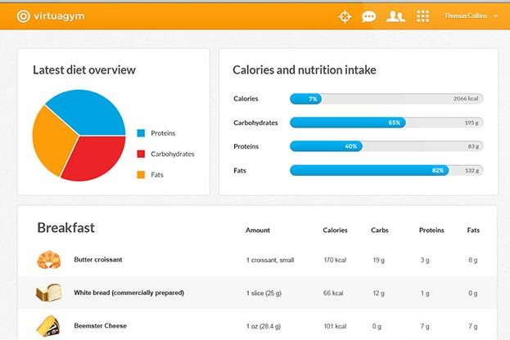

Figure

2

-

Virtuagym

(2015)

Powerful nutrition tracking for your clients

Designed by expert nutritionists, Virtuagym offers a powerful nutrition tracking system that can help boost client retention.

* The interface layout in Figure 2 is clearly organised as it tactfully splits the design into three key sections, ensuring the user is free to navigate to where they like.
* The interface uses progress bars to display the users’ nutrient limit. For example, the user will be given a set amount of calories they can take and the progress bar will indicate to the user whether they are close to exceeding that limit or not. In addition, the user has the option to view a pie chart that effectively displays their overall nutrient intake
* The interface gives the fitness instructor a breakdown of their client’s meals for the day. The fields are well tailored to the system and give the fitness instructor all the information they need to know and the use of images adds an aesthetic appeal to the interface.
* The language used is straight forward and is in context to what the system is being used for. Also, the use of bold text to appropriately highlight headings tells the user what the content is about. In addition, the colours used are suitable for the target audience.

Overall the content is clear and concise which can be easily read by the user. The nutrition system has a simple yet effective design put in place, and the use of the pie chart offers the user an aesthetic appeal that helps to keep them engaged.

#### 5.6.2 ATX Nutrition - [https://about.activtrax.com](https://about.activtrax.com/)

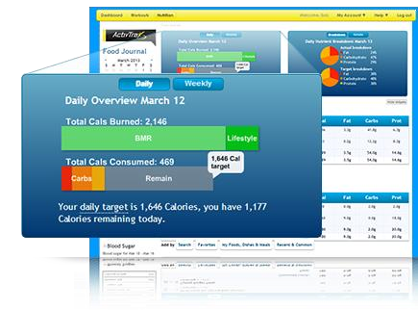

Figure

3

-

ActivTrax

(2015)

Nutrition Guidance

ActivTrax offers a suite of tools designed to help fitness professionals with guiding clients towards reaching their goals, while keeping the fitness instructors in tune with their every step.

* The layout of the interface in Figure 3 appears to be structured clearly; data visualisations at the top and reading material at the bottom. This format will ensure the user has the freedom to navigate how they wish
* In comparison to Virtuagym, this interface uses progress bars to display the users’ nutrient limit. However, this feature also displays a message that communicates this to the user. In addition, the user has the option to view many charts that effectively displays their nutrient intake.
* The interface also gives the fitness instructor a breakdown of the client’s meals for the day. However this feature has an additional button that allows the user to see ‘daily’ or ‘monthly’ in contrast to Virtuagym, that leaves the user guessing.
* The language used is clear and is in context to what the system is being used for. Also, the colours used are suitable for the target audience, and the use of bold text to appropriately highlight headings tells the user what the content is about.

Overall this nutrition system is more advanced as it allows users to filter their nutrition intake by including the “monthly” option. Overall this demonstrates that the interface includes accelerators and caters to both inexperienced and experienced users.

### 5.7 Conclusion

Based on the findings, it is clear that the creation of an online food diary will allow fitness instructors to improve their relationship with clients. This additional feature will provide the fitness instructor with an assessment of the client’s fitness level; allowing the fitness instructor to not only monitor the clients food behaviour on a frequent basis, but provide the client with vivid feedback that will help them in reaching their fitness goal.

Overall the use of an online food diary will be effective in increasing client engagement and this adheres to the solution of the project.

The design guidelines for the online food diary can be found in Section 7.5.

## 6 Requirements Analysis

This chapter aims to gather a list of requirements from both the research report and client to produce a set of high level requirements. To support the development of the system, the analyst will use MoSCoW rules to prioritise the high level requirements before the development process begins, ensuring that the fundamental requirements for the first release of the system are clearly specified.

### 6.1 Gathering Requirements

A meeting was organised between the analyst and the client to help gain a deeper understanding of the proposed system. As there was not a system currently in place, the meeting allowed the analyst to clearly communicate with the client and define the scope of the project. This supports the DSDM Atern principle, ‘Never compromise quality’, where targets of a high quality standard are set at the start of the project, ensuring the end product will be fit for purpose. In addition, the meeting keenly involved the client, assuring the system is exactly what the user wants and meets the business case. This also supports the DSDM Atern principle of ‘Collaboration’, where the client is involved in all stages of the project

Overall, the meeting allowed the analyst to offer strategies and incorporate the client on making decisions that will contribute to the success of the project.

See Appendix C for further details of the meetings; questions and answers with the client.

For the purpose of the project, the information obtained from the meeting with the proposed client will be reviewed and considered when gathering the requirements for the proposed system.

### 6.2 High level Requirements

Based on the research report and the meeting conducted with the proposed client, the list of requirements below will be used for the development of the system. These requirements will be effective in helping the fitness instructors to increase client engagement and promoting the business to attract prospective clients as well as fitness enthusiast.

* The system must give a visitor a limited version of the system in terms of what they are able to view.
* The system must allow a registered user to login to the system and visitors must be able to create an account to register with the system.
* The system must allow a registered user to view and edit their profile page.
* The system must allow a registered user to browse the system and keep up to date with information about the business.
* The system must allow a registered user to create a log in their food diary.
* The administrator must have a passcode protected view of the system where they can monitor and manage the system i.e. view, edit, delete & add.
* The system must allow an admin to view a diary log and set short term goals (give feedback).
* The system must allow an admin to create a post with a tag feature include. (This includes updates about the business and fitness)
* The system should have a search feature which will allow registered users to find other users. This includes users near to their location or people who share the same hobbies/interests.
* The system should allow registered users to create posts and comment on other posts.
* The system should include links to social media to promote the fitness instructors professional expertise and attract customers
* The system could have a personal feature that greets registered users to the website.
* The system could have a customer service facility that allows registered users to get in touch and make enquires.
* The system could have a data visualisation feature that gives the client an overview of their nutrition intake i.e. using pie charts.
* The system could allow the registered to upload a profile picture.
* The system could allow a registered user to purchase the latest fit-wear/ fitness products.

### 6.3 Prioritised High level Requirements

|  |  |  |
| --- | --- | --- |
| High Level Requirement | Hours | Priority |
| 1. The system must give a visitor a limited version of the system in terms of what they are able to view. | 60 | Must |
| 2. The system must allow a registered user to login to the system and visitors must be able to create an account to register with the system. | 80 | Must |
| *3.* The system must allow a registered user to view and edit their profile page. | 140 | Must |
| 4. The system must allow a registered user to browse the system and keep up to date with information about the business. | 100 | Must |
| 5. The system must allow a registered user to create a log in their food diary and view their diary log. | 230 | Must |
| 6. The administrator must have a passcode protected view of the system where they can monitor and manage the system i.e. view, edit, delete & add. | 340 | Must |
| 7. The system must allow an admin to view a diary log and set short term goals (give feedback) | 170 | Must |
| 8. The system must allow an admin to create a post with a tag /image included. | 110 | Must |
| 9. The system should have a search feature which will allow registered users to find other users. This includes users near to their location or people who share the same hobbies/interests. | 75 | Should |
| 10. The system should allow registered users to create posts with a tag /image included and comment on other posts. | 175 | Should |
| 11. The system should include links to social media to promote the fitness instructors professional expertise and attract customers. | 50 | Should |
| 12. The system could have a data visualisation feature that gives the client an overview of their nutrition intake i.e. using pie charts. | 175 | Should |
| 13. The system could have a personal feature that greets registered users to the website. | 55 | Could |
| 14. The system could have a customer service facility that allows registered users to get in touch and make enquires. | 400 | Could |
| 15. The system could allow the registered to upload a profile picture. | 1000 | Wont |
| 16. The system should allow the client to view and purchase the latest fit-wear/ fitness products. | 500 | Wont |
| Total Hours | 3600 |  |

Must Have

For demoing purposes, the requirements categorised as “MustHaves” will be included in the initial release as they are the main features that are needed to produce the system with basic functionality.

Should Have

The high level requirements listed as ‘Should Have’ are features that support the functionalities that are categorised as ‘Must Have’. For example, the client will only be able to search for other users once they have signed up to the system. On the other hand, although the “Should Haves” are very important, they are generally not critical features to include in the first release.

Could Have

If there is additional time, the high level requirements listed as ‘Could have’ could be built to support the system and essentially the success of the project. For example, the customer service facility could be implemented to not only help the fitness instructors interact and learn from the clients but to enhance the company profile.

Won’t Have

Although the ‘Wont Have’ features are not technically required to make the project work, they can be deemed as future developments to support the success of the product.

### 6.4 Timeboxing

Timeboxing, a RAD technique which manages incremental development, will ensure the requirements always fit within the time scope and the end product is delivered on time. In addition, this supports the DSDM Atern principle, ‘Build incrementally from firm foundations’. As mentioned in the interview, the client would like a basic system to be up and running in 6 months; 18th April 2016. Although the time scale is fixed for the life of the project, through prioritisation the requirements can be modified.

#### 6.4.1 Calculations

“8Hours x 5Days = 45Work Hours

90Work Hours x 24weeks = 2160 Project Hours “

Using simple calculations, the timeframe of 24 weeks and 2 resources (Web Designer & Systems Developer), together turning 90 hours a week would give the project time box a total of 2160 hours. Given that, the aim is to prioritise the list of features and end up with approximately 2160 hours of work that will be used to implement a respectable first release of the social network web application.

#### 6.4.2 Timebox Table

The DSDM Atern approach recommends no more than 60% effort for Must Haves, therefore it was important that the developer followed the 80:20 Rule. See Figure 4. Following this rule meant that the ‘Wont Have’ features would be deferred and not included in the time box table.

|  |  |  |  |
| --- | --- | --- | --- |
| Priority |  | Hours | Percentage (%) of Total Hours |
| Must Have | 1230 |  | 57% |
| Should Have | 475 |  | 22% |
| Could Have | 455 |  | 21% |
| Total |  | 2160 | 100% |

Overall, the time box table shows that it will only take 1230 hours to complete the ‘Must Have’ features. This means that the developer will be expected to produce a system, robust enough for operational use, within 57% of the total hours and this adheres to the 80:20 Rule.

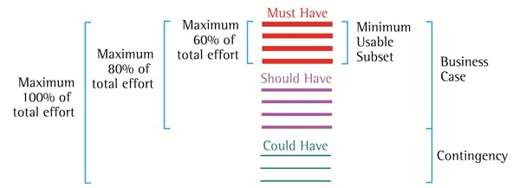

*Figure 4*

*Moscow Rules and 80:20 Rule*

### 6.5 Functional requirements

This section will clearly outline the main inputs and outputs that the system should be able to demonstrate successfully. The functional requirements listed below will be crucial to developing the social network web application for the proposed client.

|  |  |  |
| --- | --- | --- |
| User | Functional Requirements | Priority |
| Visitor | The visitor must be able to view all posts. | Must |
| The visitor must be able to view a page dedicated to what the business is about. | Must |
| The visitor must be able to view a preview of the food diary. If they wish to continue they must be redirected to the sign up page. | Must |
| The visitor must be able to sign up and create an account. | Must |
| Registered  User | The user must be able to login. | Must |
| The user must be able to browse the system. | Must |
| The user must be able to view and edit their profile page. | Must |
| The user must be able to create a log entry in their food diary and view all their logs. | Must |
| Admin | The admin must be able to login to a protected view of the system where they can monitor and manage the system. | Must |
| The admin must be able to create tags. | Must |
| The admin must be able to create a post ( tag & image included) | Must |
| The admin must be able to view a diary log and respond. | Must |
| Registered  User | The user should be able to search for friends and find fitness buddies. | Should |
| The user should be able to create a post (tag & image included) and comments on another post. | Should |
| The user should have a data visualisation that gives them an overview of their nutrition intake. | Should |
| Admin | The admin could be able to read and respond to a user’s query. | Could |
| Registered  User | The user could be greeted to the website when they sign in. | Could |
| The user could be able to submit queries. | Could |
| The user could be able to upload a profile picture. | Could |
| Visitor | The visitor could be prompted to join the email marketing list if they wish to write a comment on a post. | Could |
| Registered  User | The user should be able to view a range of fit-wear products | Wont |
| The user should be able to purchase fit-wear products | Wont |

It is important to note that the functions highlighted in grey will not be implemented for the demonstration but reviewed as future developments.

### 6.6 Non-functional requirements

This section will include the requirements that are considered as the qualities of a system. The nonfunctional requirements specify properties of the software product itself; the criteria that can be used to judge the operation of a system.

#### Organisational/Product Constraints

* The system is expected to be delivered in 6 months.
* In terms of performance, the system will be expected to have many users (registered users, visitors, admin) accessing the social network at one time. Using the SQLite database should ensure all users have a swift experience, allowing them to use the system without crashing.
* The database managements system shall have the ability to manage an increasing amount of data in a capable manner; holding 1000 user accounts.

#### Technical Constraints

* In terms of reliability, the information maintained and supplied to the system should be system should be frequently backed up. The backups should be available to administrators and easily retrievable, allowing them to recover material from the system in the case of an emergency.
* The system shall support the current technology by running on the most popular operating systems like windows 7, 8 & 10. The system shall also be usable on different web browsers e.g. Google Chrome, Internet Explorer & Mozilla Firefox.
* When deployed, the system will be hosted on herokuapp.com as this will ensure the system will be online and available to use at any hour of the day.
* The system will be modifiable by the trained administrators - e.g. to keep the system up to date with inspirational content, fitness stories, information about the business and upcoming events.

#### Security Constraints

* The database will be exceptionally well protected, assuring that important data is safe. Sensitive data will be encrypted and secure in the SQLiteStudio Database management system for SQLite.
* The developer will ensure the administrator’s dashboard is password protected and will give full access to all administrators. Other users of the system such as visitors will have limited access, and will need to register before they can carry out certain functionalities.

#### Legal & Regularity Constraints

* The system shall follow the Data Protection Act by ensuring the users details are secured and will not be shared to third parties without the consent of the individual.
* The system must have terms and conditions that are boldly published - the developer must put a notification in place that informs the customer how long their data will be saved for e.g., Clients data will be held for 6 years from the date created.
* The system will make sure not to break any copyright laws.

### 6.7 Use Case Diagrams

Following the functional requirements listed in Section 6.5, the analyst will create Use Case Diagrams. When building the Use Case Diagram it is important to showcase all the functions that the main actors can use whilst interacting with the system, therefore the analyst will create three diagrams from the perspective of the Visitor, Registered User and Administrator.

Ultimately, the use cases will illustrate the behaviour of the system, giving the developer a clear idea of how the systems intend to function. With the aid of the use case diagrams, the developer will be able to build the proposed system, ensuring that all the functional requirements listed in the analysis chapter are met.

#### 6.7.1 Use Case Diagram - Visitor Perspective

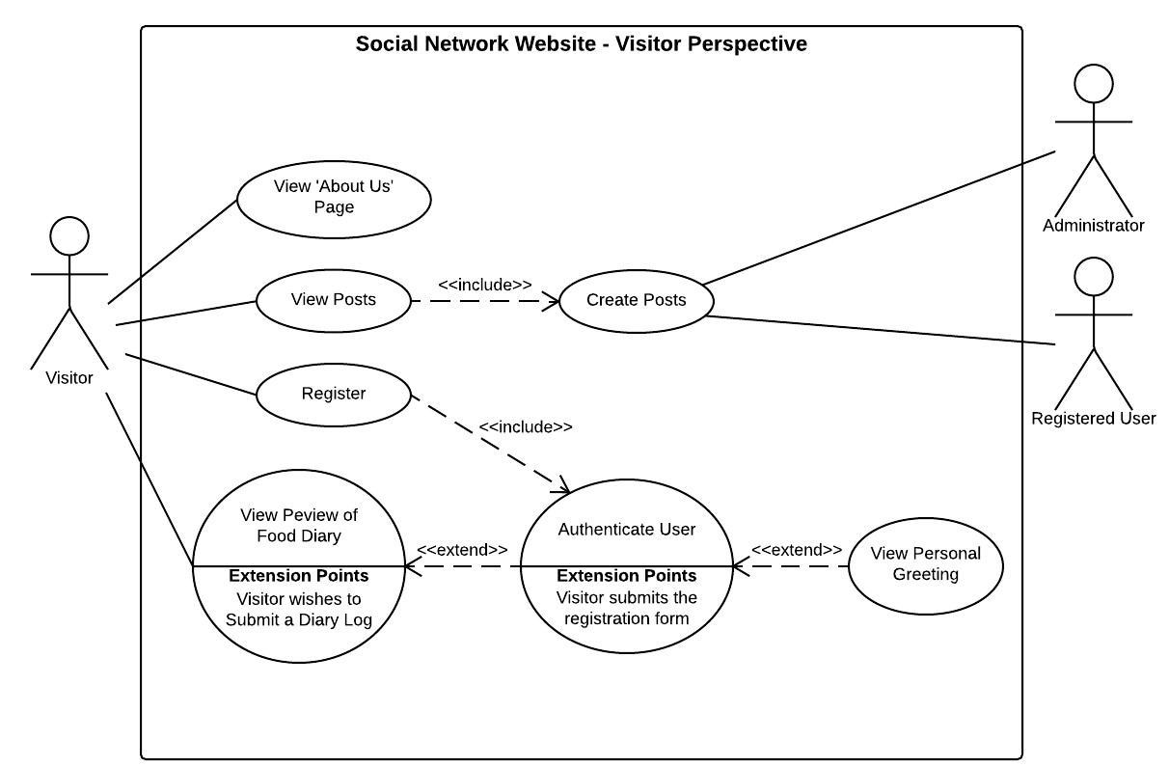

*Figure 5*

*Use Case Diagram - Visitor Perspective*

#### 6.7.2 Use Case Diagram – Registered User Perspective

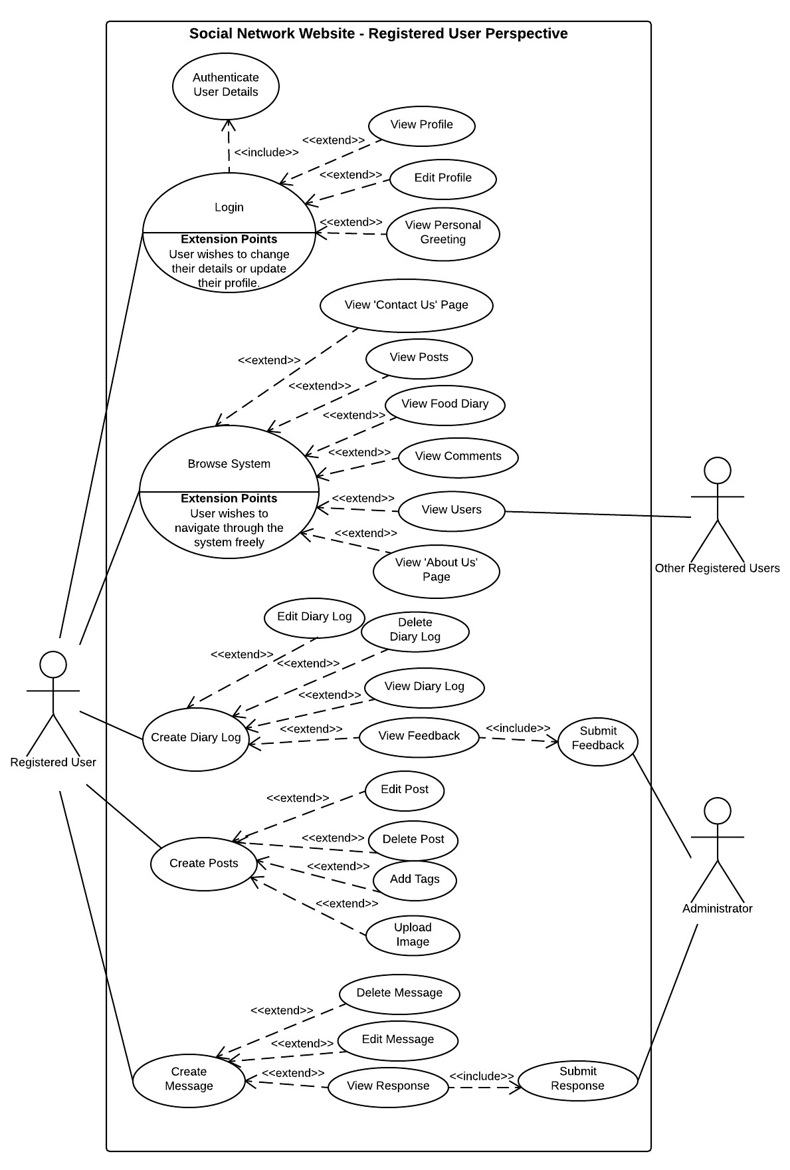

*Figure 6*

*Use Case Diagram – Administrator Perspective*

*Figure*

*7*

*Use Case Diagram*

*–*

*Administrator*

*Perspective*

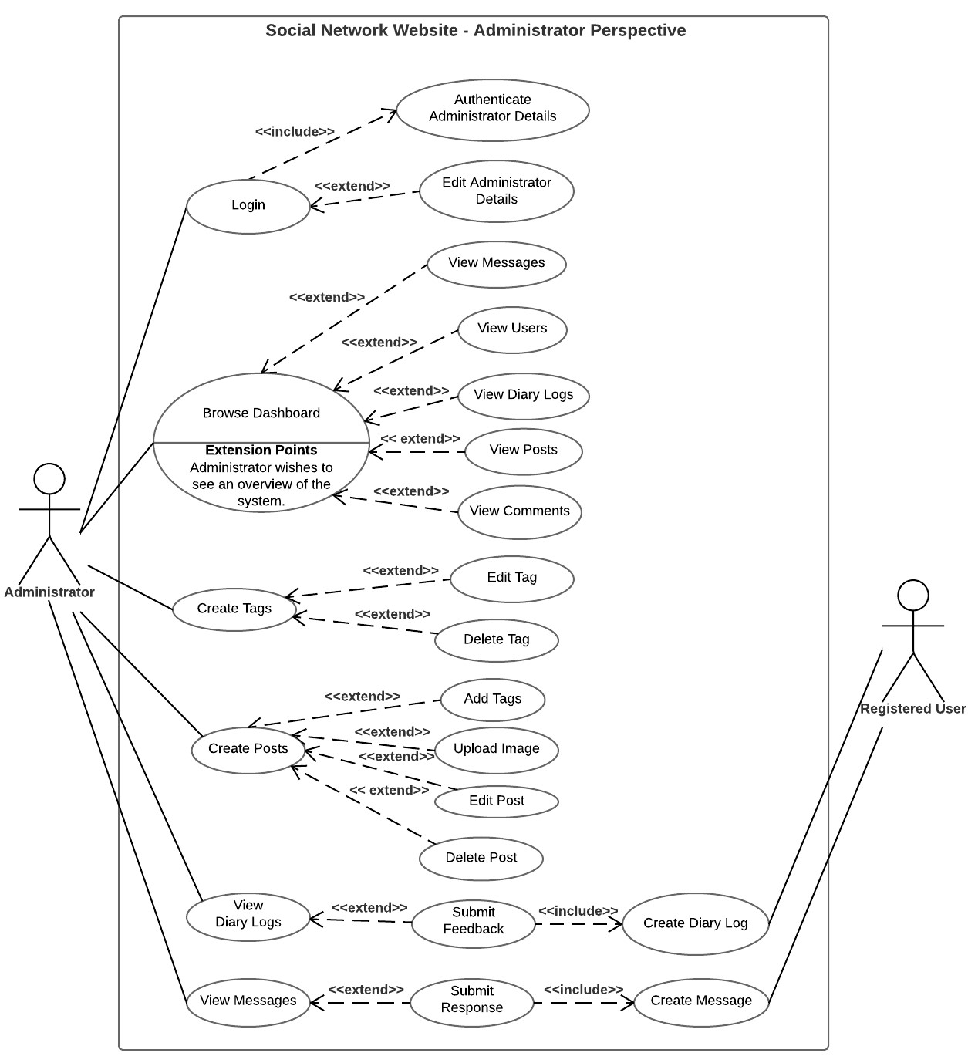

**Use Case Diagram**

**-**

**Administrator Perspective**

**6.7.3**

### 6.8 Rich Picture

The Rich Picture analysis model will be used to illustrate the system in its predicted environment; enabling the analyst to identify all the actors and each process that they are involved in.

The analyst will abstract the relevant information from the meeting with the client (See Appendix C) and produce a concise overview of the system. Due to the unrestricted nature of this technique, the analyst will also create a key that identifies all the symbols used within the Rich Picture. See Figure

8.

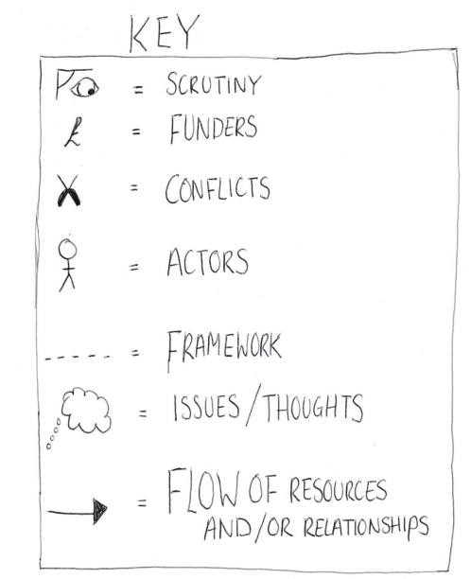

Figure 8

*Rich Picture Key*



Figure 9

*Anytime*

*-*

*FitTime Rich Picture*

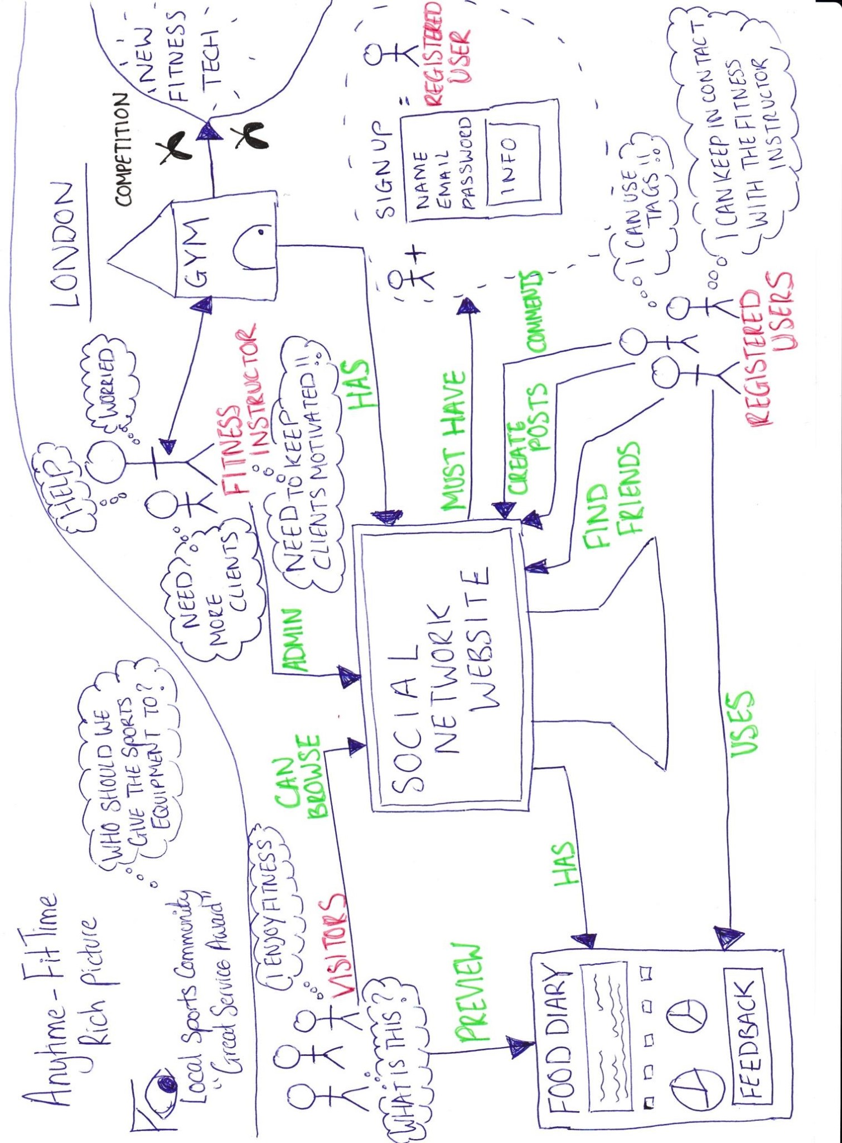

## 7 Design

In the initial release, the system will include a back-end database and front-end design. Therefore, this chapter will look at Entity Relationship Diagrams, as this will aid the developer in understanding the structure of the back-end database. In addition, the designer will create a series of sketches which will portray the front-end user interface to the client.

### 7.1 Entity Relationship Diagram

Entity Relationship Diagrams (ERD) identify all the important entities in a system along with their data attributes and relationships. This tool will capture all the data that needs to be stored in the database, which is significant for aiding the developer during the development stage.

The ERDs have been developed using Crows Foot notation (1980s). See Figure 10. Using the Crows Foot notation allowed the analyst to explain the different relationships between the entities, giving the developer a clear visualisation of how the database tables will relate to one another.

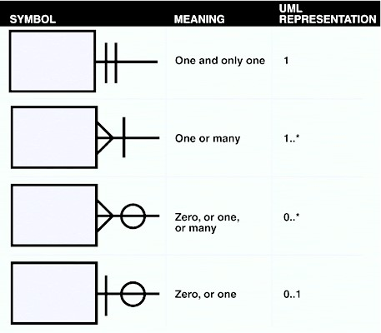

Figure

10

*O*

*verview of the*

*most im*

*portant*

*relationship symbols in Crow's Foot*

*N*

*otation*

*(*

*Sauer,*

*2014)*

Through creating the Conceptual & Logical ERD the developer will gain a broad view of the database structure and transfer it from an ERD concept into a functional website.

Brainstorm for ERD

The system will need to allow a post to have many tags AND tags to belong to many post, therefore a bridge table was created.

* Post has many tags via post _tags
* Tags has many posts_tags
* The same tag can be owned by multiple posts
* An administrator can create many posts
* A post can have many comments
* A visitor can create many comments
* A user can create may comments
* A user owns messages and can create many messages.
* A user owns diary logs and can create many logs.
* A user owns a post and can create many posts.

### 7.2 Conceptual ERD

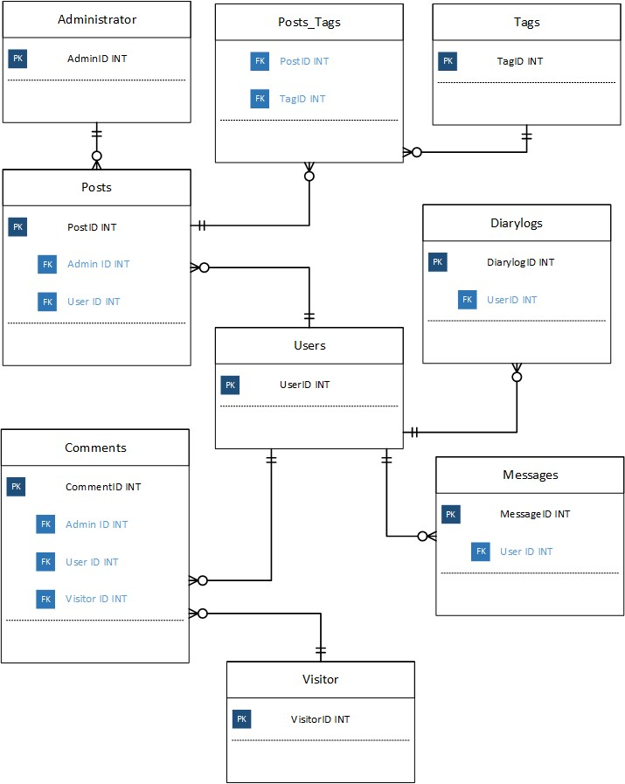

### 7.3 Logical ERD

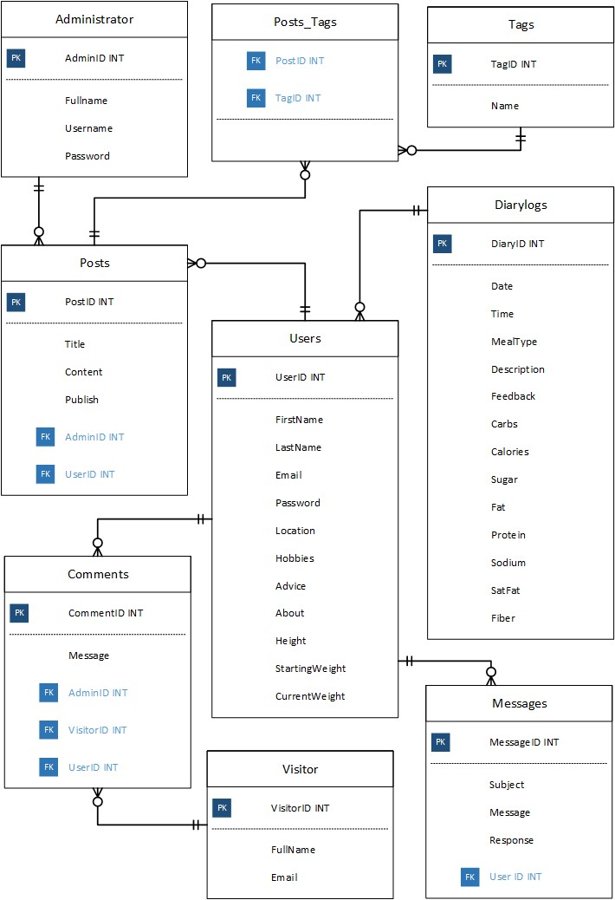

### 7.4 Data Dictionary

A Data Dictionary will be used because it will provide the developer with a greater understanding of the database structure. The data dictionary will enable the developer to manage the database efficiently, as it documents all the different types of data that will be used within the system.

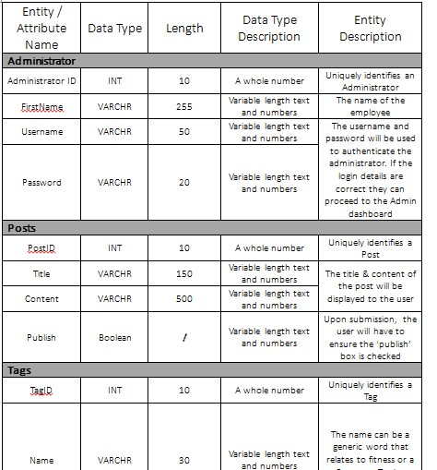

See Appendix D for the full Data Dictionary.

### 7.5 User Design Considerations

Based on the research carried out in Section 5.1 & 5.2, below is a list of guidelines the Web Designer & Systems Developer must follow to ensure the user has a pleasant experience whilst using the social network web application and online food diary.

* Ensure the language, content and icons used throughout the system are relevant to fitness and up to date.

* Using clear messages and symbols to ensure the user understands what is happening with the system at all times.

* Colours, font & text size should be suitable for all users, easy to read and allow the viewers to focus on key information i.e. The text on the button clearly informs the user what the function of the button is.

* Information on the homepage is clearly labelled and organised as a list. The user does not need to be computer literate to understand how to navigate.

* Using constraints within the system to stop the user from entering invalid data.

* The system should maintain a consistent format to ensure the user can become familiar with the website and adapt to the navigation quickly.

* Ensure the navigation panel stand outs and is easy to access. There should be no specific order to how the page should be viewed.

* Ensure the system provides the user with a memorable experience and enables the user to personalise their profile.

* In the case the user is experiencing a problem, ensure the system provides the user with documentation that is relatively easy to find

* The colours on the food diary should be suitable for all users and allow the viewers to focus on key information i.e. the text under the chart clearly informs the user what the bar chart represents.

* The text on the users diary log should be easy to read i.e. Pie chart labels should clearly highlight what the user’s nutrition intake is.

* Ensure the food diary interface maintains a consistent format and caters to both experienced and inexperienced users; offering the additional help/example button.

### 7.6 Prototyping

As this project follows the DSDM Atern approach, the designer and developer will have frequent meetings with the client where prototypes will be reviewed and refined. This process guarantees effective communication as it allows the client to offer feedback, elaborate on designs and possibly suggest new functionalities that may have been missed during the initial meeting.

Prototyping supports the DSDM Atern principle ‘Demonstrate Control’, ensuring both the developer and client can agree on the levels of functionality and usability for the system. In addition, the prototyping technique actively involves the client, allowing the designer to receive plenty of feedback and this supports the ‘Develop iteratively’ principle. Overall Prototyping will ensure both designer & developer of the project can fulfil their roles and meet the users expectations.

#### 7.6.1 Low Fidelity Paper-Based Designs

A paper-based prototype was created based on the requirements gathered from the analysis chapter including the meeting that was conducted with the client. This allowed the designer to give the client a fast and simple visual representation of what the system would aim to look like.

See Appendix E for the Low Fidelity Designs of the Social Network Website

#### 7.6.2 Low Fidelity Wireframe Design

The client was shown the paper-based prototyped during the second meeting and they approved the designs they wished to go forward with. In addition, the client suggested a few changes and ideas. Listed below is a summary of the clients’ feedback:

1. Use Blue, White & Black as the house colours.
2. Create an improved design of the Login page / Home page / Dashboard
3. Add a ‘More information’ function on the food diary page. This feature will explain how to use the online diary form.
4. Add a second pie chart to the User Diary log Visualisation. This feature will give the user comparative data.

Using the feedback provided, the designer created three low fidelity wireframes of the system to give the client an enhanced visual of how the system will look. The client was happy with the taster, and it was agreed that the prototypes will be used during the implementation of the social network website.

See Appendix F & G for all the details of the meeting conducted with the client (user feedback)

#### 7.6.2.1 Administrator Login /Dashboard

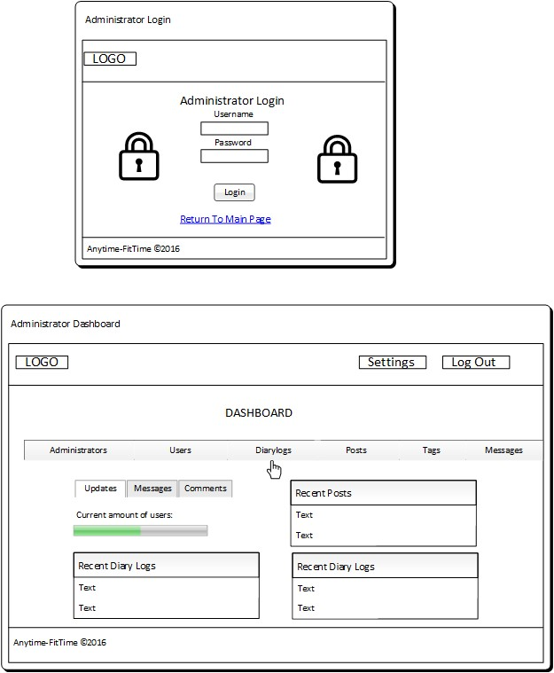

#### 7.6.2.2 User Login & Homepage / Visitor Home Page

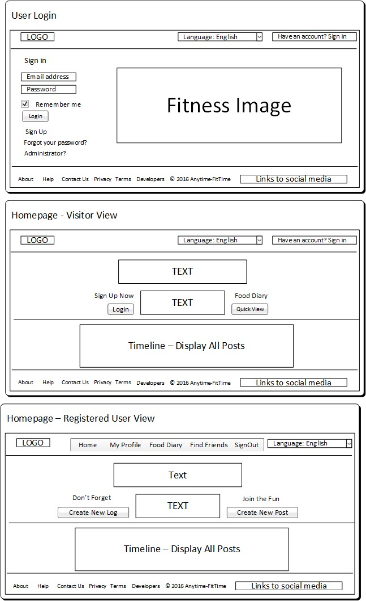

#### 7.6.2.3 Food Diary

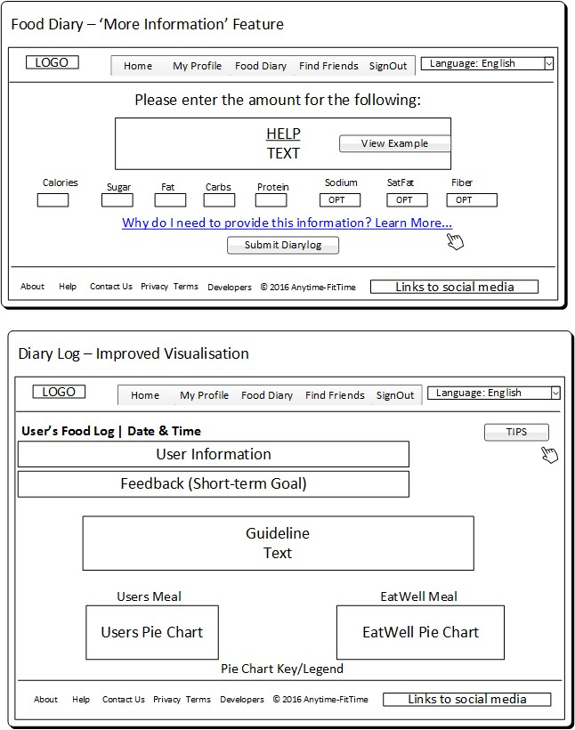

## 8 Implementation

This chapter will focus on the implementation of the social network web application. Throughout the development, the developer will work in parallel with the list of high level requirements and will examine whether the system is effective in meeting the needs of the client with concise annotations. There will also be references to Appendix H to show the code behind some of the main functionalities.

The validation codes can be found in Appendix H and all the resources used by the developer throughout the implementation stage can be found in Section 11.1.

### 8.1 Chosen Software for Development

Based on the research carried out in Section 5.4.2, the developer has chosen to use Ruby on Rails to implement the social network web application.



According to Ford (2014) Rails is a great tool for an iterative approach which adheres with the DSDM Atern methodology the project has followed, “the framework makes it easy to accommodate changes.” Similarly, this idea that Rails allows you to easily make changes to your system is supported by Zader (2016) who states that, “After site launch, future modifications to your site (e.g., adding new features, making changes to the data model) can be made more quickly.”

Moreover Rails is compatible with Bootstrap, currently the most popular front-end web development framework “Bootstrap makes front-end web development faster and easier. It's made for folks of all skill levels.” Bootstrap (2016) . Overall it is clear that using Rails will enable the developer to code the front end interface with great ease.

8.2

Social Network Website

-

Functionality

/

1

14

High

Level Requireme

nt

-

The system

must

give a visitor a limited version of the system in terms

of what they are able to view.

14

/

2

High Level Requirement

-

The system should include links to social media to promote the

fitness instructors professional expertise and attract

customers.

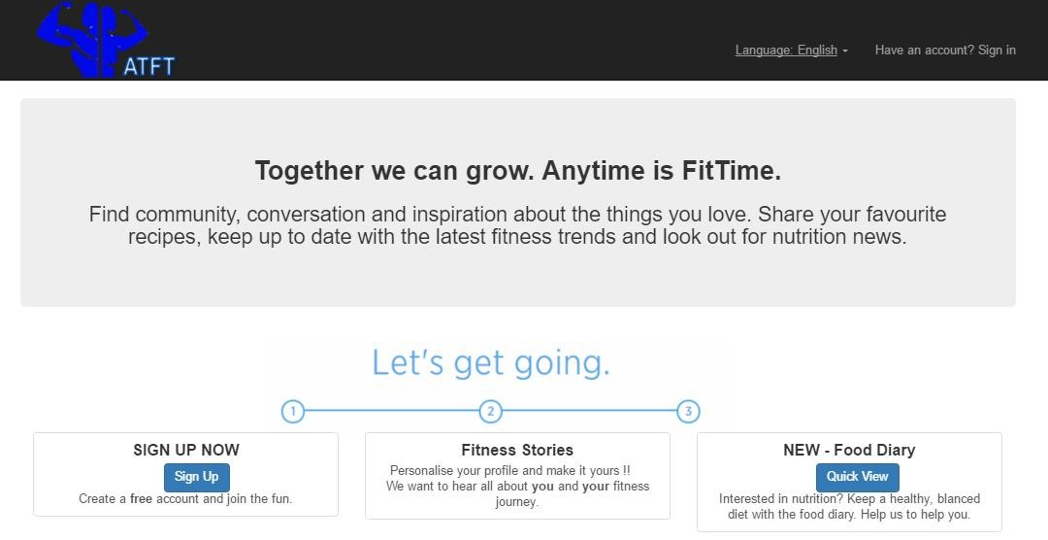

The navigation of the

website

can be viewed

on

the top panel where the

visitor

will be given

limited

navigation options.



D

esign and layout

of

the

website follows

the final prototype

wireframe. The white

and blue scheme

is a

very simpl

e

look

and

can be

easily read.



MUST

Priority

:

Visitor can sign up (

1

)

Visitor can view a preview of the food diary (

2

)

Visitor can view all Posts (

3

)

Visitor

can view information about the business (

4

)



The

system has links to the

Clients Facebook, Pinterest

& Twitter. U

sing current

social networking

sites to

promote their business

.

Social CRM



Information on the

homepage is clearly

labelled and

organised as

a list.

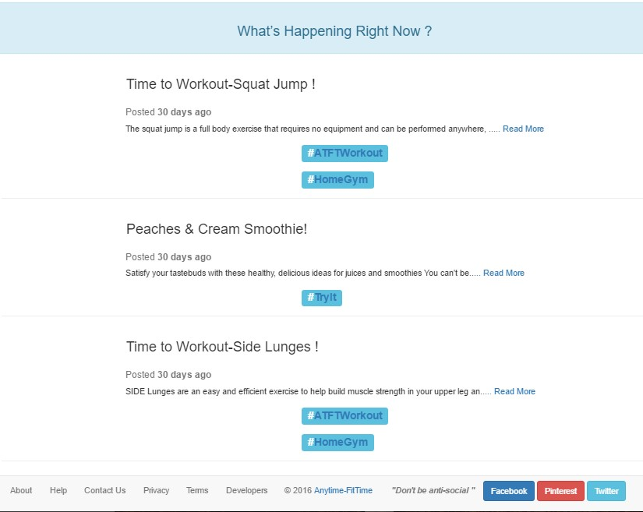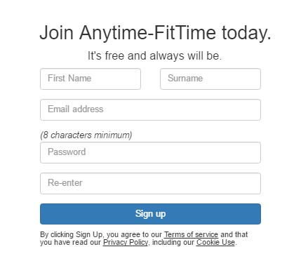

When a visitor wishes to sign

up they are expected to fill

out this registration form

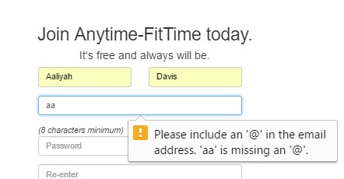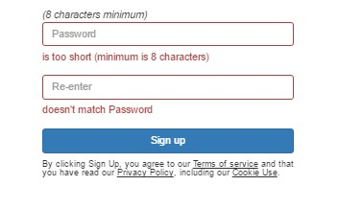

The visitor is shown the following

vali

dation error messages

if the

y do

not enter the correct data.



The co

de for the

registration f

orm

can

be found

in

H

Appendix

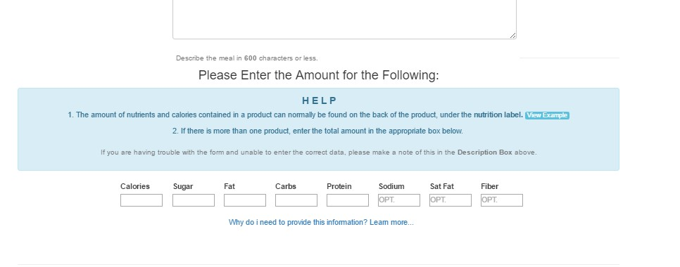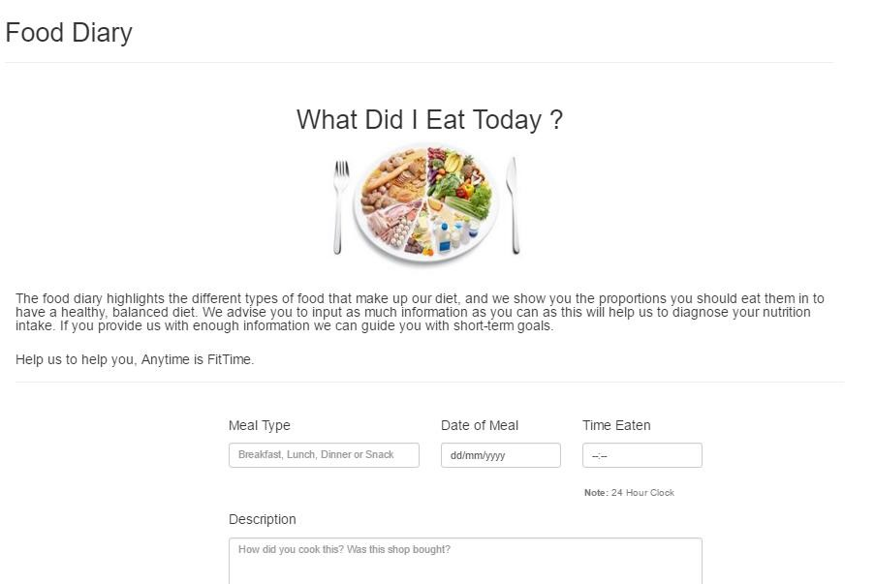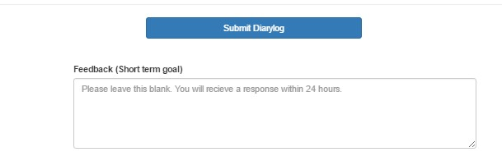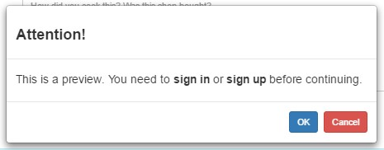

The

visitor can view a preview

of the food diary.



If the visitor wishes to

continue they are redirected to

the sign up page.



The

colours on the

food diary are

suitable allow the

viewers to focus on

key information



The food diary cat

ers

to both experienced

and inexperienced

users; offering an

option “

View

example

” button.



The co

de for the

food diary

can be

found in

H

Appendix

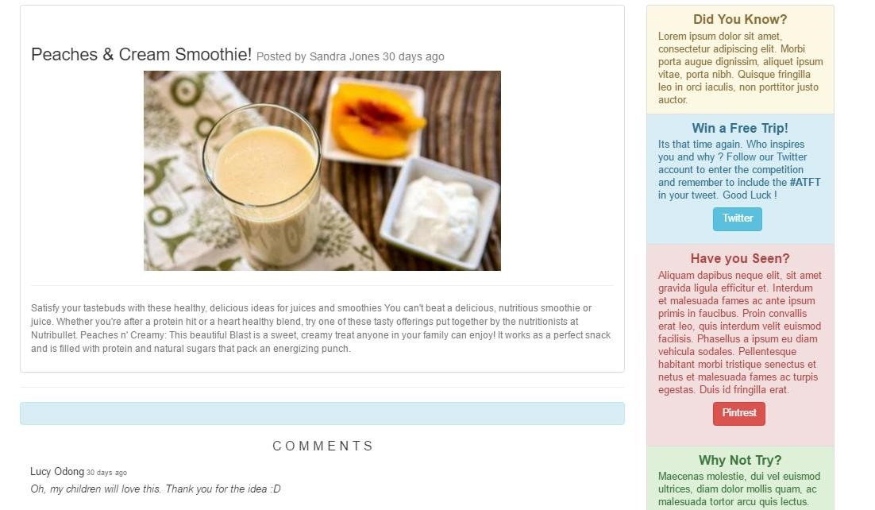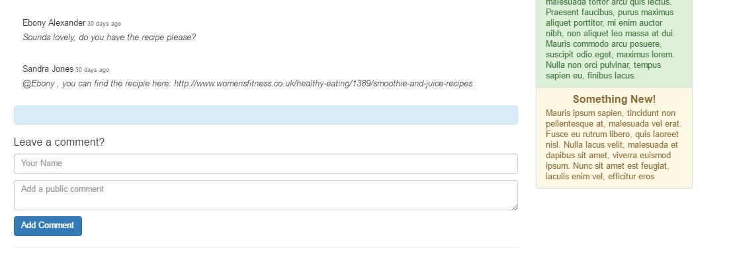

The Visitor can

view all posts



Links to social media to promote

the business, raise awareness and

incr

ease customer retention.

Social CRM



If the visitor wishes to add a

comment they are prompted

to join the email marketing list.

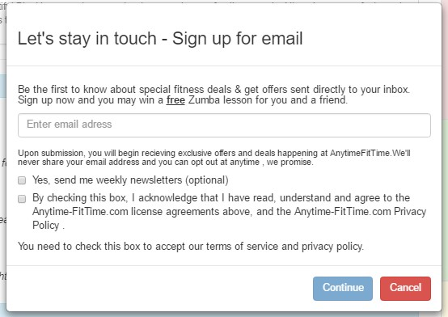

The text on the button

clearly informs the user

what function of the

button is

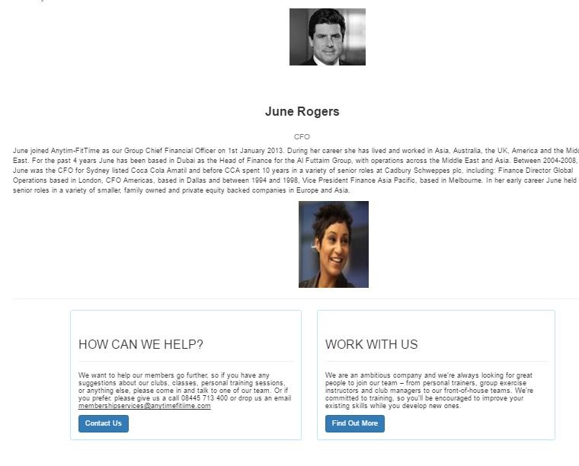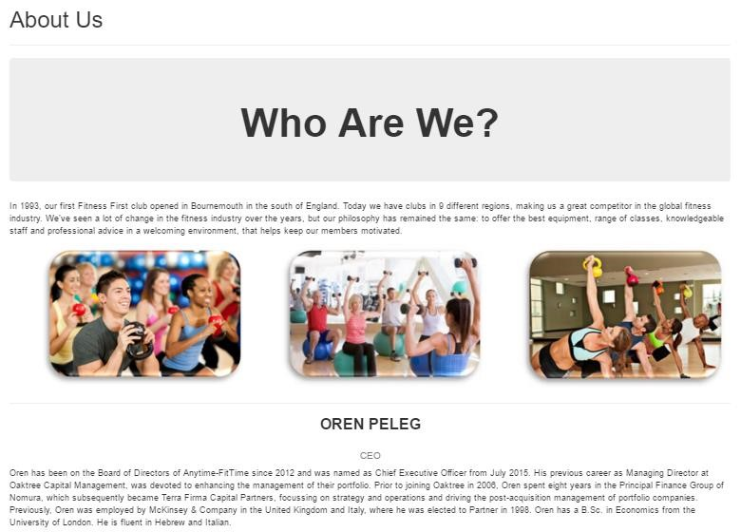

The

visitor can scroll through

a page dedicated

to what the

business is about.



Images are relevant

content as the system is

about fitness

3

/

High

14

allow a registe

red user to login to the system.

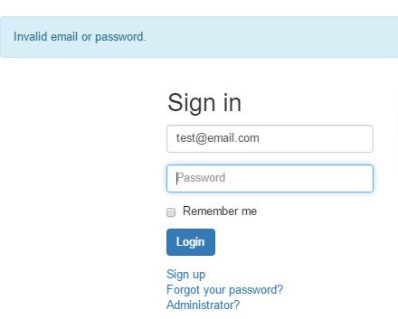

The User is shown the

following

validation error

messages

if they do not enter

the correct data.

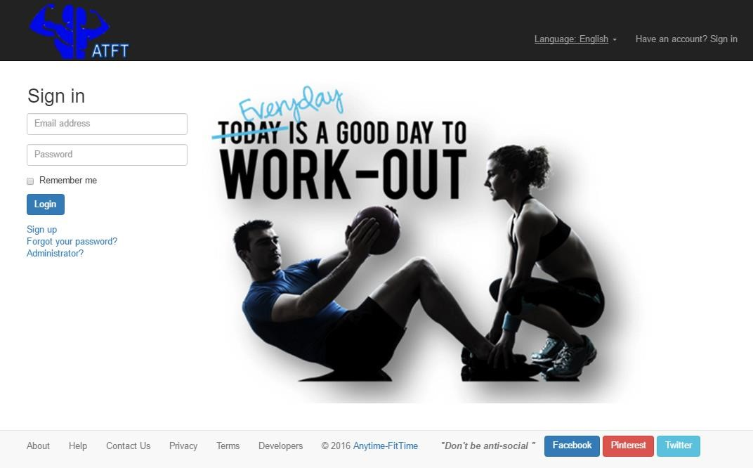

The language and image

used is relevant to fitness



This design mirrors the final

User

-

Login wireframe design

in

Section 7.6.2



The code for the

Sign in

m

for

can be found in

Appendix

H

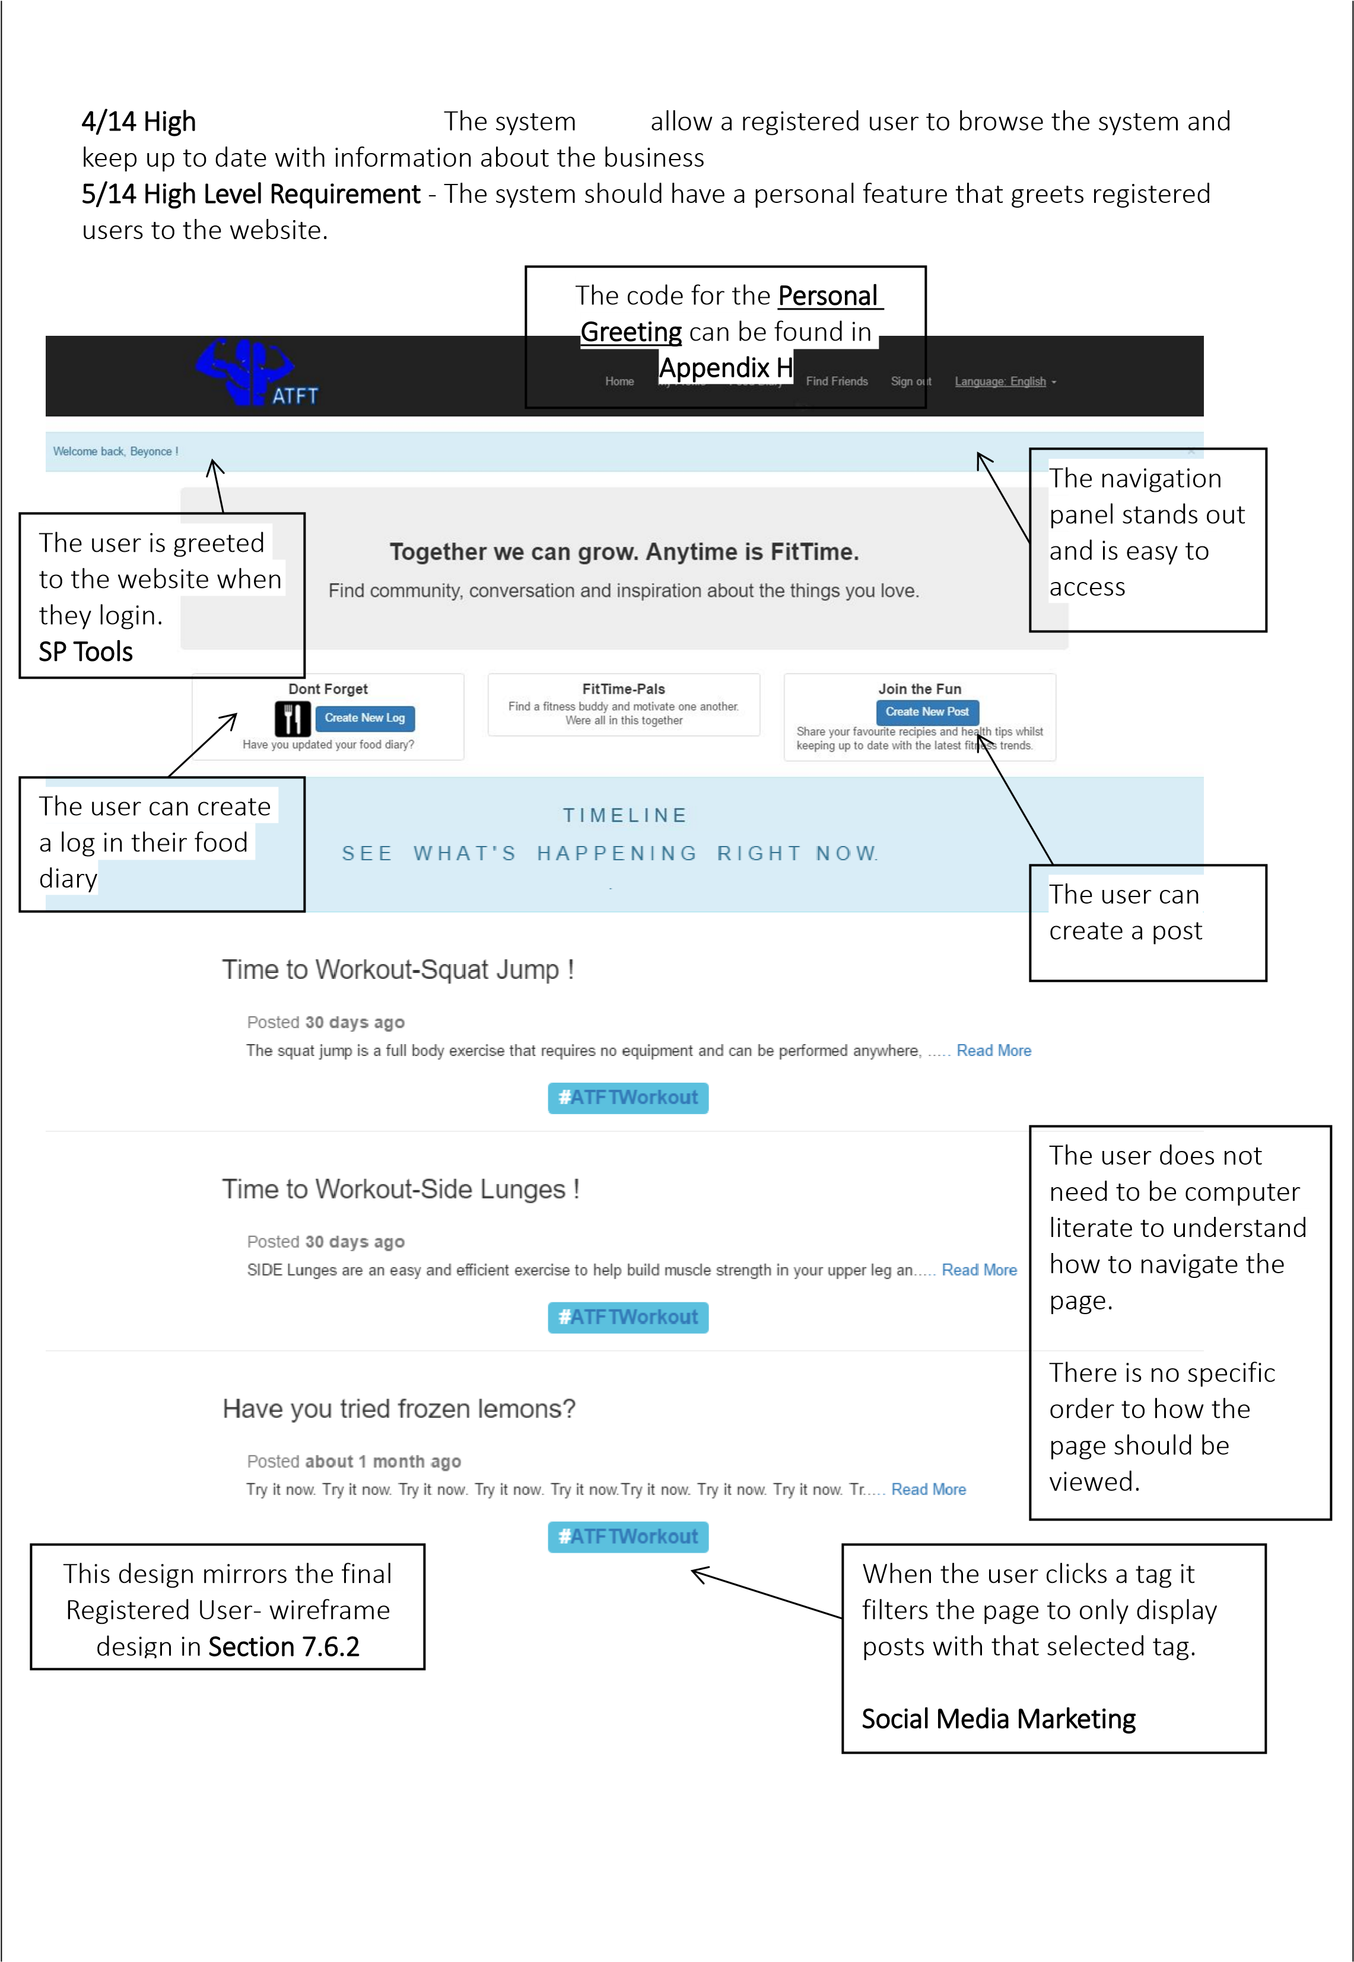

6

/14 High

allow a registered user to view and edit their profile

page.

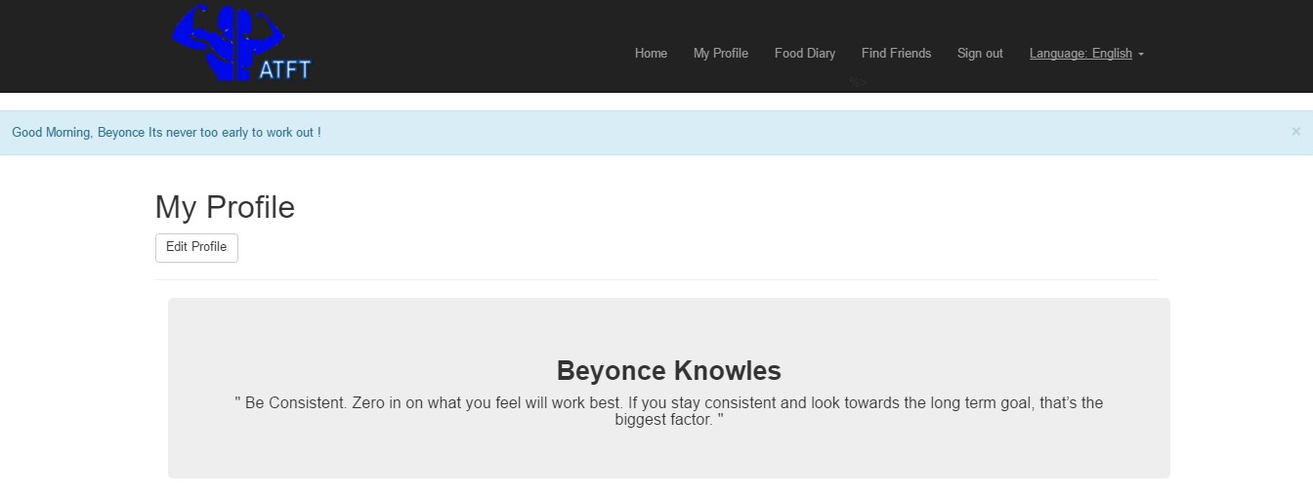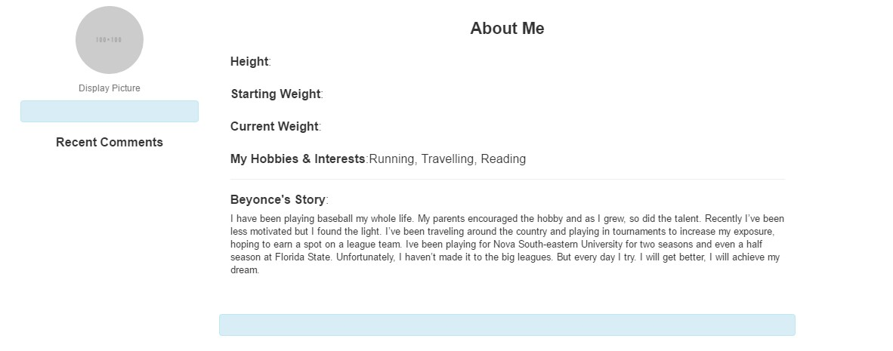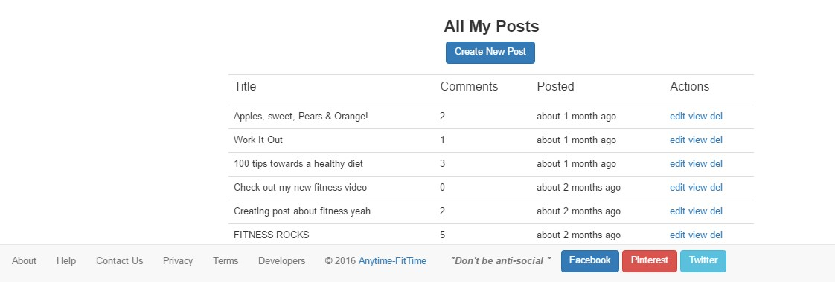

When the user

views

their profile page

, the

system immediately

identifies the time

and proceeds to use

the personal greeting

technique.

Overall the lan

guage

used is pleasant and

provides the user

with a memorable

experience.

The code for this

personal greeting

can

be found in

Appendix

H

Social Personalisation

The system maintains a consistent

format to ensure the user can

become familiar with the website

and adapt to the navigation quickly.

The user can

create new posts.

They can also edit,

view or delete

their posts.

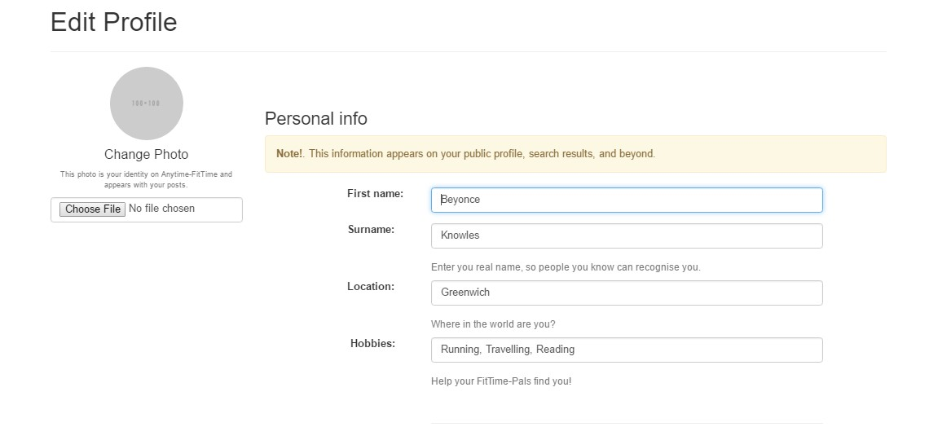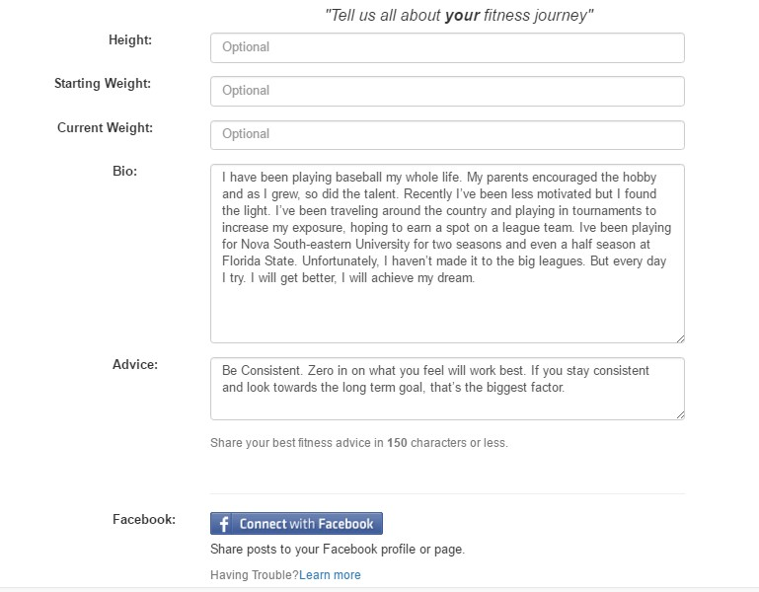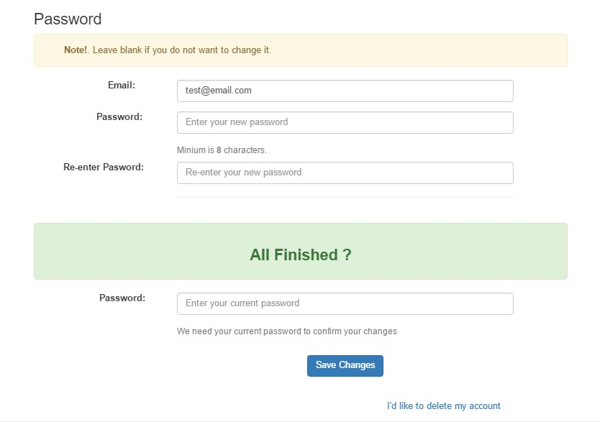

The user ca

n edit their profile



The idea is that each user will

be able to display information

that describes their own fitness

journey.

Other users will be able to read

their advice, read their story

and perhaps find a new ‘FitTime

Pal’

Reading another person’s

story

may inspire a user; motivating

them to work harder.



User can change their password

if they wish



User can delete their account.

The system offers an

advanced option

that allows the user

to share their data

externally.

Social CRM

/14 High

7

Level Requireme

nt

-

must

allow a registered user to cr

eate a log in their food

diary and view their diary log.

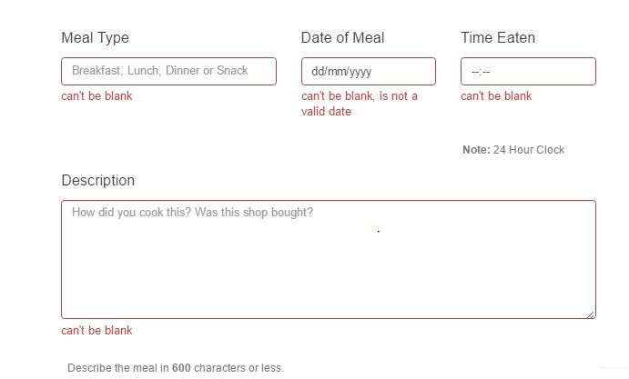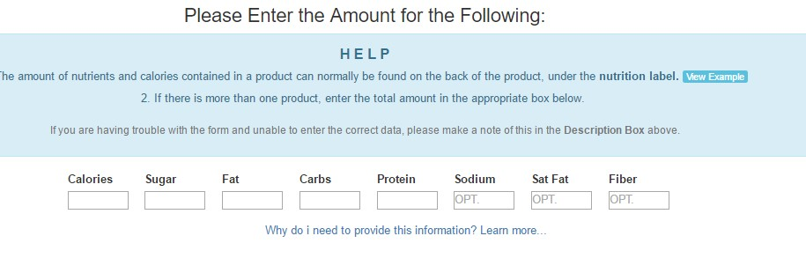

The User is show

n the

following

validation error

messages

if they do not enter

the correct data.

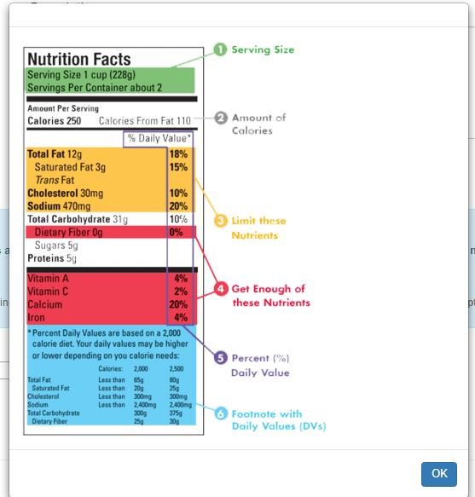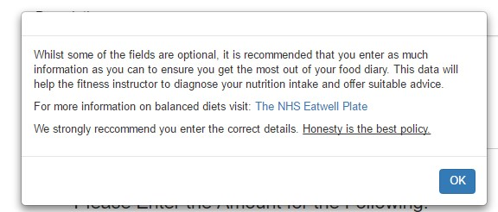

When entering the amount of nutrients they had

for a meal, the user is provided with an example

of where they can find this information.

Also, if the user wants to

learn mo

re

, a dialog box

will pop up with information.

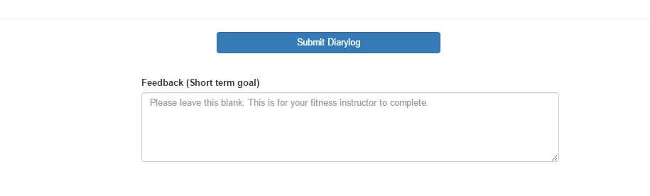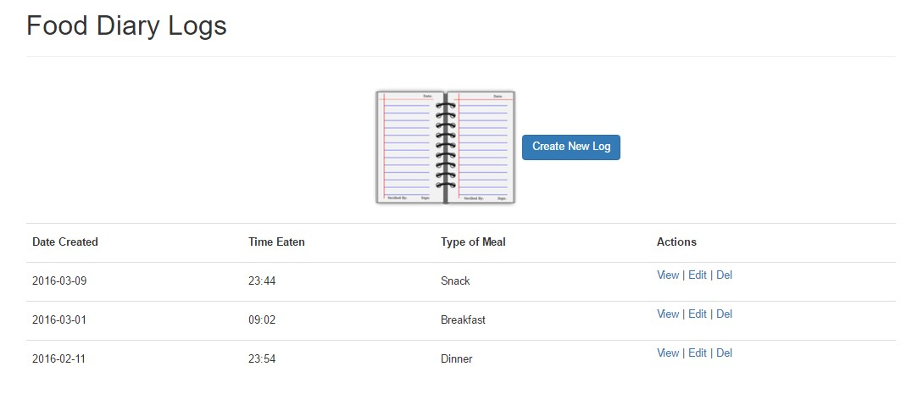

When the user submits their diary log,

they will be redirected to the ‘Food Diary

Logs’ Page where they can view, edit &

delete diary logs.

8

/

High

14

Level Requireme

nt

–

should

have a data visualisation feature that gives the

client an overview of the nutrition intake.

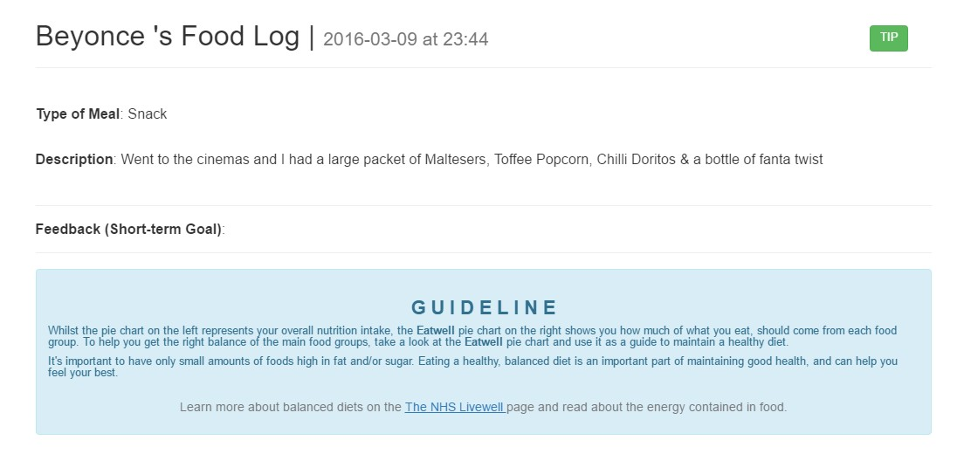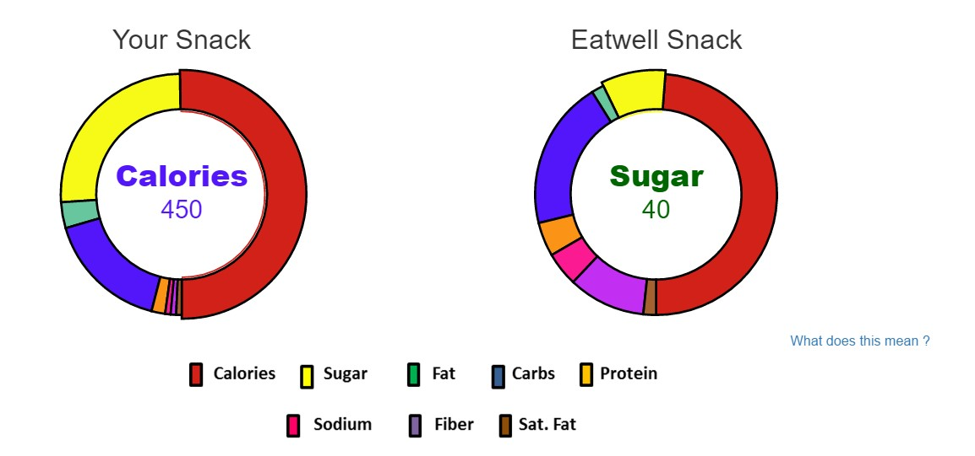

In the case that a user is

experiencing problems, the

system provi

des the user with

documentation that is

relatively easy to find.



Whilst the pi

e chart on the left represents the users

overall

nutrition intake, the

*Eatwell*

pie chart on the right displays

how

much of what you eat, should come from each food group.

To he

lp

the user

get the right balance of the main food groups,

they need to

take a look at the

*Eatwell*

pie chart and use it as a

guide to maintain a healthy diet.

The developer used the

NHS Livewell page

to obtain information

about balanced diets and has also

recommended the user to visit

this page if they would like to learn more.



Data Visualisation

to help

the user

to understand

information quickly.

In addition this can help

the fitness instructor can

to understand the user’s

behaviour



The user can view a l

ist

of tips

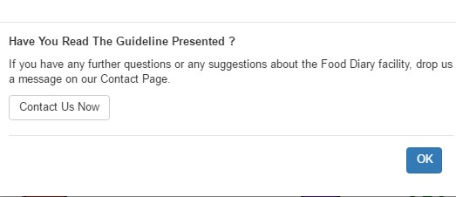

9

/14 High

Level Requireme

nt

-

The system should

have a

search feature which will allow registered

user

s to find other users. This includes users near to their location or people who share the same

hobbies/interests.

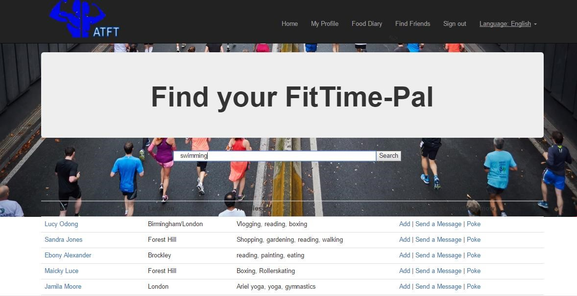

The background image used is

suitable and relevant to

fitness.



The user can search for

people, places and hobbies

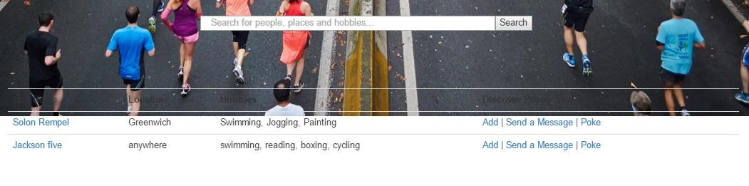

The code for the

Search

can be found

in

Appendix

H

10

/

High

14

-

The system should allow registered users to create posts

with a

tag/image included

and comment on other

posts.

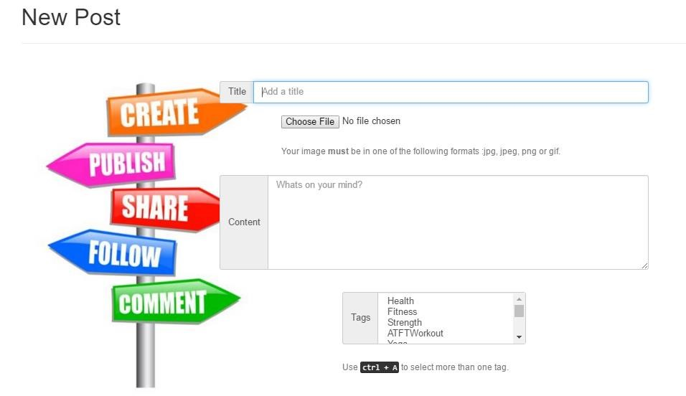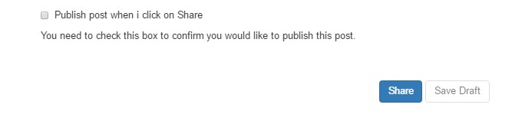

The user can

select

an image

to upload



The user can select many

tags.

The developer used clear

message and symbols to

ensure the user understands

how to use the system.

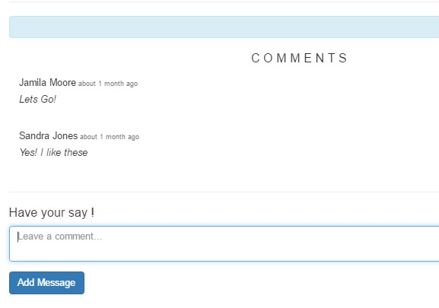

The information is clearly

labelled and informs the user

what the section is about.

User can type a c

omment and click the

button. A swift process.

The code for the

Post

form

can be

found in

Appendix

H

11

/

14

High

–

The system could have

a customer service facility that allows

registered users to get in touch and make enquiries.

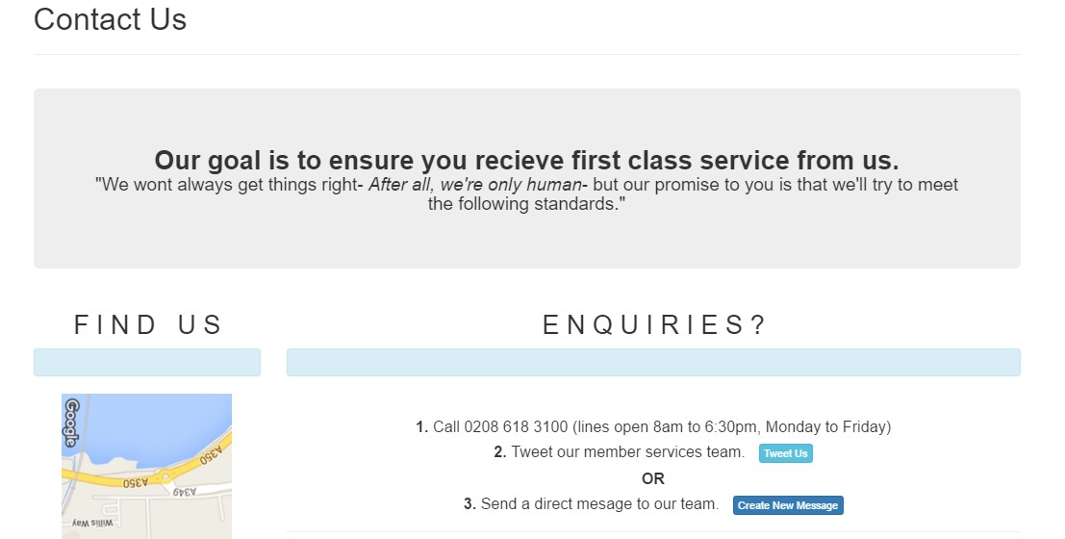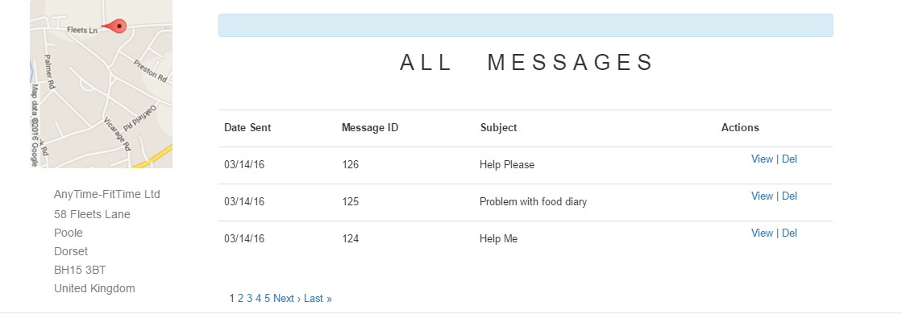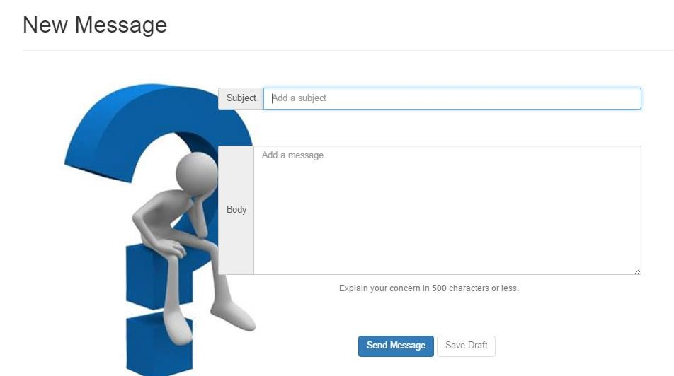

Information on the page

is clearly labelled and

organised.



User can submit messages.

View or delete their

messages.

12/14 High – The administrator must have a passcode protected view of the system where they can monitor and manage the system.

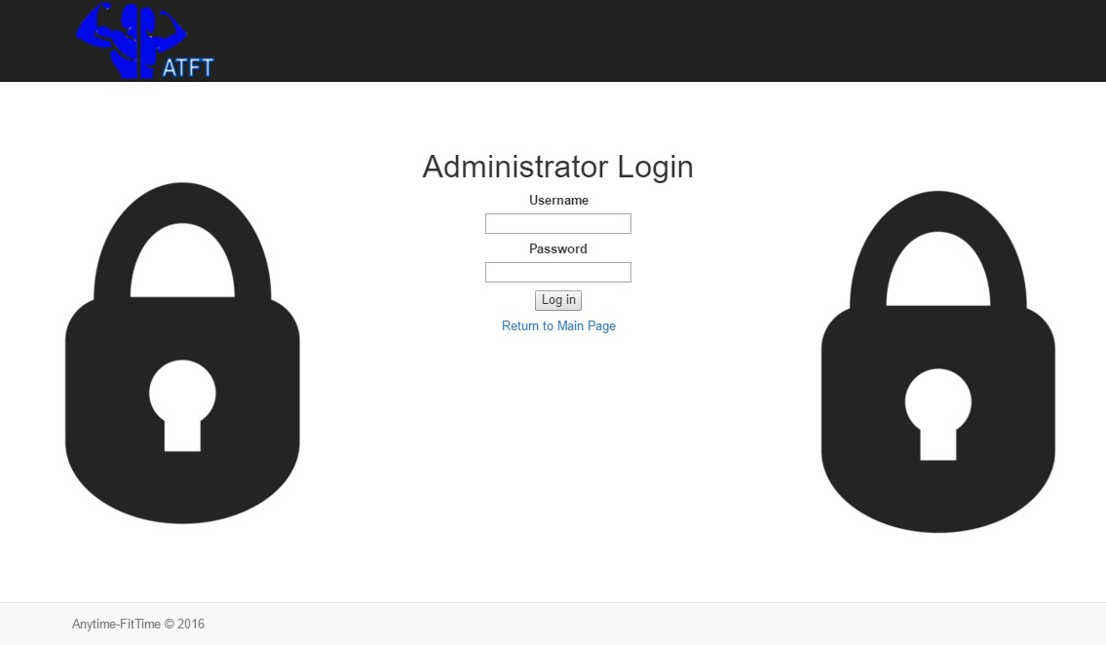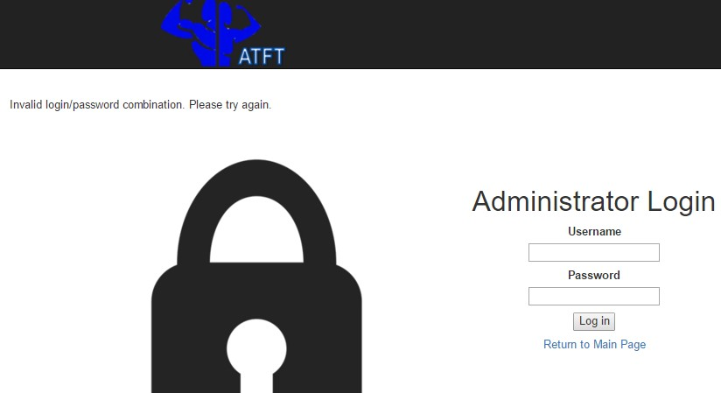

The User is shown the

following

validation error

mess

age

if they do not enter

the correct

data.



This design mirrors the final

User

-

Login wireframe design

in

Section 7.6.2

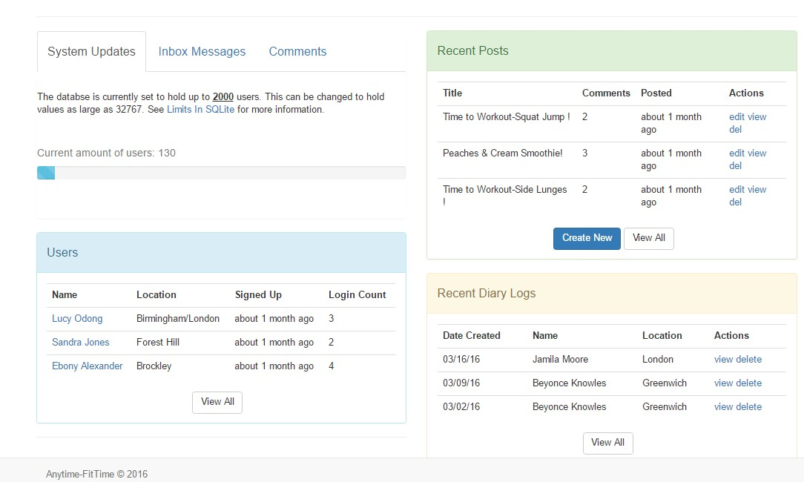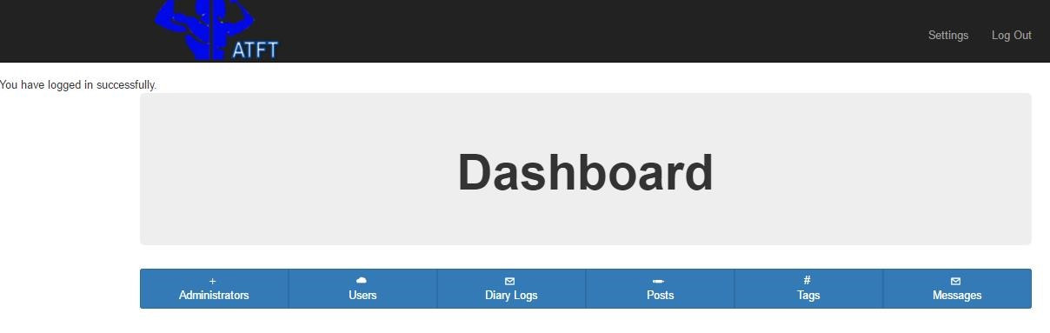

This admin can monitor an

d

mana

ge the system

: ‘edit,

view & delete’



Colours, font & text size is

suitable and easy to read,

allowing the administrator to

focus on key i

nformation.



This design mirrors the final

User

-

Login wireframe design

in

Section 7.6.2

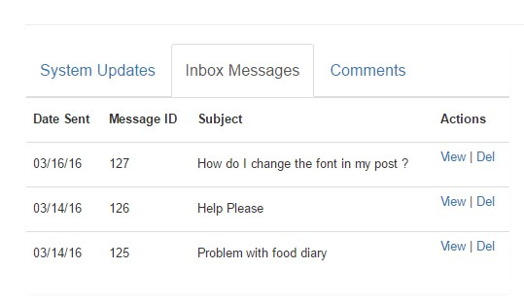

Admin can view all users who

have signed up to the system.

/14 High

13

Level Requireme

nt

–

The system

must

allow an admin to view a diary log and set short

term goals (give feedback)

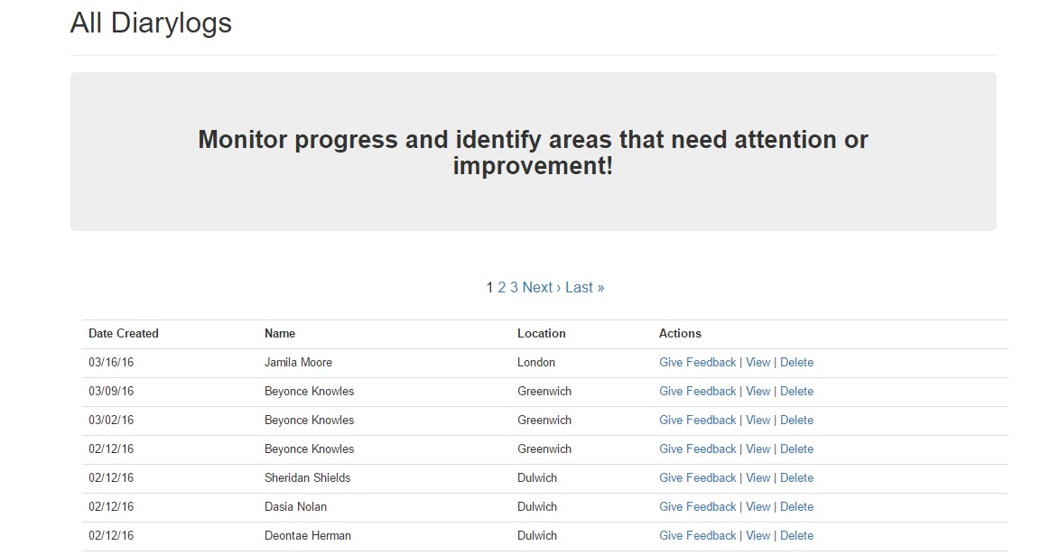

This admin can view all diary

logs that have been

submitted.

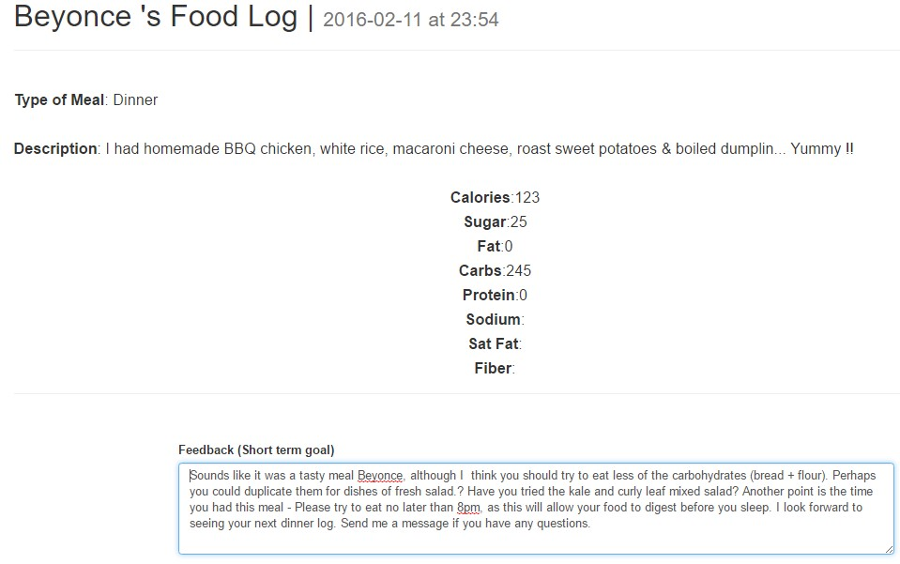

When the admin selects to

view

a

user’s dia

ry they will see this

interface



The admin can provide the user wi

th

feedback and set a short term goal

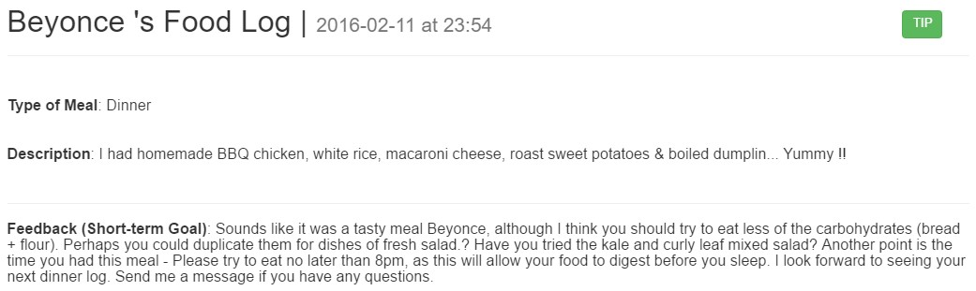

The feedback will be displayed on

the users’ view of their diary log.

14

/ 1

4

High

Level Requireme

nt

–

The system

must

allow an admin to

create a post (tag and image

include)

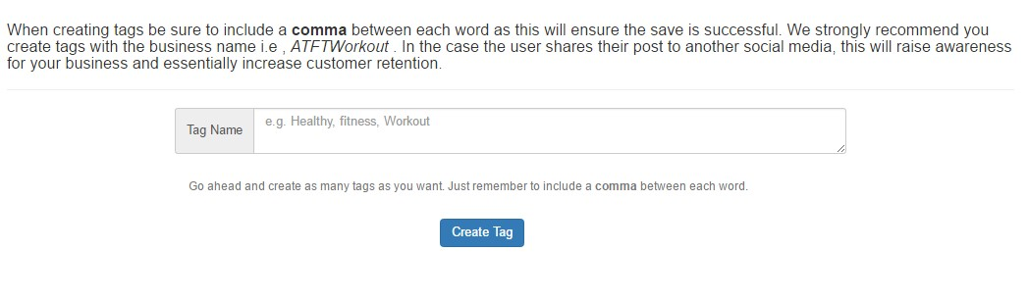

The system only allows the administrator to

create Tags. This feature allows the

administrator to create tags; Keywords relevant

to fitness / healthy eating. In addition the

system encourages the administrator to create

tags with the bus

iness name e.g.

*ATFTFitness.*



Hashtags are a great

Social Media Marketing

Tool

.

If a user shares their post to another social

media i.e. Twitter, this will raise awareness

for the business and potentially increase

customer retention.

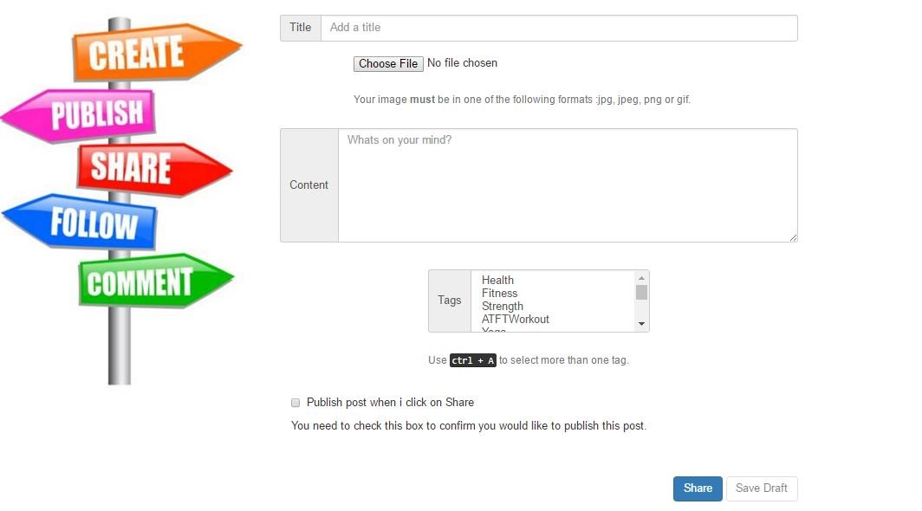

The administrator will have the same

interface as registered users when they are

creating posts.

8.3

Social Network Website

–

L

egal & Social Issues

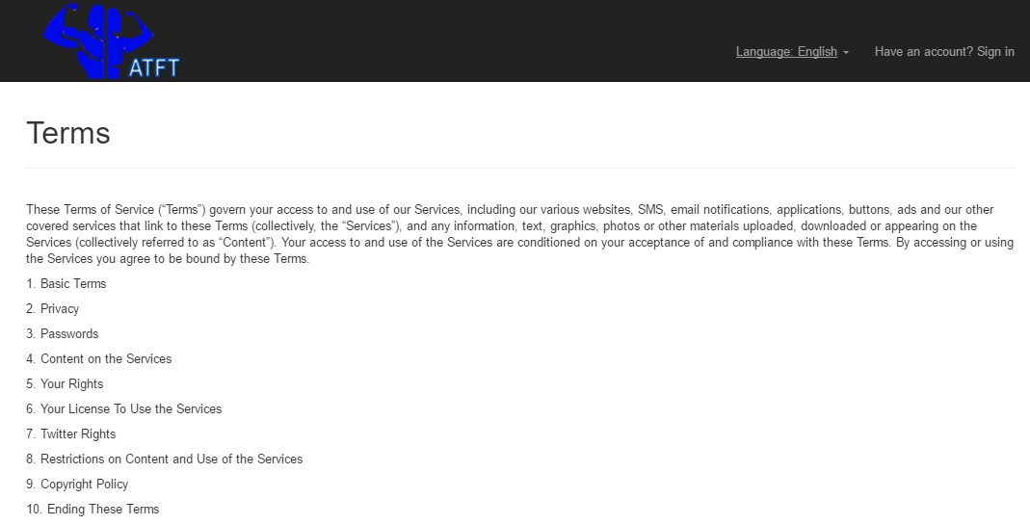

The Terms of Servic

e for Anytime

-

FitTime



The system tells the user that they are responsible for

setting a strong password. The user is also aware that

Anytime

-

FitTime will not be liable for any loss or

damage arising from their failure to comply.

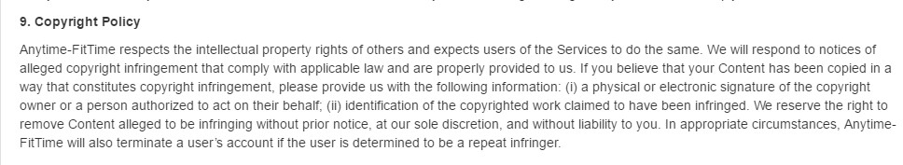

The system respects the

intellectual property rights of

others and expects the users of the service to do the

same. The system will not break any copy right laws.

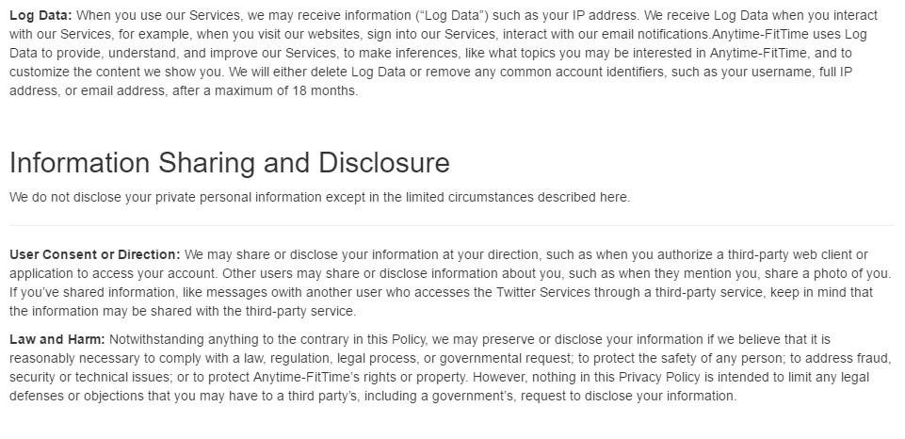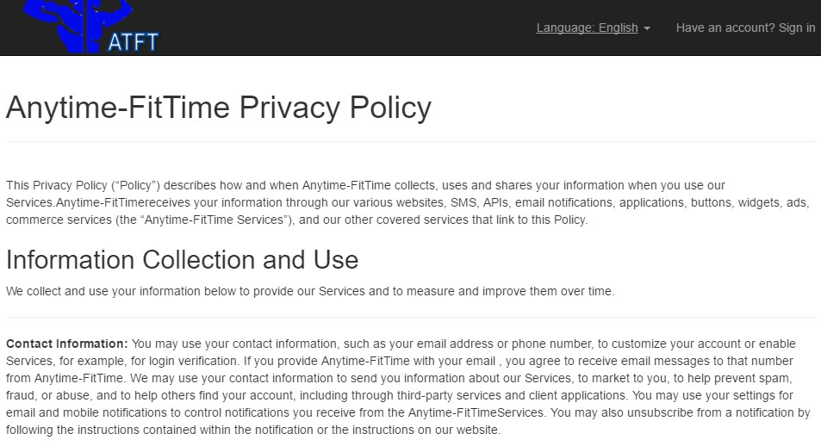

The user is clear about what their information will be used for

and how it will be shared. For example, Anytime

-

Fit

Time may

disclose the users’ information if they believe that it is necessary

to comply with a legal process.



The developer has been

transparent about data

collection.



The developer has informed

the user that their Log data

will be removed from the

syst

em after a maximum of

18

months.



The developer has informed

the user that other users may

share or disclose their

information i.e. Posts.

Therefore users will need to

be aware of what information

they post and refrain from

sharing sensitive information

.



The developer has informed the user how their information

will be discarded

-

“After

30

days

, we begin the process of

deleting your account from our system, which can take up to

a week”

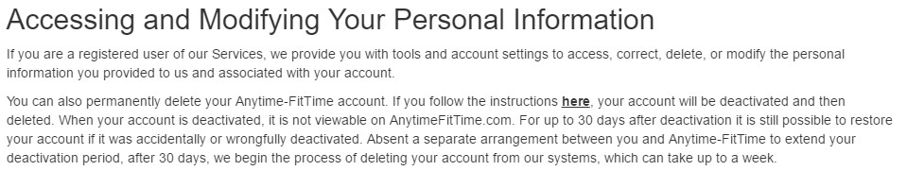

The system has

included a ‘OPT

-

out &

OPT

-

in’ clause within the sys

tem



confirm or

Prompting the user to either

decline the collection of data

.



This feature will be used as an agreeme

nt;

telling the user how

their information is

intended to be used

.

## 9 Testing

From a professional stand point, it is the developers’ responsibility to conduct a series of tests to avoid a poorly implemented system from being built. Therefore the developer will use White-Box & Usability testing, to ensure the client receives a quality system. Testing will highlight functionality issues within the code and allow the developer to rectify the problem. In addition, testing will allow the developer to assure the system is user- friendly.

Ultimately, through testing the developer will be able to manage the development incrementally. By identifying errors and issues at an earlier date, the developer will avoid delays - ensuring the system is produced within the time scope and delivered on time.

### 9.1 White Box Testing

White Box Testing allowed the developer to identify functionality errors, including the validation of functions that may have been overlooked during the development.

See Appendix I for the White Box Testing on the Social Network Web Application.

### 9.2 Usability Testing

Usability testing ensured that users from all technical backgrounds would have a pleasant experience when using the social network website. The usability test used the design & usability principles that were researched in Section 5.1, and the results gathered from the heuristic evaluation for existing social networks (See Appendix B)

See Appendix J for the Usability Testing on the Social Network Web Application.

## 10 Critical Evaluation

This chapter will allow the developer to review the project and critically evaluate the success of the Social Network Web Application. This reflective approach will enable the developer to discuss the problems and challenges issues faced during the development of the product. In addition, the developer will explain how things could have been done differently to avoid any faults or failures. Furthermore, this chapter will highlight all the things that have been learnt during the course of the project.

### 10.1 Product Evaluation

The business used the DSDM Atern methodology and this provided the project with an incremental approach to delivery and iterative approach to development.

In the beginning, a development plan for the entire project was created (Appendix K) to manage the time effectively; organising the workload, ensuring that all milestones were met and the product was delivered on time. Furthermore, the project used timeboxing to manage the development of the product as this would enable the developer to build the system rapidly and within the strict deadline of 6 months.

Although the developer had a basic understanding of social media and how it worked, this was not enough to build an effective web application. Initially, the developer struggled to think of creative features that would enhance customer engagement and this was not an effective start to the project. Fortunately, the project carried out extensive research on current tools and techniques used within social media, therefore, the developer was provided with a list of functional requirements that would need to be implemented. Furthermore, effective meetings with the client allowed the analyst to further gather key concepts, ensuring the developer had a list of high level requirements that would ensure the end product was fit for purpose.

When developing the system, the designer was fortunate to use the prototyping technique to collaborate with the client and receive essential feedback that would help refine initial designs; shaping the Food Diary to include comparative data.

However when transferring the designs to implementation, the developer experienced much more difficulty than expected. It was recommended that the developer used Ruby on Rails to implement the system because it was “a fast and easy programming language to learn” but unfortunately, the implementation stage took much longer than the Gantt chart predicted.

The developer found it challenging to build the ‘add image to post’ function. After deep thought and determination the developer had no choice but to use online forums for additional support. In the midst of using online support it became clear to the developer that the function was not working because the gem (code) implemented was not compatible with the version of Ruby on Rails being used. After seeing this developer removed the gem from the system and began to search for the earlier version.

Finally, the developer got the function to work; allowing registered users to create posts with tags and images included. Although this was time consuming, the Gantt chart included contingency time. This meant that the developer was still on track to meeting the deadline.

#### 10.1.1 Future Developments

* The user could be able to upload a profile picture - Upload profile picture function. Amending the functionality on the user profile page, allowing users to personalise their profiles with a picture of their choice.

* The visitor could be prompted to join the email marketing if they wish to write a comment on the post – This functionality has been partially created but has not been fully implemented.

* The user should be able to view a range of fit-wear products – This feature would aim to attract users who enjoy trendy fitness threads.

* The user should be able to purchase fit-wear products. – The idea is that the business would expand their online presence further and begin to sell their own fitness clothing line.

### 10.2 Personal Evaluation

Working on this project has been a challenging yet thriving experience. There have been many highs and lows throughout the development of the product but I have enjoyed the journey nonetheless.

Before beginning this project, I will say that I would not have chosen the DSDM Atern methodology for the project because I didn’t truly understand its purpose. But now that I have used the DSDM Atern approach and worked with it throughout the course of the project I can see how the project has benefited from it; managing and delivering projects on the time - offering an incremental approach to development & an iterative approach to delivery.

I will take everything I’ve learnt from the DSDM Atern approach and apply it to any future projects I may be involved in as it has proven to be a successful methodology.

I believe that working on this project was definitely character building. During the implementation stage I was forced to learn a new programming language, which at the time seemed like it would be impossible. I chose to use Ruby on Rails because I saw that it had a lot of online support in terms of Youtube tutorials. The plan was to use the tutorials for guidance throughout the duration of the project but then I came to realise that the coding wasn’t that difficult. Once I had built the framework for the system I was able to code sections on my own, it was just a matter of extreme concentration and determination.

I honestly took a risky move by learning a new system to which I had no experience with , but I managed my time effectively and started to implement the code from the early stages. Therefore, if I did have any programming errors, I would have time to panic and solve it.

Personally, I thoroughly enjoyed designing the system the most. For me, designing is therapeutic. This project allowed me to identify opportunities for improvements and make constructive suggestions for change during the prototyping phase and I relished the moment. I enjoy the freedom of being able to create anything the mind imagines. However, I believe I got carried out with the designs and essentially began to waste time.

If I could do this project again I would spend less time designing the system and more time implementing functions. Although I was able to implement a number of functions, I could have implemented the ‘profile picture’ function which would have improved the personalisation features within the system. In addition, if I could do this project again I would spend more time coding the ‘allow visitor to comment’ feature. Implementing an opt-in feature where visitors enter their names and e-mail addresses for the emailing list would allow the system to capture the visitors contact information. The proposed client would then be able to send visitors newsletters about the business, possibly offering valuable discounts and deals on services. Ultimately, this function would adhere to the project solution.

Finally, if I could do this project again I would jump at the chance to have a live client. I’m aware that a live client may be more difficult but I enjoy solving problems and thrive on challenges.

### 10.3 Conclusion

The main aim for the project was to solve the problem of fitness instructors failing to encourage clients to stay active in their free time. Therefore the solution proposed for the project was to increase customer retention and client engagement through building a social network web application

By providing the fitness instructor with smart tools and personalised accounts, the fitness instructor can now motivate clients through the online food diary; monitoring their food habits and setting short term goals. In addition the fitness instructor has the platform to display their professional content, inspire users with posts and market their business with links to social media & SMM tools such as Hashtags; attracting prospective clients.

From this it is clear that the product meets the user requirements and has met the purpose for the project.

Although it was a challenge to implement the system, the developer was able to turn to the Ruby on Rails community and receive quick and effective support. Moreover the developer has learnt a new programming language that may be used for future developments.

Finally, in terms of deployment, <https://anytimefittime.herokuapp.com/>, the developer is in the process of deploying the application to Heroku, a free platform that enables developers to build and run applications entirely in the cloud.

Overall I thoroughly enjoyed switching between the roles of a Business Analyst, Designer, & Developer. I will take everything I've learnt throughout the course of this project and apply it to my future endeavours both professionally and personally.

## 11 References

(n.d.). Retrieved from http://moveableonline.com/blog/2014/11/03/6-principles-design-la-donaldnorman/

Applebaum, V. (2008, March 01). *Fitness in the Age of Technology.* Retrieved December 04, 2015, from Idea Health & Fitness Association: http://www.ideafit.com/fitness-library/fitness-inthe-age-of-technology

Balter, A. (2013, May 10). *Why Use Microsoft Access?* Retrieved December 16, 2015, from quepublishing: http://www.quepublishing.com/articles/article.aspx?p=2044341&seqNum=2

Bootstrap. (2016, Jan 01). *Designed for everyone, everywhere.* Retrieved April 07, 2016, from Bootstrap: http://getbootstrap.com/

Bresciana, S., & Eppler, M. J. (2008, February). *The Risks of Visualization.* Retrieved November 1,

2015, from

http://webcache.googleusercontent.com/search?q=cache:bNTpTkz_EekJ:www.knowledgecommunication.org/pdf/bresciani-eppler-risks-visualization-wpaper-

08.pdf+&cd=1&hl=en&ct=clnk&gl=uk

Cline, J. L. (2014, September 11). *5 Tools for Personal Trainers on Facebook.* Retrieved November 30,

2015, from http://www.ideafit.com/fitness-library/5-tools-for-personal-trainers-on-facebook Day, T. (2013). *Success in Academic Writing.* Palgrave.

Dean, J., & Soto, J. (2015, January 01). *MS Access Database, Why Choose It?* Retrieved December

16, 2015, from Blue Claw Database Design: http://www.blueclawdb.com/microsoft_access.htm

DesignPrinciples. (2013, July 11). *10 Usability Heuristics for User Interface Design*. Retrieved December 12, 2015, from Design Principles FTW: http://www.designprinciplesftw.com/collections/10-usability-heuristics-for-user-interfacedesign

Digital Ocean. (2014, Febuary 21). *SQLite vs MySQL vs PostgreSQL: A Comparison Of Relational Database Management Systems.* Retrieved April 07, 2016, from Digital Ocean:

https://www.digitalocean.com/community/tutorials/sqlite-vs-mysql-vs-postgresql-acomparison-of-relational-database-management-systems

Elliot, T. (2014, March 17). *13 REASONS TO USE OF SUBLIME TEXT OVER DREAMWEAVER.* Retrieved April 07, 2016, from Web Dev Door: http://www.webdevdoor.com/sublime-text/advantagessublime-dreamweaver

Fita, M. (2012, Novemeber 28). *6 Reasons Why Social Netowrking is So Popular These Days*. Retrieved November 15, 2015, from Brandignity: http://www.brandignity.com/2012/11/6reasons-why-social-networking-is-so-popular-these-days/

Fita, M. (2013, January 18). *Using Twitter Hashtags for Your Small Business.* Retrieved November 29, 2015, from Branddignty: http://www.brandignity.com/2013/01/using-twitter-hashtags-foryour-small-business/

Ford, M. (2014, January 10). *RUBY ON RAILS: WHAT IT IS AND WHY WE USE IT FOR WEB APPLICATIONS.* Retrieved April 07, 2016, from BitZesty: https://bitzesty.com/2014/01/10/ruby-on-rails-what-it-is-and-why-we-use-it-for-webapplications/

Gresham, T. (2013, January 1). *The Purpose of Facebook.* Retrieved December 10, 2015, from eHow: http://www.ehow.com/info_8770738_purpose-facebook.html

Hague, N. (2014, June 13). *The Uberfication of Personal Trainers.* Retrieved November 28, 2015, from LinkedIn: https://www.linkedin.com/pulse/20140613020424-34765788-theuberfication-of-personal-trainers

Hamel, G. (2010, September 1). *What Are The Disadvantages of Chat Rooms ?* Retrieved November

27, 2015, from http://www.ehow.com/list_6592194_disadvantages-chat-rooms_.html

Harkins, S. (2008, July 24). *10+ reasons why IT pros hate Microsoft Access (but really shouldn't).* Retrieved December 16, 2015, from TechRepublic: http://www.techrepublic.com/blog/10things/10-plus-reasons-why-it-pros-hate-microsoft-access-but-really-shouldnt/

Harkins, S. (2009, February 26). *10 tips for securing a Microsoft Access database.* Retrieved December 16, 2015, from TechRepublic: http://www.techrepublic.com/blog/10-things/10tips-for-securing-a-microsoft-access-database/

Hills, J. (2014, September). *Motivate - A Health And Behaviour Change Summit.* Retrieved September 29, 2015, from Unseen Degrees: http://unseendegrees.com/summit/

Hoffman, F., & Vogel, A. (2014, Auugst 20). *Fitness at Your Fingertips (or Thumbs).* Retrieved November 30, 2015, from Idea Health & Fitness Association: http://www.ideafit.com/fitnesslibrary/fitness-at-your-fingertips-or-thumbs

Hofstrand, D. (2009, October 1). *What is a Feasibility Study?* Retrieved December 13, 2015, from Extension and Outreach: https://www.extension.iastate.edu/agdm/wholefarm/html/c565.html

Ian. (2015, January 1). *Microsoft Access Versus SQL Server.* Retrieved December 16, 2015, from Quackit:

http://www.quackit.com/microsoft_access/tutorial/microsoft_access_versus_sql_server.cfm

Keller, J., & Cline, J. (2013, June 1). *Social Media For Fitness Professionals.* Retrieved November 30,

2015, from https://www.ideafit.com/files/June_2014_Fitnographic.pdf

Krupali. (2014, September 03). *10 Usability Heuristics explained.* Retrieved December 13, 2015, from LinkedIn: http://www.slideshare.net/crafted/10-usability-heuristics-explained

Lakin, J. (2013, June 10). Retrieved December 4, 2015, from https://econsultancy.com/blog/62881the-10-essentials-of-social-personalisation/

LearnIt. (2013, November 18). *Know The Advantages And Disadvantages Of Microsoft Access.* Retrieved December 16, 2015, from LearnItAnytime: http://learnitanytime.com/4031/knowthe-advantages-and-disadvantages-of-microsoft-access-2/

LearnIt. (2015, January 1). *Access 2013 Training*. Retrieved December 15, 2015, from http://learnitanytime.com/: http://learnitanytime.com/courses/office-courses/access-2013training/

MacDonald, R. (2015, September 08). *Pros and Cons of Ruby on Rails.* Retrieved April 07, 2016, from MadeTech: https://www.madetech.com/blog/pros-and-cons-of-ruby-on-rails

Matz, K. (2012, June 28). *Donald Norman’s design principles for usability.* Retrieved December 13,

2015, from Architecting Usability: http://architectingusability.com/

McGunagle, M. (2013, January 1). *Fit Tech Failures.* Retrieved December 9, 2015, from UnseenDegrees: http://unseendegrees.com/2014/07/fit-tech-failures/

McNeil, P. (2015, January 16). *Taking Donald Norman’s Design Principles to Web Design, Part 2 .* Retrieved December 13, 2015, from HOW: http://www.howdesign.com/web-designresources-technology/donald-normans-design-principles-applied-modern-web-design-part2/

MicrosoftSupport. (2015, June 12). *Description of how to help protect a Microsoft Access database.* Retrieved December 16, 2015, from support microsoft: https://support.microsoft.com/enus/kb/289885

Mitchell, J. (2012, April 18). *What Is the Point of... Instagram?* Retrieved December 13, 2015, from readwrite: http://readwrite.com/2012/04/18/what_is_the_point_of_instagram

Mitchell, T. (2015, January 1). *Social Networking Sites.* Retrieved November 28, 2015, from Get Safe Online: https://www.getsafeonline.org/social-networking/social-networking-sites/

MoveableOnline. (2014, November 3). *The 6 Principles Of Design, a la Donald Norman.* Retrieved December 13, 2015, from MoveableOnline:

http://moveableonline.com/blog/2014/11/03/6-principles-design-la-donald-norman/

Neil, T. (2009, May 17). *Designing Web Interfaces.* Retrieved December 13, 2015, from O'Reilly Media: http://designingwebinterfaces.com/6-tips-for-a-great-flex-ux-part-5

Nielsen, J. (1995, January 1). *10 Usability Heuristics for User Interface Design*. Retrieved December 12, 2015, from Nielsen Norman Group: http://www.nngroup.com/articles/ten-usabilityheuristics/

PCNet. (2013, January 01). *Glossary-Definition-Access.* Retrieved December 15, 2015, from Pc.Net: http://pc.net/glossary/definition/access

Popp, S., Oliver, D., & Rouse, M. (2014, October 1). *How are front-end development and back-end development different?* Retrieved December 16, 2015, from TechTarget: http://searchwindevelopment.techtarget.com/answer/How-are-front-end-developmentand-back-end-development-different

Portocarrero, J. M., Delicato, F. C., Pires, P. F., Gámez, N., Fuentes, L., Ludovino, D., & Ferreira, P. (2014). Autonomic Wireless Sensor Networks: A Systematic Literature Review. *Journal of Sensors*.

Roberton, M. (2010, September 27). Retrieved December 04, 2015, from http://robertsontrainingsystems.com/blog/5-ways-to-keep-your-clients-or-yourselfmotivated/

Rogers, J. (2013, August 02). *Why your personalisation strategy has to include social data:*

*infographic.* Retrieved December 04, 2015, from Wallblog: http://wallblog.co.uk/2013/08/02/why-your-personalisation-strategy-has-to-include-socialdata-infographic/

Rouse, M., & Wigmore, I. (2015, May). *Social Media.* Retrieved November 26, 2015, from WhatIs: http://whatis.techtarget.com/definition/social-media

Rudestam, K. E., & Newton, R. R. (2007). *Surviving Your Dissertation: A Comprehensive Guide to Content and Process* (3rd ed.). SAGE.

Ruiter, Z. d. (2014, October 9). *New Research Uncovers Biggest Challenges Facing UK SMES.* Retrieved October 15, 2015, from SME: http://www.smeweb.com/management/news/4976new-research-uncovers-biggest-challenges-facing-uk-smes

SAS Institute. (2014). *Data Visualization: What it is and why it is important.* Retrieved October 29,

2015, from http://www.sas.com/en_us/insights/big-data/data-visualization.html

Sauer, L. (2014, January 30). *Biological Database.* Retrieved April 11, 2016, from Technical Programming and Design:

http://losauer.blogspot.co.uk/2011_09_01_archive.html?view=sidebar

SecureIdeas. (2014, October 7). *SQLite: the good, the bad, the embedded database.* Retrieved April 7, 2016, from SecureIdeas: https://blog.secureideas.com/2014/10/sqlite-good-badembedded-database.html

Šilingas, D., & Butleris, R. (2015). Towards implementing a framework for modeling software requirements in MagicDraw UML. *Information Technology and Control, 38*(2).

SQLite. (2016, Jan 01). *Distinctive Features Of SQLite.* Retrieved April 07, 2016, from SQLite: https://www.sqlite.org/different.html

SQLite Crypt. (2016, Jan 01). *SQL Databse Encryption/ Decryption.* Retrieved April 07, 2016, from SQLCrypt: http://www.sqlite-crypt.com/index.htm

SQLiteStudio. (2016, Jan 01). *About SQLiteStudio.* Retrieved April 07, 2016, from SQLiteStudio: http://sqlitestudio.pl/

Tedbury, K. (2015, January 01). *Benefits of using Microsoft Access*. Retrieved December 16, 2015, from software-matters: http://www.software-matters.co.uk/microsoft-accessbenefits.html#general

Trent, J. (2015, February 1). *Will Fitnes Technology Replace Trainers ?* Retrieved December 3, 2015, from Wellness Force: ttp://wellnessforce.com/resource/will-fitness-technology-replacetrainers/

Tripathi, B. (2015, October 19). *Harnessing the Power of Social Media for Business Development.* Retrieved November 29, 2015, from http://www.synquis.com/blog/harnessing-the-powerof-social-media-for-business-development

Tuli, A. (2014, October 31). *Proliferation of social networks, is a threat or an opportunity?* Retrieved

November 28, 2015, from LinkedIn: https://www.linkedin.com/pulse/20141031040838-

7068280-proliferation-of-social-networks-is-a-threat-or-an-opportunity

UAUUG. (2012, January 1). *Data Visualization and Presentation.* Retrieved October 30, 2015, from http://www.uauug.org.uk/what-are-the-advantages-of-data-visualisation.html

UsabilityGov. (2015, January 1). *Heuristic Evaluations and Expert Reviews*. Retrieved December 12, 2015, from Usability.gov: http://www.usability.gov/how-to-and-tools/methods/heuristicevaluation.html

Vogel, A. (2004). *Fitness Goes High Tech.* Retrieved from http://www.ideafit.com/fitness-library/ghtech

Vulliamy, E. (2013, August 8). *The Top Best Fitness Apps.* Retrieved November 26, 2015, from Independent: http://www.independent.co.uk/life-style/gadgets-and-tech/features/the-10best-fitness-apps-8750925.html

Williams, L. (2014, October 07). *How to Use Pinterest to Maximize Your Workout Routine.* Retrieved

December 04, 2015, from About Health: http://altfitness.about.com/od/Online-Fitness-

Mobile-Apps/fl/How-to-Use-Pinterest-to-Maximize-Your-Workout-Routine.htm

Zader, J. (2016, Jan 01). *Is Ruby on Rails a Good Choice for your website?* Retrieved April 07, 2016, from Atlas Web Development: http://www.atlaswebdev.com/ruby-on-rails

### 11.1 References of Code

|  |  |  |
| --- | --- | --- |
| Criteria / Function | Resources | Comments |
| Getting started with Ruby on Rails | [http://guides.rubyonrails.org/getting_st arted.html](http://guides.rubyonrails.org/getting_started.html) | As the developer was expected to learn a new programming language, many resources were used for guidance and additional support.    This includes the Ruby on Rails Guide, online video tutorials for beginners. & Online forums; a question and answer website specifically designed for programmers.    During the implementation stage the developer would come across programming errors that could not be solved in a timely manner. Therefore the developer would turn to online forums where other developers posted useful code to help. |
| Building the framework for the System ( Lesson 1  – 54) | [https://www.youtube.com/watch?v=hk0](https://www.youtube.com/watch?v=hk0BKU8Sn0&list=PLid95FTT3ehjpjtix2)  [BKU8Sn0&list=PLid95FTT3ehjpjtix2](https://www.youtube.com/watch?v=hk0BKU8Sn0&list=PLid95FTT3ehjpjtix2)    [https://www.youtube.com/watch?v=rTP](https://www.youtube.com/watch?v=rTP1eMfI5BsdmC28f17w8DcLLt)  [1eMfI5BsdmC28f17w8DcLLt](https://www.youtube.com/watch?v=rTP1eMfI5BsdmC28f17w8DcLLt) |
| How to do the connection to the database | [https://www.youtube.com/watch?v=VIF 62a5fH5A&index=4&list=PLid95FTT3ehj pjtix2dmC28f17w8DcLLt](https://www.youtube.com/watch?v=VIF62a5fH5A&index=4&list=PLid95FTT3ehjpjtix2dmC28f17w8DcLLt) |
| Sign Up Function - Ruby on Rails Devise    Modifying the Form to  add first name / last name | [https://www.youtube.com/watch?v=qY 5HccvIuS4&index=4&list=PL5Dq9xKbrI3](https://www.youtube.com/watch?v=qY5HccvIuS4&index=4&list=PL5Dq9xKbrI3B29cHi2C4iBSjPldFnE0Pi)  [B29cHi2C4iBSjPldFnE0Pi](https://www.youtube.com/watch?v=qY5HccvIuS4&index=4&list=PL5Dq9xKbrI3B29cHi2C4iBSjPldFnE0Pi)    [http://jacopretorius.net/2014/03/addin g-custom-fields-to-your-devise-usermodel-in-rails-4.html](http://jacopretorius.net/2014/03/adding-custom-fields-to-your-devise-user-model-in-rails-4.html) |
| User Profile Page - Creating a user’s show page | [http://stackoverflow.com/questions/708 6583/creating-a-users-show-page-usingdevise](http://stackoverflow.com/questions/7086583/creating-a-users-show-page-using-devise) |
| Designing the system - (Bootstrap 3 Tutorials) | [http://getbootstrap.com/gettingstarted/](http://getbootstrap.com/getting-started/)    [https://bootstrapbay.com/blog/builtwith-bootstrap/](https://bootstrapbay.com/blog/built-with-bootstrap/)    [https://www.youtube.com/watch?v=qp](https://www.youtube.com/watch?v=qpWlaOeGZ_4)  [WlaOeGZ_4](https://www.youtube.com/watch?v=qpWlaOeGZ_4) |
| Adding image uploading to the post | [https://www.youtube.com/watch?v=abc](https://www.youtube.com/watch?v=abcnfFS_DS8&list=PL3voZgS-)  [nfFS_DS8&list=PL3voZgS-](https://www.youtube.com/watch?v=abcnfFS_DS8&list=PL3voZgS-)    [https://github.com/thoughtbot/papercli p](https://github.com/thoughtbot/paperclip)    [https://www.youtube.com/watch?v=Mp](https://www.youtube.com/watch?v=MpFO4Zr0EPE)  [FO4Zr0EPE](https://www.youtube.com/watch?v=MpFO4Zr0EPE) |
| Personalisation | [http://mczuchnowski.github.io/tutorials /2015/03/23/dynamic-flash-messagesin-devise/#comment-2291559724](http://mczuchnowski.github.io/tutorials/2015/03/23/dynamic-flash-messages-in-devise/#comment-2291559724) |  |
| Creating Comments | [https://www.youtube.com/watch?v=wO DY11lM7wk](https://www.youtube.com/watch?v=wODY11lM7wk) |  |
| Bugs / defects in the code | <http://stackoverflow.com/> |  |
| Deployment | <https://dashboard.heroku.com/apps> |  |

## 12 Appendix

### 12.1 Appendix A – Project Proposal

#### 12.1.1 Project Background

The fitness industry has evolved dramatically over the past few years due to the rapid change in technology. According to Vulliamy (2013), in this day and age there are clever workout apps that can provide users with a digital personal trainer, helping them to stay fit and healthy. This is not an issue for the user as they are able to manage their own fitness training however, Hague (2014) claims that fitness instructors are at risk of being marginalised, “the fitness industry, (and in particular, personal trainers), have not yet grasped how they're currently being replaced by (arguably!), a better and more convenient solution.”

Furthermore, Hills (2014) states that fitness instructors are great at interacting with clients onsite but, they are currently failing to encourage clients to stay active in their free time and fear that they are at risk of losing business. Following this, Hills (2014) argues that “personal trainers are good at their jobs. But being the best in the world for an hour a week still leaves 167 hours that their clients can choose whether they will take their advice or not. So the question arises, what about the other

167 hours; the time when the client gets closer to their goals, or further from them.”

In conclusion, the notion that fitness instructors fear that they are at risk of losing business, and in the long term their jobs, is supported by McGunagle (2013) who argues that, “fitness professionals have spent years studying their craft, but still struggle to find clientele who are willing to pay for their services.”

Keywords: [Fitness Technology, Social Media, Data Visualisation, Fitness Instructors, Social CRM,

Social Media Marketing, Enterprise Social Networking, Social Personalisation]

#### 12.1.2 Aims

The aim of the project is to empower fitness instructors by building Anytime-FitTime, a social networking site that will elevate their professional expertise.

**12.1.3 Objectives**

### A Research Report

The research report will focus on current technologies and tools used in social media, and look at how these tools could be used to support fitness instructors. In addition I will explore the effectiveness of data visualisation, and consider how the tools could help fitness instructors.

#### 12.1.3.1 To research Social Media

Formulate plans for research on how fitness instructors could motivate & interact with their clients by October 2015.

#### 12.1.3.2 To research Social Media Marketing and Tools

Formulate plans for research on how Marketing Tools could support fitness instructors to find people who are willing to pay for their service, by October 2015.

#### 12.1.3.3 To research Social CRM

Formulate plans for research on key social media elements that could support fitness instructors to establish their business; expanding their online presence in order to attract potential clients, by October 2015.

#### 12.1.3.4 To research the background study on Data Visualisation

Formulate plans for research on how fitness instructors could motivate and engage with their clients by October 2015.

#### 12.1.3.5 To research Personalisation Techniques

Formulate plans for research on how personalisation techniques could enhance the clients experience, by October 2015.

### Product Research

The product research will look at the use of social media in the fitness industry, and will produce an analysis of key features, functionalities and designs that are used in existing social networks.

#### 12.1.3.6 To analyse existing social networks

Comparing and contrasting the key features, functionalities and interface designs that are used within social networks by October 2015.

#### 12.1.3.7 To look at fitness technology systems

Analysing fitness assessments (systems that plan nutrition/ lifestyle programmes) examining the advantages and disadvantages of the features used by October 2015.

#### 12.1.3.8 To Research Development Tools

Looking at the benefits and drawbacks of development software; ideal to use to build

the system by October 2015.

### Analysis

12.1.3.9 To identify functional requirements

12.1.3.10 To identify non-functional requirements

#### 12.1.3.11 To prioritise requirements

To complete the analysis chapter, using Moscow Rules & Timeboxing to identify high level requirements by November 2015.

### Design

12.1.3.12 To produce a Conceptual ERD

12.1.3.13 To produce a Design ERD

12.1.3.14 To produce a Rich Picture

#### 12.1.3.15 To produce a Use Case Diagram

To design the back-end of the database (relationships) and complete the analysis of requirements by December 2015.

### Prototype/Design

The design documentation will produce a series of ideas and experiment designs which will be based on the requirements.

12.1.3.16 To produce a User Interface Design

To create the Human Computer Interface by December 2015.

### Product Implementation

The product implementation will involve building the back-end database, front-end design and adhering to the high priority requirements. This will ensure a system with basic functionality is created as a partial solution (Demo)

12.1.3.17 Using SQLiteStudio

#### 12.1.3.18 Using Ruby on Rails

* Generating Models & Controllers (2 days)
* Database Connection (2 days)
* Populate the tables with generated data. (2 days)
* Membership & Roles (3 weeks)
* Registration Forms & Profiles (3 weeks)
* Create Online food diary(3 weeks)
* Security & Validation Controls (1 week)

#### 12.1.3.19 Using Bootstrap (HTML, CSS, and JS framework)

➢ Write code for front-end interface design(2 weeks)

The first release of the system will be developed by March 15th 2016.

### Testing Documentation

12.1.3.20 Database Testing

12.1.3.21 White-box Testing

12.1.3.22 Black-box Testing

12.1.3.23 Conclusion of Testing

The system will be ready for demonstration by April 2016.

### Post Implementation

12.1.3.24 Data Migration

* From the development environment to target environment

12.1.3.25 Training

12.1.3.26 System Support Reflection Report

12.1.3.27 Evaluation of Products

* Evaluation of product against the requirements.

12.1.3.28 Usability

12.1.3.29 Readability

#### 12.1.3.30 Suitability

##### 12.1.4 Legal, Social, Ethical and Professional Issues

This chapter will produce a management summary identifying Legal, Social, Ethical and Professional issues that a system developer would need to be aware of during this project.

#### 12.1.4.1 Legal

Naturally, the development of a social network system will allow users to register themselves, log in, re-set passwords and have the option to store their personal details.

This shows that users will be prompted to input sensitive information and for this reason, it can be deemed that the security of the customers’ data is a major legal issue that the developer should be aware of. By following the Data Protection Act (DPA) 1988, the developer would be able to encrypt the database management system to ensure sensitive information is secure from unauthorised access. Also, adhering to the DPA would protect the users’ information further by making sure that their data is not shared to third parties, without the consent of the individual.

The data collection process is another major legal issue that the developer should be aware of. As The system will be collecting the users’ data , it is important that customers are clear about what their data is being used for, therefore the developer would have to include an ‘Opt-out & Opt-in’ clause within their system. This feature would be used an agreement; telling the user how their information is intended to be used, then prompting the user to either confirm or decline the collection of data.

Following the idea of being transparent about data collection, the Data Protection Act would also enable the developer to make it clear how a customer’s information will be discarded. For example, the developer would be able to highlight this issue in the terms and conditions and state whether the users’ information will be kept up to a period of 12 months. Alternatively, if a user withdraws from the system, the developer would be able to state that their data will be deleted instantly.

Although the users will not be asked to share confidential information such as their payment details, data accessibility still remains as another major legal issue that a developer should be aware of. For example, a system developer should be aware of who is authorised to access which information (under which conditions) in order to prevent sensitive data being stolen. The Computer Misuse Act 1990 deals with unauthorised access or modification of any computer material, and this Act would help the developer to reduce the risk of hacking. In addition, the developer would be able to issue policy guidelines on the website to make sure potential offenders are aware of the criminal offence.

Moreover, as the users will be sharing messages and images over the social network the system will fall under the Harassment Act 1997. In the case that an individual is being harassed during their visit on the website, the system will encourage users to report it to the police and remove the suspect from the website. The system will not accept cyber bullying.

#### 12.1.4.2 Social

When re-setting a password it will be the user who will be responsible for setting a strong password therefore, it is important that the system prompts them to choose something that cannot be easily guessed and advises them to refrain from telling anyone.

Furthermore, access to the system will be for anyone who wishes to sign up, therefore users will need to refrain from sending out personal information to users who they do not know as this could allow individuals to use this data maliciously.

#### 12.1.4.3 Ethical & Professional

One of the greatest ethical issues in the role of system developers is the trust factor. The client is putting trust into the developers’ skills & abilities to produce a quality system, therefore it is important that all expectations set are viable and not misleading.

From a professional stand point, it is the developers’ responsibility to follow the clients’ needs and build what they say they will do. If the developer knows they will not be able to deliver they would need to be honest about what they can offer, or consider hiring people that obtain the sufficient skills to avoid misleading the client, as this could influence their ethical stance.

Following professional competence and integrity it outlined in the BCS Code of conduct that members should not claim any level of skills that they do not possess. Following the guidelines will ensure the developers possess the correct skills, and will assure the system is exactly what the user wants and the end product is delivered on time.

##### 12.1.5 LSEPI Conclusion

In summary, there are many LSEPI’s that a system developer would need to be aware of during this project, and by following the Acts and solutions listed, the business will not only be able to keep the customers data well-secured but it will ensure that the developers aim to fulfil their trust and deliver something that is 100% and not half hearted.

12.2 Appendix B - Heuristics Evaluation for Facebook & Instagram (see page 122)

### 12.3 Appendix C - Initial Meeting with Business Analyst & Client

Analyst: Tell me about your business.

Client: At Anytime-FitTime I offer fitness classes and 1-1 training with my clients. I currently provide these sessions in a local gym where I pay for the space. If a client wants to join my gym they will have to go through the registration process where they will provide their personal details. I have won 2 awards from the local sports community for providing a great service and they give the gym new equipment. At the moment my clients work hard when they are at the gym, but when they are at home their enthusiastic energy fades, which is expected - but I would like to motivate and interact with them whilst they are away from the gym.

Analyst: How do you feel about the idea of a social network website? It would allow you to engage with clients through motivational posts on the timeline. It could also have an online food diary that would allow you to monitor their nutrition intake and offer them appropriate advice and short term goals

Client: That would be great! I like that idea. I do get worried that I might start losing customers soon but if I combine with technology that does sound positive. Right now, my competition is all the new fancy wearable tech. I need to stay on top of the game.

Analyst: Can you tell me any other functional requirements you would like to be in this system?

Client: I would like to expand my online presence and promote my business, so it would be great if you could add something that allows me to gain more customers.

I would like the users to have their own profile page and they should be able to browse the system freely.

When a user uses the online food diary, I should be able to view the diary logs and respond; I also would like to see where the user is from.

I like the idea of using Tags. When a user creates a post, this will make it easy for me to monitor what people are saying when they talk about the business.

And I would like to be able to have an overview of the whole system, monitor the growth and make suitable changes.

Analyst: Is there anyone else who should be able to use this system?

Client: Visitors could be able to comment on posts but only if they agree to the “Opt-in” - using their email address to promote the business, advertise offers/ discounts. Otherwise visitors should have a limited view of the system.

Also it would be ideal if you could add multiple administrators, I’m hoping to join up with another fitness instructor soon so it would be ideal if we could both run this system.

Analyst: Anything else you would like to add?

Client: Perhaps Users should be able to contact us and submit queries if they are experiencing issues, or if they generally have a question.

Analyst: When do you need the system by?

Client: 6 months, specially 18th April 2016

### 12.4 Appendix D – Data Dictionary

|  |  |  |  |  |
| --- | --- | --- | --- | --- |
| Entity /  Attribute  Name | Data Type | Length | Data Type Description | Entity Description |
| Administrator |  |  |  |  |
| Administrator ID | INT | 10 | A whole number | Uniquely identifies an Administrator |
| FirstName | VARCHR | 255 | Variable length text and numbers | The name of the employee |
| Username | VARCHR | 50 | Variable length text and numbers | The username and password will be used to authenticate the administrator. If the |
|  |  |  |  |
| Password | VARCHR | 20 | Variable length text and numbers | login details are  correct they can  proceed to the Admin dashboard |
| Posts |  |  |  |  |
| PostID | INT | 10 | A whole number | Uniquely identifies a Post |
| Title | VARCHR | 150 | Variable length text and numbers | The title & content of the post will be displayed to the user |
| Content | VARCHR | 500 | Variable length text and numbers |
| Publish | Boolean | / | Variable length text and numbers | Upon submission, the user will have to  ensure the ‘publish’ box is checked |
| Tags |  |  |  |  |
| TagID | INT | 10 | A whole number | Uniquely identifies a Tag |
| Name | VARCHR | 30 | Variable length text and numbers | The name can be a generic word that  relates to fitness or a Company Tag i.e.  ‘ATFTWorkOut’ |
| Visitors |  |  |  |  |
| VisitorID | INT | 10 | A whole number | Uniquely identifies a Visitor |
| FullName | VARCHR | 255 | Variable length text | In the case that a |

|  |  |  |  |  |
| --- | --- | --- | --- | --- |
|  |  |  | and numbers | visitor wishes to comment on a post, |
|  |  |  |  |
| Email | VARCHR | 40 | Variable length text and numbers | they will be prompted  to input their details to join the ‘email marketing’ scheme. |
| Users | | | | |
| UserID | INT | 10 | A whole number | Uniquely identifies a Tag |
| FirstName | VARCHR | 255 | Variable length text and numbers | The users personal details and  information about  them. The email  password will be used to authenticate the  administrator. If the login details are  correct they can  proceed to the Admin dashboard |
| LastName | VARCHR | 255 | Variable length text and numbers |
| Location | VARCHR | 255 | Variable length text and numbers |
| Email | VARCHR | 40 | Variable length text and numbers |
| Password | VARCHR | 30 | Variable length text and numbers |
| Hobbies | VARCHR | 30 | Variable length text and numbers | Information about the user which will be displayed on their  profile |
| Advice | VARCHR | 200 | Variable length text and numbers |
| About (BIO) | VARCHR | 500 | Variable length text and numbers |
| Height | VARCHR | 10 | Variable length text and numbers |
| StartingWeight | VARCHR | 10 | Variable length text and numbers |
| CurrentWeight | VARCHR | 10 | Variable length text and numbers |
| Messages | | | | |
| MessageID | INT | 10 | A whole number | Uniquely identifies a Message |
| Subject | VARCHR | 150 | Variable length text and numbers | The title & content of the message will be displayed to the user |
| Message | VARCHR | 500 | Variable length text and numbers |
| Response | VARCHR | 500 | Variable length text and numbers | The response will be left empty for the  administrator to respond |
| Diarylogs | | | | |
| DiarylogID | INT | 10 | A whole number | Uniquely identifies a log in the food diary |
| Date | DATE | / | dd/mm/yyyy | Information about the |
| Time | TIME | / | hh:mm:ss | meal eaten |
| MealType | VARCHR | 20 | Variable length text and numbers |
| Description | VARCHR | 300 | Variable length text and numbers |
| Carbs | INT | 1000 | A whole number | Users nutrition intake |
| Calories | INT | 1000 | A whole number |
| Sugar | INT | 1000 | A whole number |
| Fat | INT | 1000 | A whole number |
| Protein | INT | 1000 | A whole number |
| Sodium | INT | 1000 | A whole number |
| SatFat | INT | 1000 | A whole number |
| Fiber | INT | 1000 | A whole number |
| Feedback | VARCHR | 500 | Variable length text and numbers | The feedback given will include a short term goal. This will  depend on the users  results |
| Comments | | | | |
| CommentID | INT | 10 | A whole number | Uniquely identifies a  Comment |
| Message | VARCHR | 500 | Variable length text and numbers | The comment will be displayed |

12.5

Appendix E

–

Low Fidelity Designs of Social Network Website

**Low fidelity Design**

**Admin Dashboard**

**& User Home Page**

**12.5.1**

Below is a low fidelity breakdown of the Navigation Bar & Footer

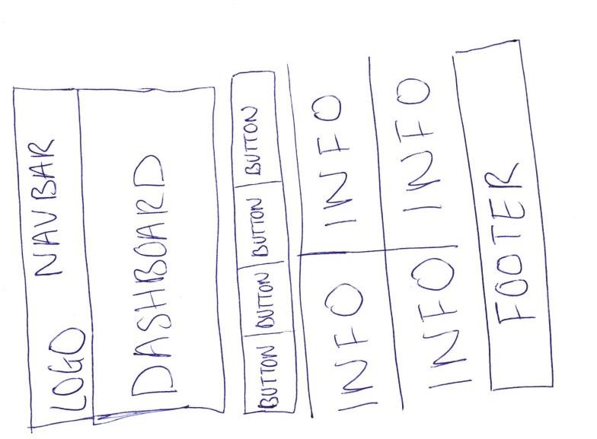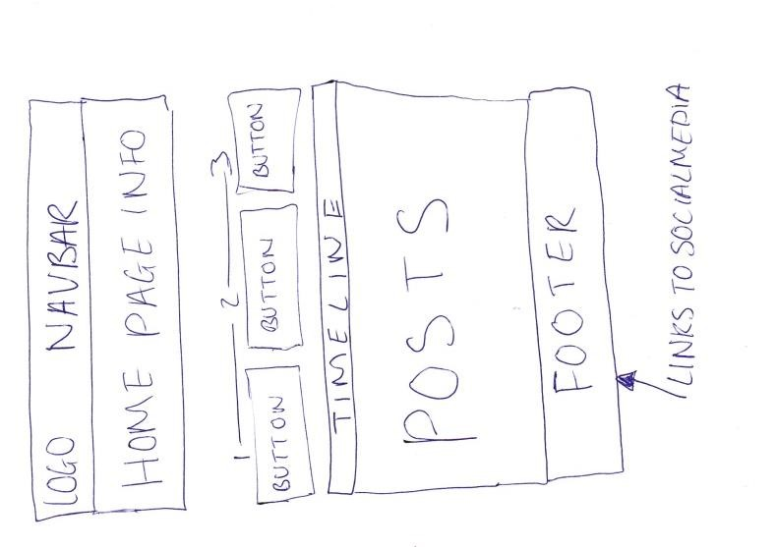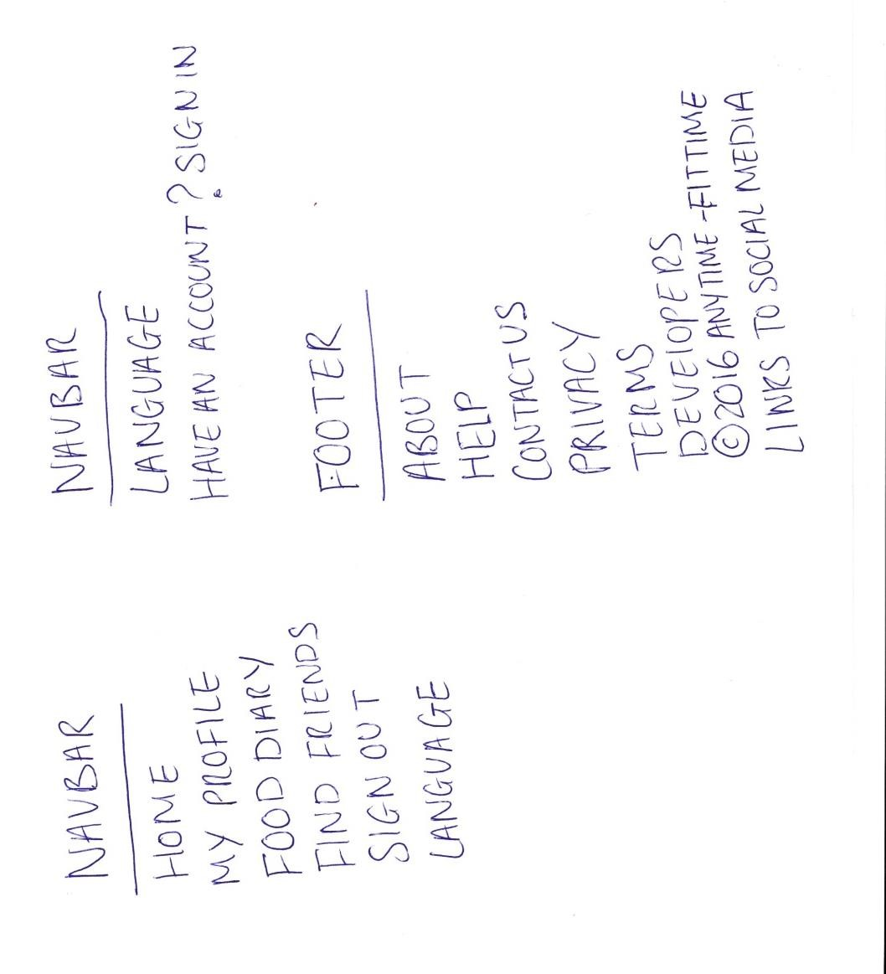

Visitor View



Registered

User View

#### 12.5.1Low Fidelity Design of User Registration Form

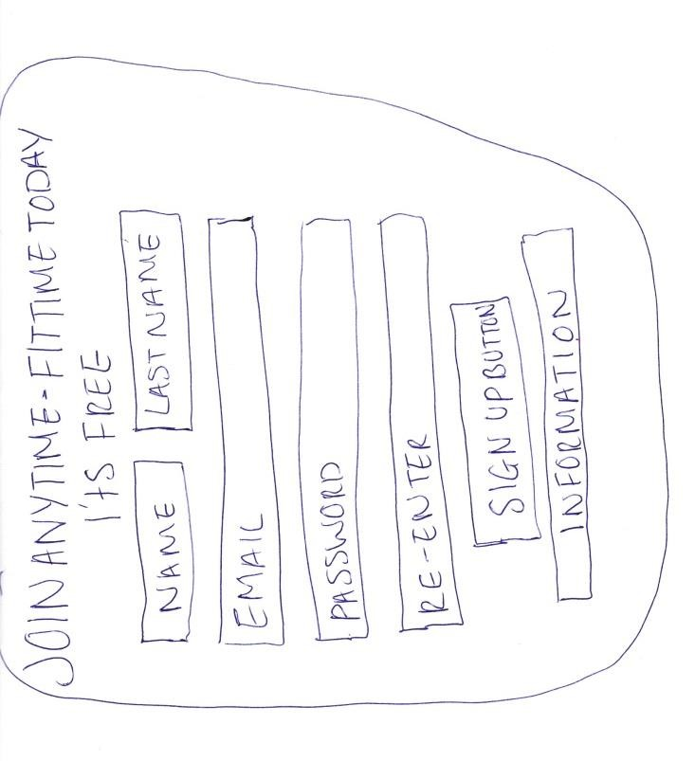

##### 12.5.2 Low Fidelity Design of Food Diary & User Diary Log

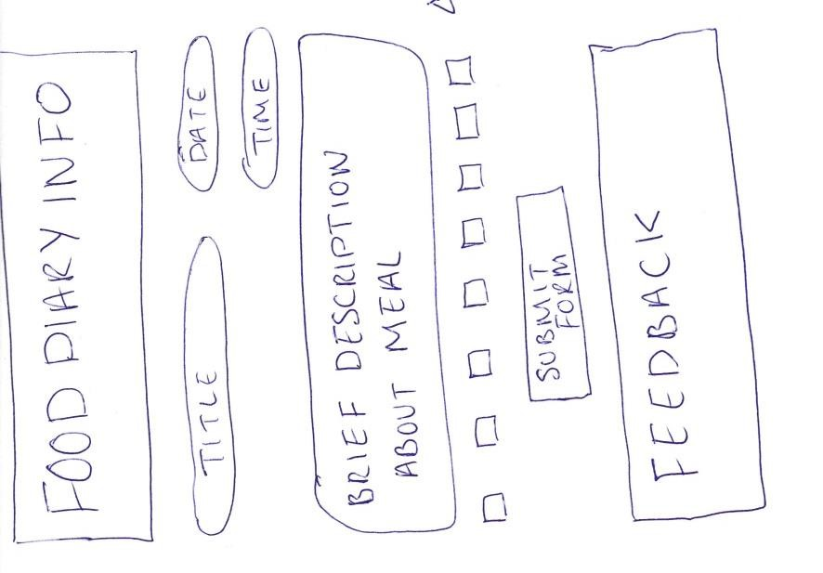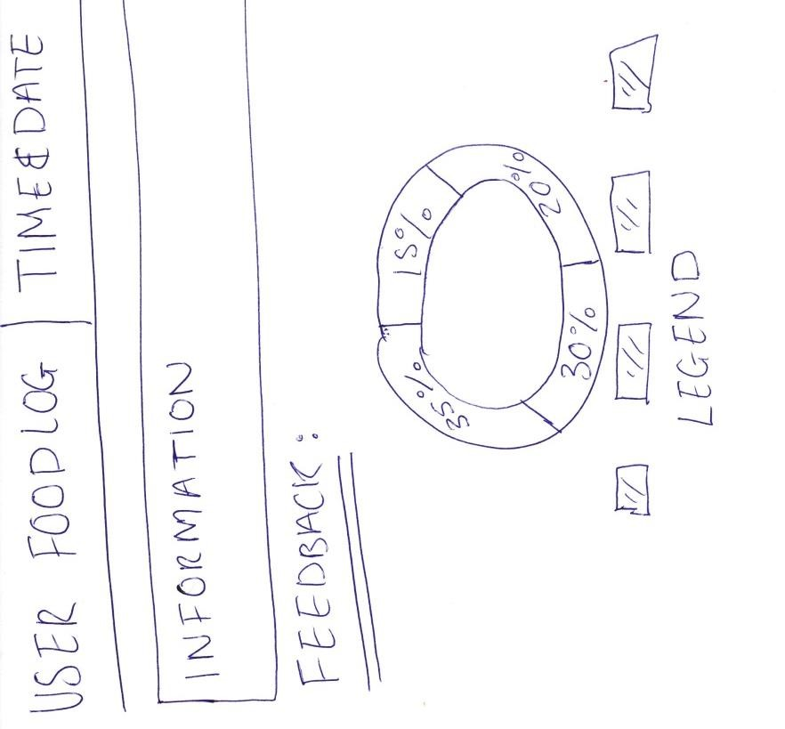

Insert Value for

nutrition inta

ke

##### 12.5.3 Low Fidelity Design of the User Profile Page & Edit Profile Page

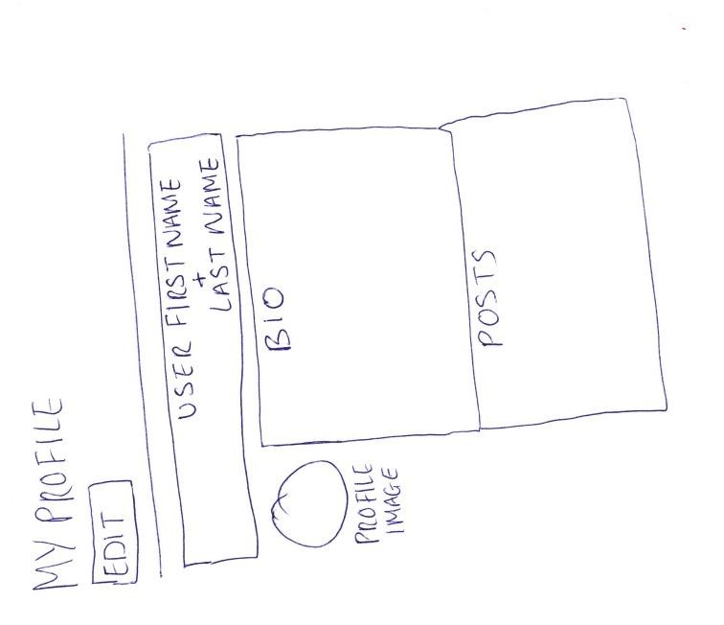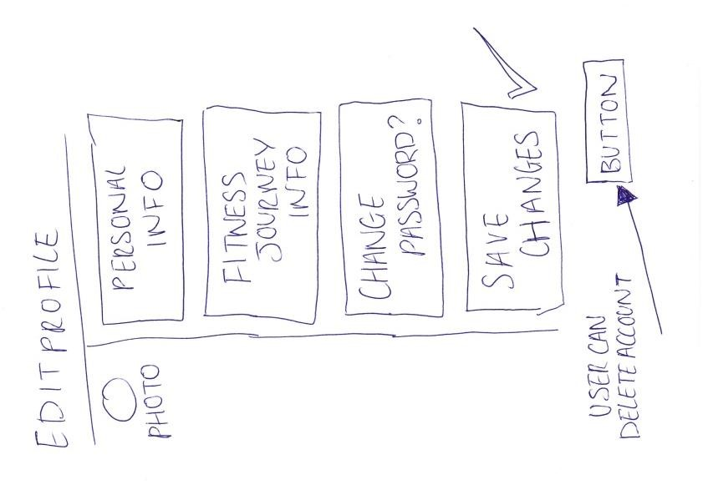

##### 12.5.4 Low Fidelity Design of User ‘Find Friends’ Page

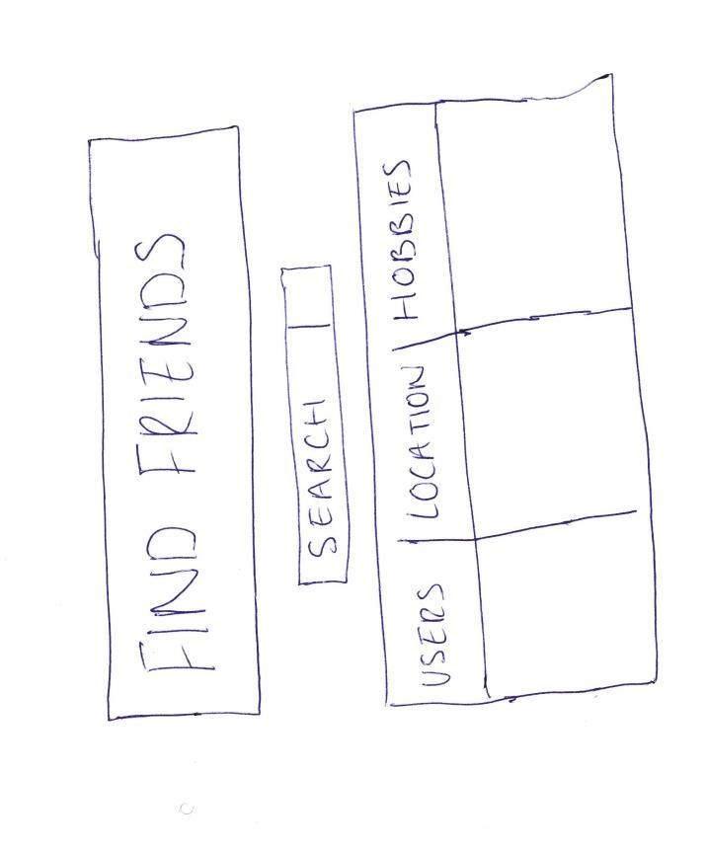

**12.5.5 Low Fidelity Design of User Login & Administrator Login Forms**

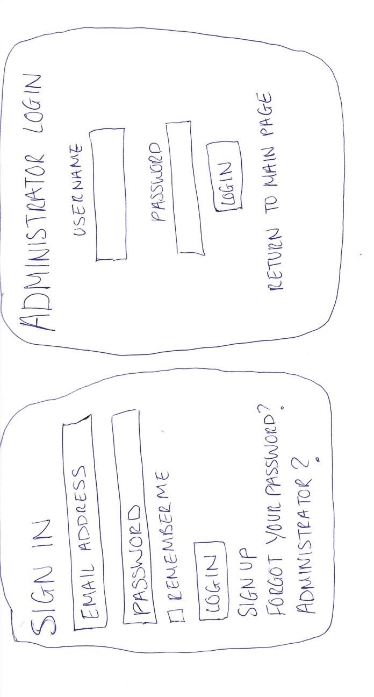

##### 12.5.6 Low Fidelity Design of About Us & Contact Us Page

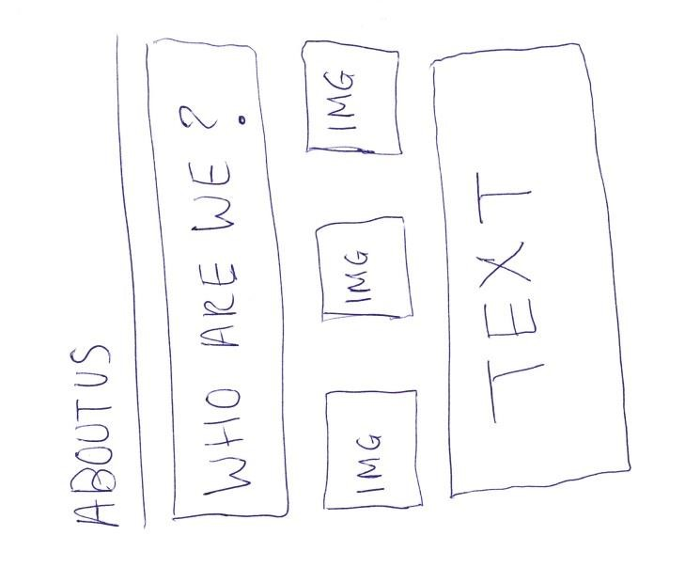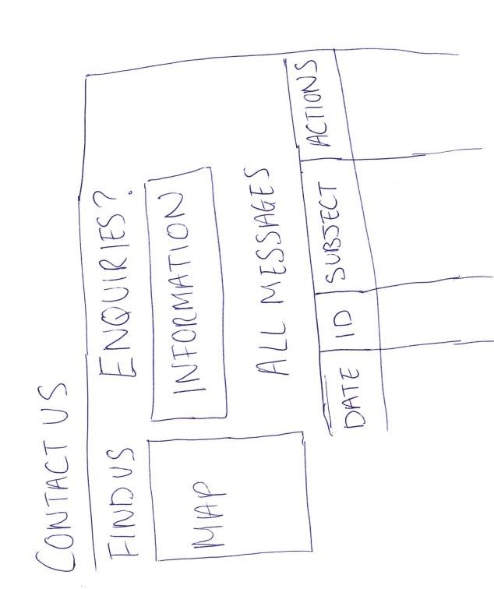

##### 12.5.7 Low Fidelity Design of Message & Post Forms

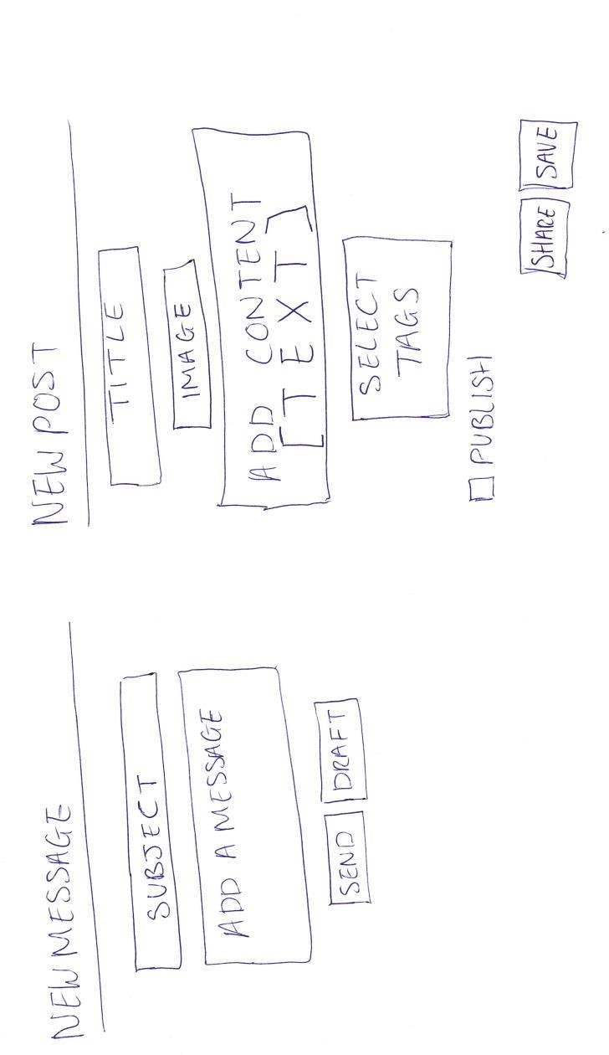

### 12.6 Appendix F - Meeting with Designer, Developer & Client (User Feedback 1)

Designer: Please take a look the prototypes for the system, what are your initial thoughts?

Client: I like what you have done, I’m happy with that. Although I would prefer if you used blue, black & white as the house colours because that would match our logo.

Developer: I can do that for you. Do you have a particular font you would like to use?

Client: I honestly don’t mind which font you use as long as it’s readable… Is it possible to have a more in depth visualisation of the User & Admin Login Form? I would like to see how it would look on the web page with the Navbar & footer

Designer: Yes, I can do that for you. I can also do this for the Admin Dashboard & Home Page to give you a general feel of how the overall system navigation format will be.

Developer: Are you happy with the Online Food Diary?

Client: The online food diary is amazing; you did a good job with including all the nutrients. However is it possible to include some sort of ‘More information’ button, something that will explain to the user how to use the form.

Also, I think the visualisation on the user diary log design would be better if you added a second pie chart to give the user something to compare it to.

Developer: Yes, I understand, I can do this for you.

Designer: Is there anything else you would like to add?

Client: No, that’s perfect, thank you for your help!

### 12.7 Appendix G - Meeting with Designer, Developer & Client (User Feedback 2)

Designer: Based on your feedback from the last meeting, we have created a few wireframe designs to give you a taste of what the social network website will look like. What are your initial thoughts?

Client: Yes this is definitely much better; it looks like it will be modern and well-tailored to the fitness theme. I’m happy with this.

Designer: Is there anything you would like to change?

Client: No, I’m 100% happy for you to use these designs to build the system. I’m excited now, I can’t wait to see what it will look.

12.8

Appendix H

–

Coding

Screenshots

& Brief Annotations

**Database connection**

**12.8.1**

The developer

firstly generated

models (tables) in the

git bash

termin

al

. For example

rails g model

Administrator

first

_name:string

Using

rake db:migrate

the developer then

create

d the tables. The m

odel folder connects code to

the database

.

In the

seeds.rb

the developer

created information about the administrator and

was able to

generate random data to populate the tables.

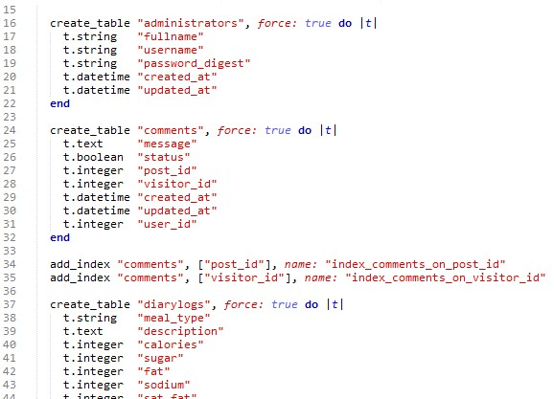

Schema.rb

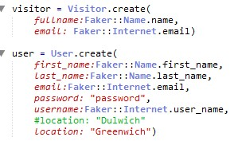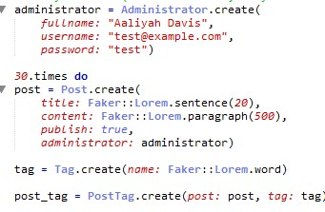

Seeds.rb

After the seed data has been done, the developer was able to do rake db:seed in the Git Bash terminal This would run the newly created model and seed the database with the information It has been given

|  |
| --- |
| Administrator table in database |

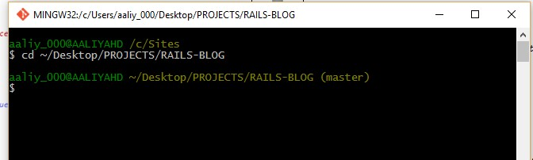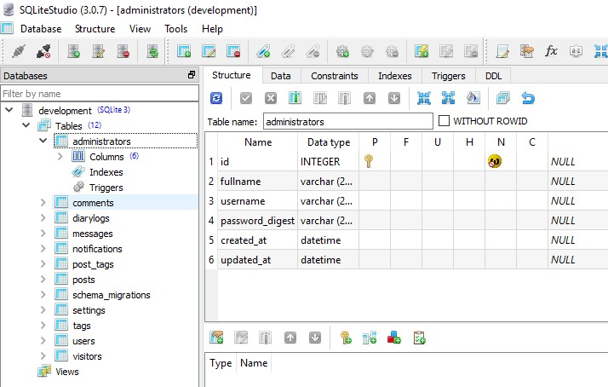

Git Bash

**Registration Form**

**12.8.2**

The developer used the devise gem, a

popular authentication solution for Rails applications

.

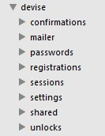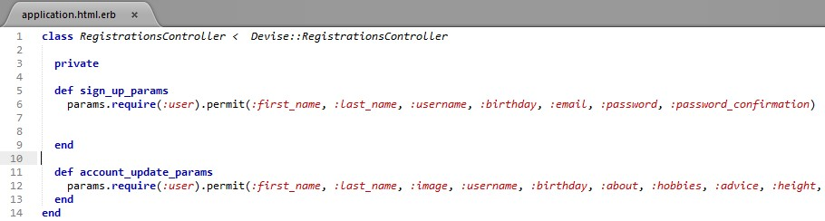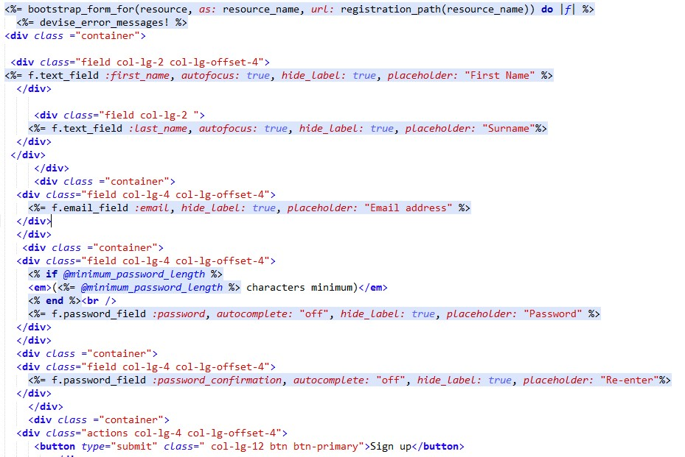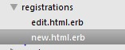

Bootstrap_form

used to

improve the user

interface design



f.text_field

allows the

user to insert text



f.email_field

accepts

email addresses



f.password_field

ensures

the users

password is hidden

when they type. i.e

“ ***** “



Params.require

permit

s the user to

enter only theinformation listed.

This limits what the user can input and

ensures the form is secure.

#### 12.8.3 Signing In

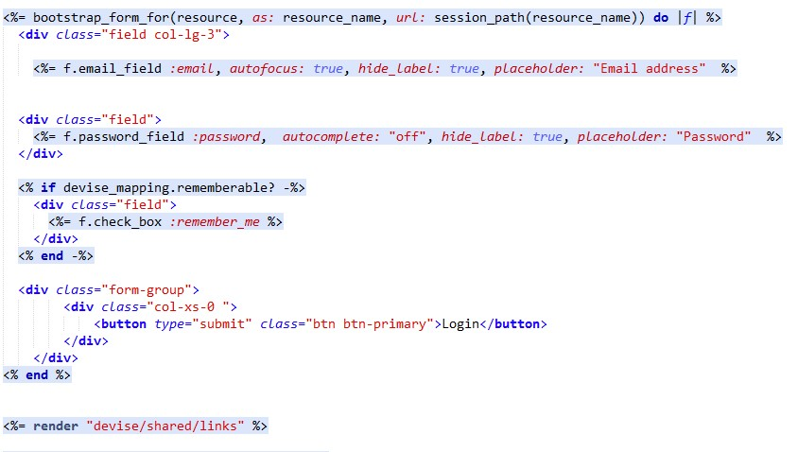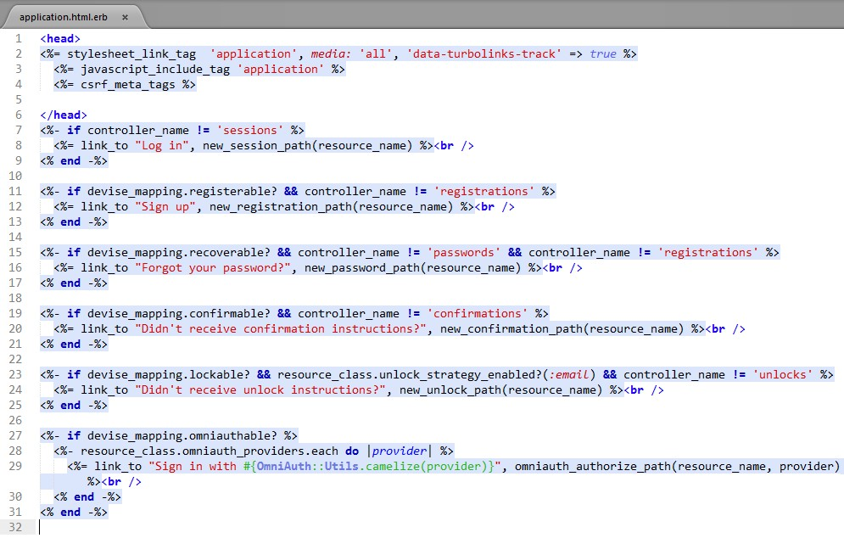

The devise shared links

will be rendered when

the user submits the

form.

#### 12.8.4 Personal Greetings

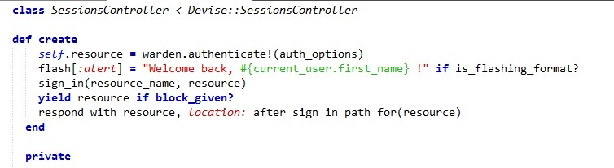

User will be greeted with their

first

name

when they sign in

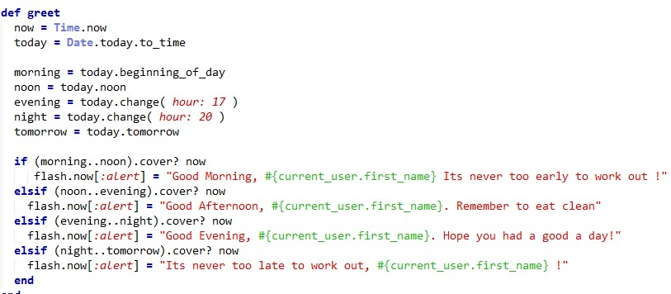

Depending on the

time of day

, the

user will view a pleasant message

that motivates them

**Editing Profile**

**Page**

**12.8.5**

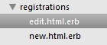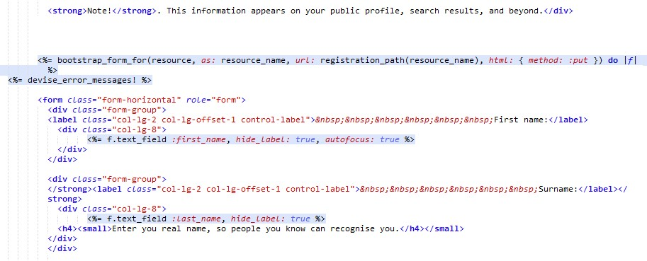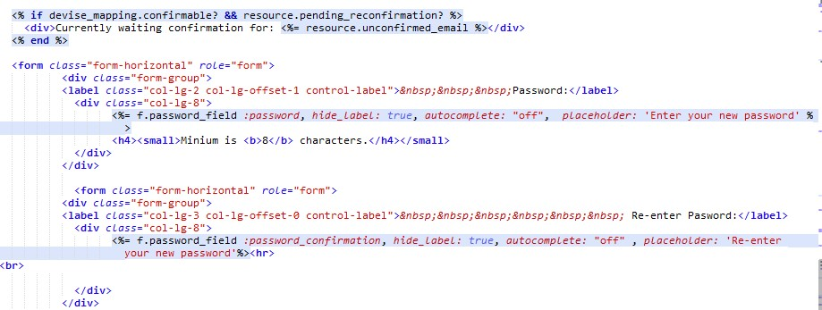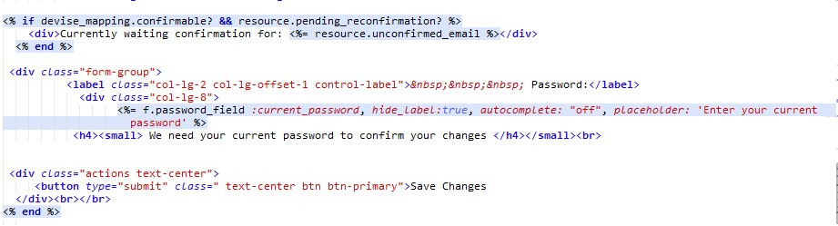

#### 12.8.6 Using the Food Diary – Visitor

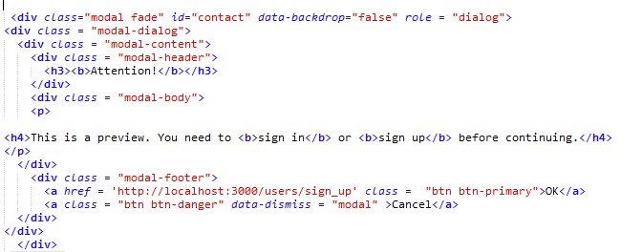

The modal dialog box will pop up with an

alert message when the visitor clicks the

‘

Submit D

iarylog’ b

utton

**12.8.7 Using the Food Diary – Registered User**

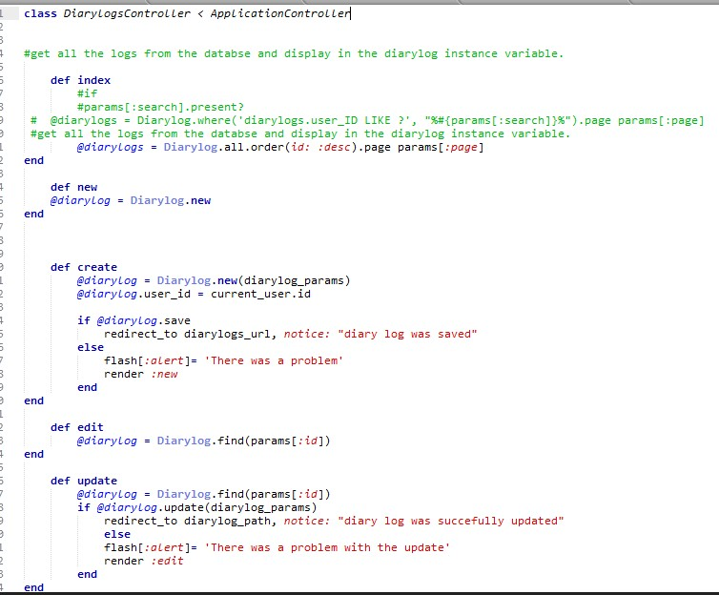

The diary log allows the user to

create

a

new

log,

edit,

view

, &

delete

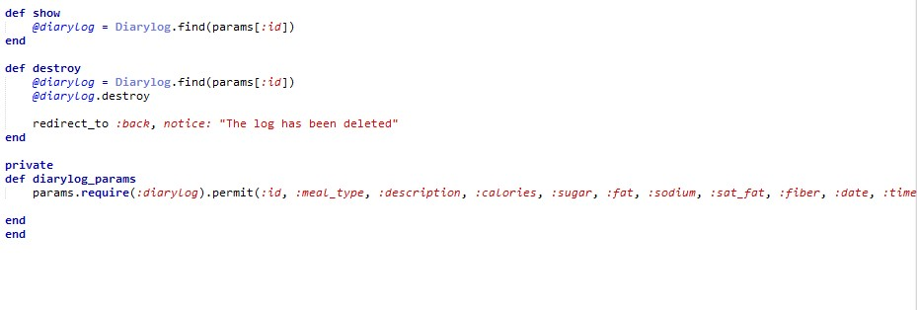

#### 12.8.8 Using the Food Diary – Admin



The diary log allows the admin to

update

a

diary

log.

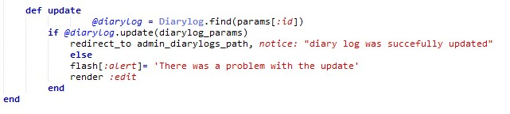

#### 12.8.9 Searching For a ‘Fit-Time Pal’



The system allows the admin to

search

for

other users, (

name

)

, locations, or

hobbies/interests

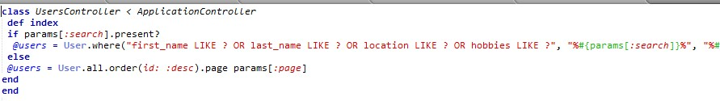

**12.8.10 Creating a Post**

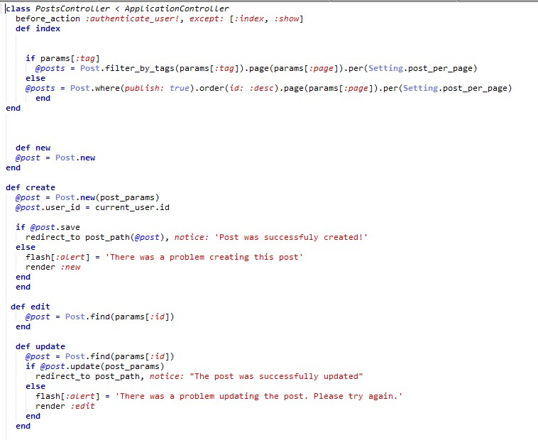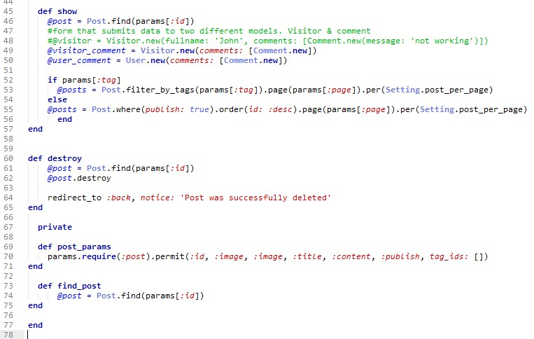

The user can

create

a

ne

w

post,

edit,

view

, &

delete

**12.8.11 Creating a Tag**

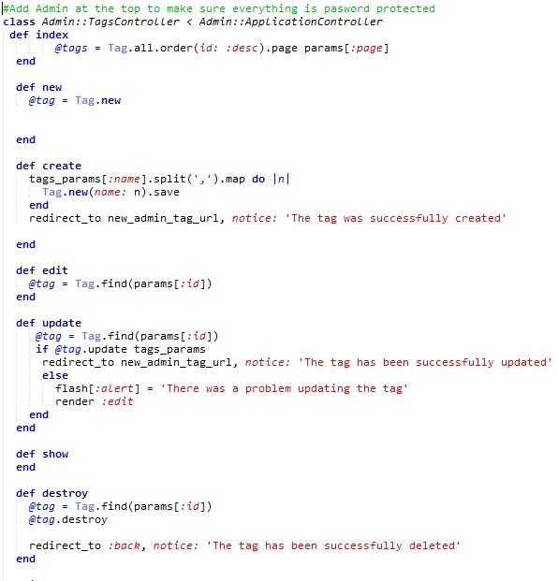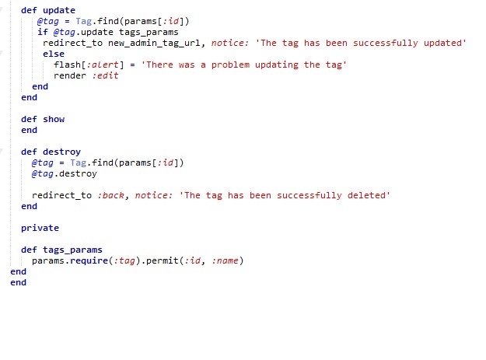

The admin can

create

a

new

tag,

edit,

view

, &

delete

#### 12.8.12 All Validations

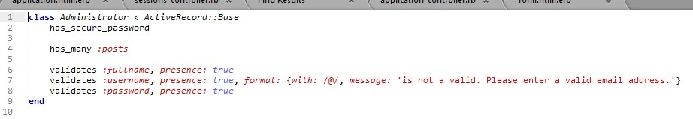

Password is hashed, so this is more

secure. using "has_secure_password"

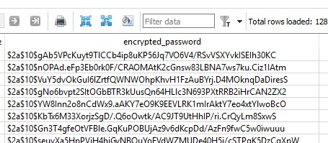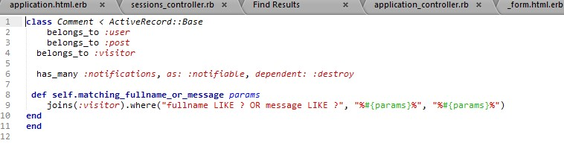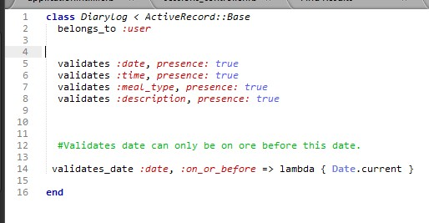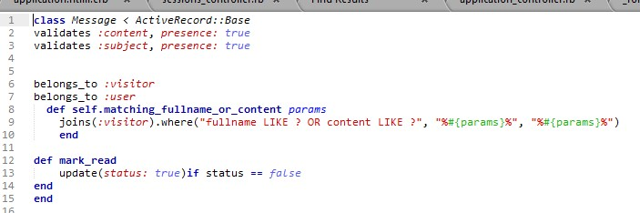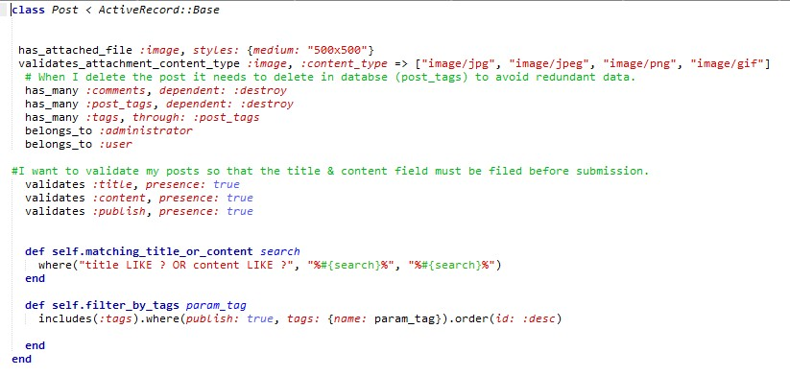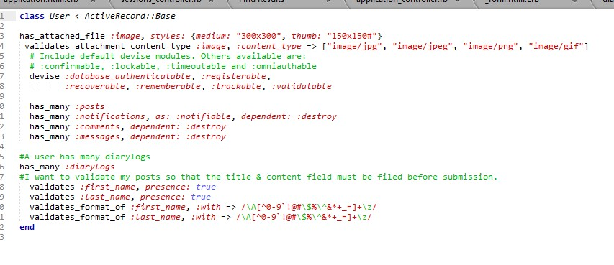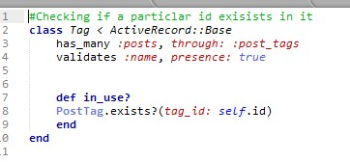

### 12.9 Appendix I – White Box Testing

|  |  |  |  |  |  |  |
| --- | --- | --- | --- | --- | --- | --- |
|  |  | Sign Up Form | |  | | |
| Test No. | Testing Criteria | Data Input / Action Required | Output Required | Output Achieved ? | | Changes |
| 1. | Entering an invalid email address | aaliyahdavis@ | Display Error Message:  Please enter a part following ‘@’.  ‘aaliyahdavis@’ is incomplete |  | | NA |
| 2. | Entering a password that has 6 characters | Password: 123456 | Display Error Message:  Password is too short.  (Minimum is 8 characters) |  | | NA |
| 3. | Re-entering a password that does not match. | Password:123 | Display Error Message: Password does not match. |  | | NA |
| 4. | Leaving all required fields blank. | No input required | Display Red Error labels:  First Name can’t be blank  Surname can’t be blank  Password can’t be blank |  | | NA |
| 5. | Entering characters that the system should  not accept in the ‘First Name’ field | character such as ({}*^%$#@ | Display Error Message: First name is invalid |  | | NA |
|  |  | Food Diary | |  | | |
| 6. | If the visitor wishes to use the food diary they should be  redirected to the  Sign up page | Clicking the  Submit Diarylog button | Pop up dialog box that alerts the visitor that they  need to sign up. If they press continue it will  redirect them to the sign up page. |  | NA | |
| 7. | The user can only create diary logs for the current date or previous dates. | Attempting to create a diary log for a future date | Display Error message:  Date must be on or before [Enter current  Date] | FAIL  This has now been changed so that the user cannot select a  ‘future date’ from the calendar  provided. | | |
|  |  | User Sign in Form | |  | | |
| 8. | Entering an email address that has not  been registered with  the system / saved to the database | Wrong credentials | Display Error Message: Invalid email or password |  | | NA |
|  |  |  |  |  | |  |
|  |  | Creating a post | |  | | |
| 9. | The title can be no longer than 70 characters. | Attempting to enter more than 70 characters | When the user enters more than 70 characters the field prevents the user from carrying on. |  | | NA |
| 10. | The image can only accept images in the  following formats: jpg, jpeg, png or gif. | Attempting to upload PDF | Display Error Message:  Image content type is invalid |  | | NA |
| 11. | The user needs to check the publish  checkbox if they wish to share a post. | Attempting to share a post  without checking the publish checkbox. | Display Error Message:  There was a problem creating this post. Publish can’t be blank |  | | NA |
|  |  | Administrator Login Form | |  | |  |
| 12. | Entering a username and password that has  not been registered with the system /  saved to the database | Wrong credentials | Display Error Message: Invalid email or password |  | | NA |
|  |  | Creating a Tag | |  | |  |
| 13. | Creating a blank tag | No input required | Display Error Message: Tag can’t be blank |  | | NA |

### 12.10 Appendix J – Usability Testing

|  |  |  |  |
| --- | --- | --- | --- |
| Test No. | Heuristic Criteria | Pass/Fail | Comment |
| 1. | Constraints | Pass | The developer has included many constraints (validations) to restrict the users’ behaviour. This design helps the user to understand the status of the system. |
| 2. | Visibility of the system status | Pass | The developer has used alerts to tell the user whether an action has been successful or not. |
| 3. | Match between the system and the real world | Pass | The language used in the system can be understood by all users and is relevant to the nature of the system. For  example, the use of “Find FitTime Pals” reinforces the  concept of Anytime-FitTime being a social network for fitness enthusiast to motivate each other. |
| 4. | User control and freedom | Pass | The system allows the user to revert to a previous state in the likelihood that they click a system function by mistake |
| 5. | Consistency and standards | Pass | The system maintains a consistent layout that makes it easy for a user to navigate |
| 6. | Error Prevention | Pass | The system includes designs that prevent problems for example the system prompts the user to enter their  password before they proceed. This helps to save the user from having to modify the ‘edit profile’ page again. |
| 7. | Recognition rather than recall | Pass | The system includes a guideline for the pie chart. This is easy for the user to identify and the user does not have to remember a great load of information. |
|  |  |  | The system has auto-search feature that types ahead for the user and remembers profiles / places they have looked at before. |
| 8. | Flexibility and efficiency of use | Pass | The system caters to both experienced and inexperienced users; offering the option “View example” button on the food diary but this is not sufficient to pass this test.    The system offers a set of advanced options that allows the user to share their data externally. |
| 9. | Aesthetic and minimalist design | Pass | The profile page succeeds in showing information that is relevant to the user. The edit profile page prompts the user to enter information about them, using suitable labels to allow users to focus on key information. |
| 10. | Help users recognise,  diagnose ad  recover from errors | fail | In the case the user is experiencing technical issues and cannot load the page. The system does not display a clear message or image that precisely indicates the problem |
| 11. | Help and documentation | Pass | The system provides the user with a “view example” button that aids the user in creating a Diarylog. |

### 12.11 Appendix K Development Plan – Gantt Chart

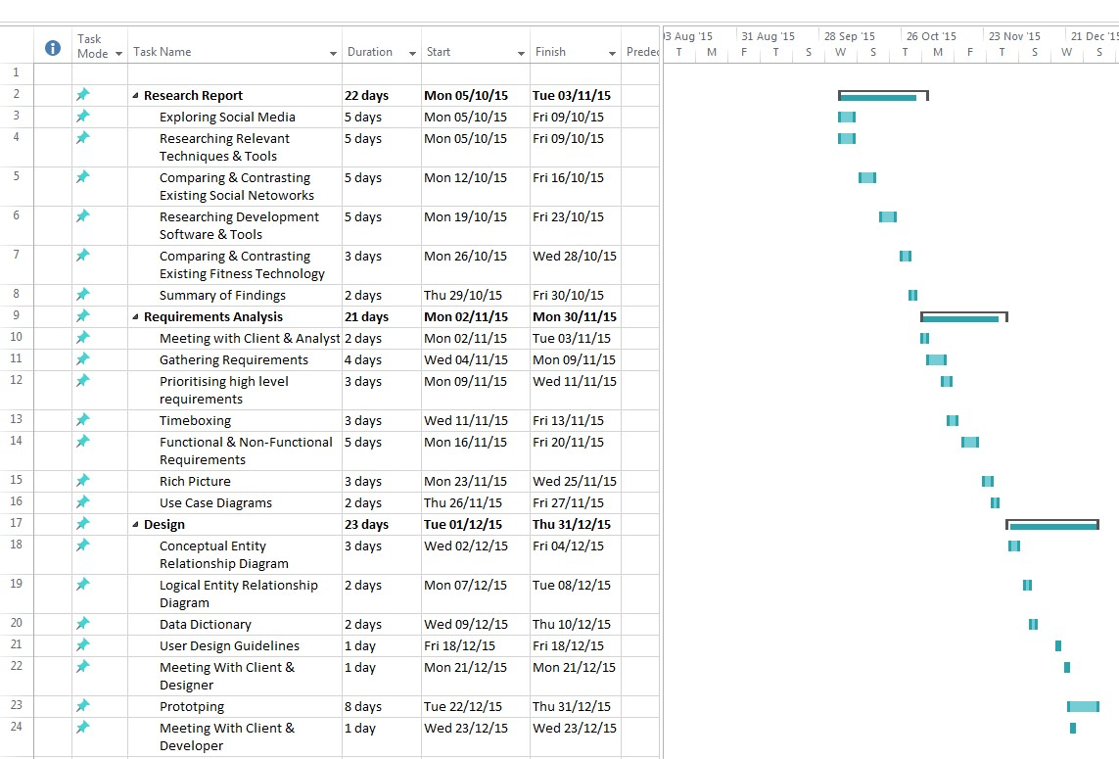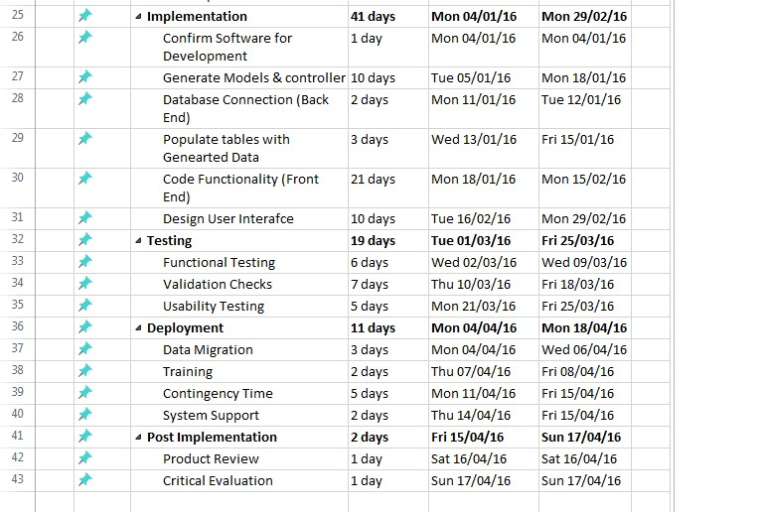

#### 12.11.1 Facebook

<https://www.facebook.com/>

Ratings = (1) poor, (2) fair, (3) good, (4) very good and (5) excellent

|  |  |  |  |
| --- | --- | --- | --- |
| Heuristics  Evaluation on  Facebook | Image | Analysis/ Explanation | Rating |
|  | | |  |
| 1. Visibility of system status | Logging In | “Logging In”, appears in the centre of the screen and a small grey circle proceeds to turn clockwise, communicating to the user that the page is  loading. Although this feedback helps the user to understand that the page is loading, it is not clear how long the page is expected to load for.  This could be improved if numerical percentages were used to give the user an exact update of how long they have left to wait for, as opposed to just a circle turning clockwise. | 1  2  3  [4]  5 |
|  | Uploading a photo | “Uploading…” appears in the top left-hand corner of the window and an active progress bar is displayed, showing the user the status of the upload. Whilst this feedback gives the user a general idea of how long a photo will take to upload, this could be improved if there was a timer that gave the user an exact update of how long the wait time will be. | 1  2  3  [4]  5 |
|  | User Profile | The active bar is displayed along with “66% complete” which allows the user to see the progress of their user profile. The user should not have to guess what the system is doing at any point and Facebook is effective in giving them a time estimate for this particular feature. | 1  2  3  4  [5] |

|  |  |  |  |
| --- | --- | --- | --- |
|  | | | |
| 2. Match between system & the real world | Finding Friends | The common use of the word, “Friends” on Facebook reinforces the concept of  Facebook being a social network for friends to connect. According to Gresham  (2013) , “Personal engagement in an online space is the core purpose of Facebook and It serves to allow individual users to connect with friends.”  Overall the content on the website is relevant to what the website is used for. | 1  2  3  4  [5] |
|  | Home Page | The language can be understood by all users e.g. the information is organised as a list and clearly labelled so the user does not need to be computer literate to understand how to navigate. Overall Facebook is for everyone and the language used overall in the website are simple/informal words. | 1  2  3  4  [5] |
|  | Personalisation | When the user logs into Facebook, the system immediately identifies the time and proceed to use the personal greeting technique.  Overall the language used is pleasant and provides the user with a memorable experience. | 1  2  3  4  [5] |
|  | | | |

|  |  |  |  |
| --- | --- | --- | --- |
| 3. User Control and freedom | Updating Status | The icons displayed work as visual aid to guide the user- almost prompting them on what they could say and making the process easier. The post button is  clearly labelled and the colour blue makes it clear at first sight that this button will finalise the update. In the case that the user chooses the wrong  image/video to upload, there is a grey X in the right hand corner of the image that works as an "emergency exit" and allows the user to remove the image. | 1  2  3  4  [5] |
|  | Updating Personal Information | The navigation bar is not only easy to access but, the use of different colours and text helps the user to identify all the navigation options. In addition, the  use of bold font makes the navigation panel stand out, and the blue line next to the heading clearly highlights where the user currently is on the website.    Overall, there is no specific order to how the page should be viewed therefore, the user has complete control as to which buttons they can click and which page they would like to access. | 1  2  3  4  [5] |
|  | | | |
| 4. Consistency and standards | Signing In | The system should include features that would be deemed as ‘familiar’ by the user and on the initial interface for Facebook, the “ Log in “ fields are displayed at the top of the page. Overall, this follows the platform conventions. | 1  2  3  4  [5] |

|  |  |  |  |
| --- | --- | --- | --- |
|  | Main Toolbar | At the top of every page there is always a blue toolbar with the same primary menu options: Users profile, Home, Find Friends, Friend Requests icon, Messages icon, Notifications icon and Privacy Shortcuts icon.    The fact that the keywords and order of icons are always the same makes it easier for the user to become familiar with the website and adapt to the  navigation quickly. Furthermore, the consistent format ensures that users will never be confused as to what each feature does. Overall the website maintains a consistency and high standard. | 1  2  3  4  [5] |
|  | | | |
| 5. Error Prevention | Adding a Short Bio | The ‘cancel’ button is prominently located next to the save button, allowing the user to stop the process and return back to the main display. In addition, the  text on the button clearly informs the user what the function of the button does. For example, In the case that the user suddenly wanted to stop publishing information, the cancel button prevents this from happening. | 1  2  3  4  [5] |
|  | Searching for Friends | The auto suggestion feature not only helps users to navigate quickly but reduces the amount of misspelt words. | 1  2  3  4  [5] |
|  | Confirmation Option | In the case that a user clicks off the page by accident, Facebook presents the user with a window box to which they must read before they commit to that action. Overall, this can help the user to avoid losing important data. | 1  2  3  4  [5] |
|  | | | |

|  |  |  |  |
| --- | --- | --- | --- |
| 6. Recognition rather than recall & 7. Flexibility and efficiency of use | Favourites | Facebook offers users a Favourite list; important actions for the system. Overall these actions are easy to identify and access as they are located on the home page. | 1  2  3  4  [5] |
|  | Edit Preference | Furthermore, Facebook allows advanced users to tailor the Favourite list by including the “edit preference” option. By doing this the user can take control and customise their News Feed. Overall this demonstrates that the system includes accelerators and caters to both inexperienced and experienced users. | 1  2  3  4  [5] |
|  | Auto-Search | The user should not have to remember a great amount of information and Facebook has a feature that types ahead for the user and suggests places/ people they should view. | 1  2  3  4  [5] |
|  | | | |

|  |  |  |  |
| --- | --- | --- | --- |
| 8. Atheistic and minimalistic design | User Profile | The user’s profile prompts the user to enter information about themselves that will be displayed to other users. The interface also uses bold text to allow users to focus on key information. Overall, the profile succeeds in showing  information that is relevant to the user | 1  2  3  4  [5] |
|  | Personalisation | Although the colours used on the users profile are basic, Facebook allows the user to personalise their profile with a cover photo. Naturally this would appeal to the users eye because it’s their own choice. | 1  2  3  4  [5] |
|  | | | |
| 9. Help users recognize, diagnose, and recover from errors  (RECOVERY) | Recovery | In the case that a user is viewing a user’s profile that has been deleted,  Facebook will display a image with a clear message that states the problem,  “the link you followed may be broken, or the page may have been removed”    Following this, Facebook continues by suggesting a solution which includes links, “Go back to the previous page – go the Facebook homepage – Visit the  Help Center.” Overall this demonstrates that Facebook offers accurate information that will help the user to solve their problem. | 1  2  3  4  [5] |
|  | | | |

|  |  |  |  |
| --- | --- | --- | --- |
| 10. Help users recognize, diagnose, and recover from errors  (RECOVERY) | Finding Help | To help the user further, Facebook provides the user with documentation that is relatively easy to find. The Help window opens a new window within Facebook with a full set of help resources: search, popular issues, links to further assistance. | 1  2  3  4  [5] |
|  | Instructions | Once the user has found the subject of their issue, Facebook provides the user with a list of concise instructions. The process is explained in short steps and  uses visual aid to support the explanation as well as to showcase feature. In  addition, this feature can help to introduce users to Facebook | 1  2  3  4  [5] |
|  | | | |

#### 12.11.2 Instagram

<https://www.instagram.com/>

Ratings = (1) poor, (2) fair, (3) good, (4) very good and (5) excellent

|  |  |  |  |
| --- | --- | --- | --- |
| Heuristics  Evaluation on  Instagram | Image | Analysis/ Explanation | Rating |
|  | | |  |
| 1. Visibility of system status | Logging In | For the user to know whether an action has been successful, they will have to view the tab in the browser and identify if the small grey circle is moving.  Although this is a form of feedback, this is not the greatest communication. This could be improved if a message was displayed on the interface as soon as the user actions the button. | 1  [2]  3  4  5 |
|  | | |  |
| 2. Match between system & the real world | Home Page      Time Line - Personalisation | In the initial launch of Instagram, it was declared that it was a photo sharing social network. According to Mitchell (2012) “the point of Instagram, just as much as taking photos, is finding new photos.”    Following this, the home page of Instagram is relevant to the nature of the system as it allows users to search for new pictures. In addition the time line is easy to read; the users account name is displayed along with ‘5m’ (5 minutes ago). Overall the language used in Instagram is simple and does not confuse the user. | 1  2  3  4  [5] |

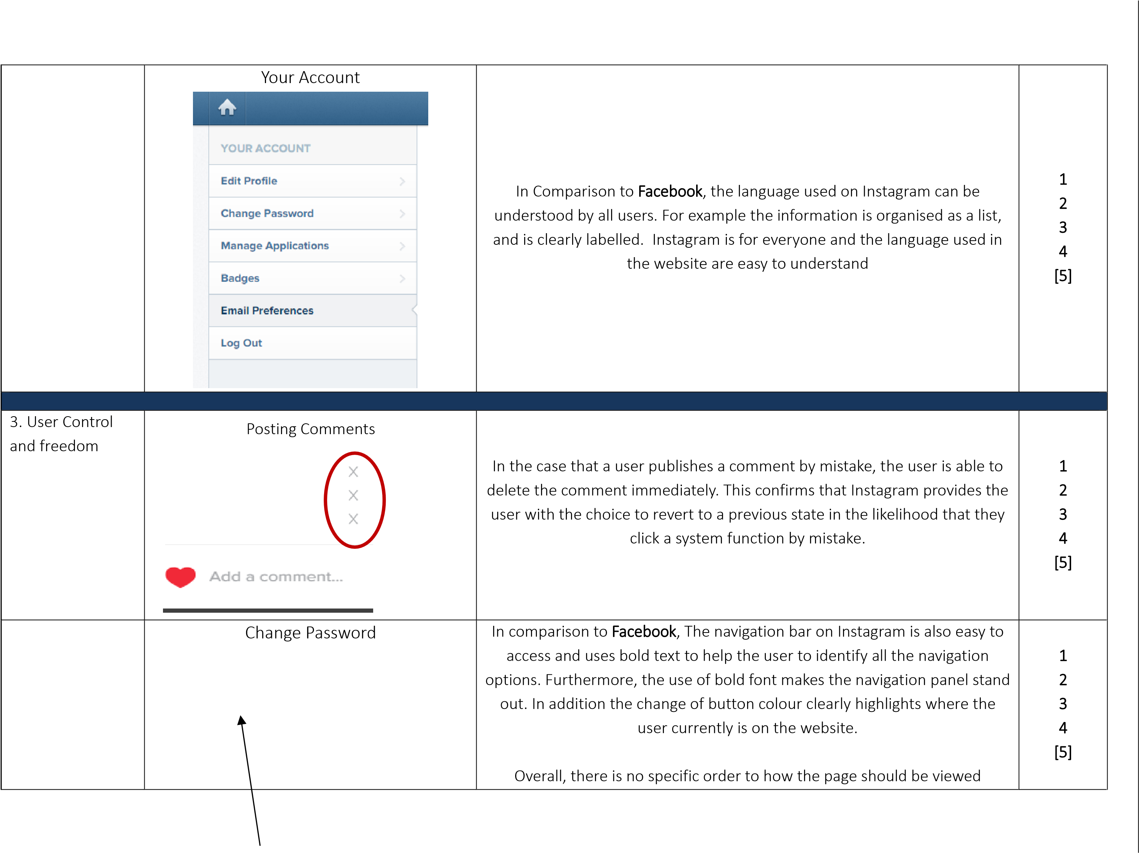

|  |  |  |  |
| --- | --- | --- | --- |
|  |  | therefore, the user has complete control as to which buttons they can click and which page they would like to access. |  |
|  | | | |
| 4. Consistency and standards | Signing Up | The system should include features that would be deemed as ‘familiar’ by the user and on the initial interface for Instagram, the user is informed that they need to download the app to sign up to the system.  With technology evolving dramatically each year, this process will become the standard platform convention. | 1  2  [3]  4  5 |

|  |  |  |  |
| --- | --- | --- | --- |
|  | Main Toolbar | At the top of every page the Instagram logo is always left-aligned and the search box is always center-aligned. This order is always the, therefore it  makes it easier for the user to become familiar with the website and adapt to the navigation quickly. Furthermore, in comparison to Facebook, the consistent format ensures that users will never be confused as to what each feature does.    However, I think the tool bar is currently sparse and could be improved by adding more icon for visual aid. | 1  2  [3]  4  5 |
|  | | | |
| 5. Error  Prevention & 6. Recognition rather than recall | Auto Search- Hashtags | The auto suggestion feature not only helps users to find pictures quickly, but it reduces the amount of misspelt words.  In addition, the user should not have to remember a great amount of information and Instagram also has a feature that types ahead for the user and suggests places/ people they should view. | 1  2  3  4  [5] |
|  | | | |
| 7. Flexibility and efficiency of use | Embed Photo | Instagram allows advanced users to not only copy the code to embed pictures but gives them option to include captions. By doing this the user  can take control and modify the settings how they would like to. Overall this demonstrates that the system includes accelerators and caters to both inexperienced and experienced users. | 1  2  3  [4]  5 |
|  | | | |

|  |  |  |  |
| --- | --- | --- | --- |
| 8. Atheistic and minimalistic design | User Profile | The interface of the user’s profile mainy surrounds the effectiveness of pictures. The short bio at the briefly introduces the user however it is cleart  that pictures are the heart of the profile. The interface also uses bold text to allow tells the viewer the amount of pictures the user has posted, Overall, the profile succeeds in showcasing many photos that is relevant to the purpose of the social network. | 1  2  3  4  [5] |
|  | Personalisation | Although the colours used on the users profile are basic, Instagram allows the user to personalise their profile with a display photo. Naturally this would appeal to the user’s eye because it’s their own choice. | 1  2  3  4  [5] |
|  | | | |
| 9. Help users recognize, diagnose, and recover from errors  (RECOVERY) | Recovery | In the case that the user is experiencing difficulties on the Instagram website, there is currently no plan of action that offers accurate information that will help the user to solve their problem.    Alternatively, the user would have to seek an update from another social network, such as Twitter. | [1]  2  3  4  5 |
|  | | | |

|  |  |  |  |
| --- | --- | --- | --- |
| 10. Help users recognize, diagnose, and recover from errors  (RECOVERY) | Finding Help | To help the user further, Instagram provides the user with documentation that is relatively easy to find. The Support window opens a new window within Instagram with a full set of help resources: Known Issues, Frequently  Asked Questions, Privacy & Safety center | 1  2  3  4  [5] |
|  | Instructions | Once the user has found the subject of their issue, Instagram provides the user with a list of concise instructions. The process is explained in short steps and uses visual aid to support the explanation as well as to showcase feature.    However, majority of the instructions are tailored to mobile users in contrast to the website users. | 1  2  3  [4]  5 |
|  |  | |  |